Digital revolution in patient care to start in Morriston Hospital
Wednesday, 22 November 2017
A digital healthcare revolution to improve the quality and safety of services for patients is being introduced in Morriston Hospital.
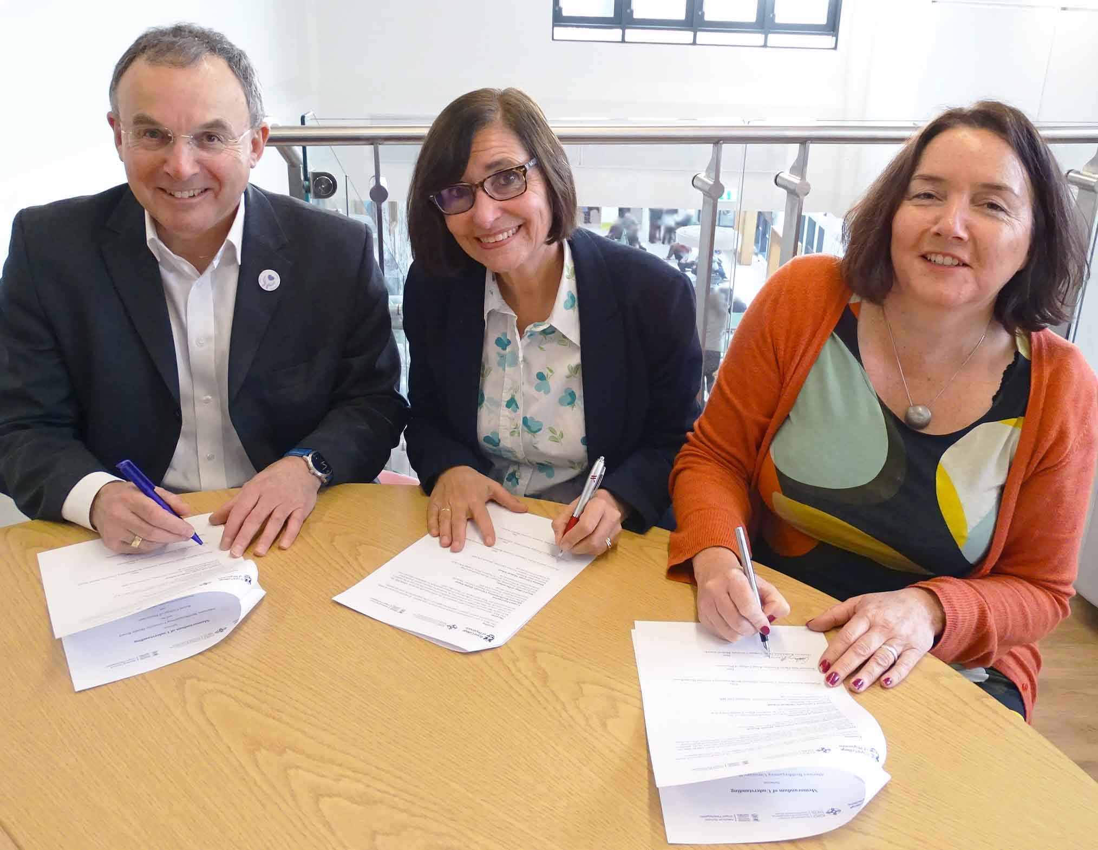
TROCAR, an electronic system for recording patient information, will start on one of the hospital’s medical wards but will eventually be rolled out across the health board.

ABMU Chairman Andrew Davies, Royal College of Physicians President Jane Dacre and Swansea University Medical School Deputy Head Cathy Thornton sign the agreement
It’s the first project to be undertaken as part of a collaboration between ABMU, Swansea University Medical School and the Royal College of Physicians in London.

TROCAR aims to improve the quality, usefulness and speed of information sent to GPs when patients are discharged from hospital.

Clinicians use a variety of paper-based and electronic systems to access clinical information and investigations for hospital patients. In most cases these systems are not connected.

When a patient is ready to go home, a doctor has to write up a discharge summary which is then sent to the patient’s GP.

But it is not yet possible to electronically import the information which was previously collected. So doctors have to spend time collating the various notes and writing a summary from scratch.

This is time-consuming but, more importantly, could potentially lead to compromised care, delays and risk through the slow or incomplete transfer of information.

TROCAR (Improving Transfer of Care) involves recording all information electronically from the moment the patient arrives in hospital.

The doctor writing the discharge summary will have instant access to all this information, meaning the summary can be produced in minutes.

The project is being led by Dr David Price, Associate Unit Medical Director for Medicine and Consultant Nephrologist Dr James Chess at Morriston Hospital, and by Professor John Williams Professor of Health Services Research at Swansea University Medical School.

Dr Price said: “GPs say having an incomplete or delayed discharge summary is a major problem. So having more accurate and timely discharge information will improve patient care.”

Professor Williams, who also leads the Health Informatics Unit at the Royal College of Physicians in London, added: “The hope is that as we transform digital healthcare it will empower patients and improve outcomes.”

Representatives of ABMU, Swansea University Medical School and The Royal College of Physicians gathered in Morriston Hospital to sign an important agreement known as a Memorandum of Understanding.

This aims to support the health board’s digital strategy, with specific objectives including improving the recording, communication and use of clinical information.

ABMU’s Informatics Directorate and the NHS Wales Informatics Service are also partners in TROCAR.

It will start in Morriston Hospital’s Ward D following consultation with medical staff, GPs, hospital managers and patients.

Professor Hamish Laing, ABMU’s Medical Director, said: “As the NHS moves away from paper to more digital applications it is vital our hospital clinicians and GPs have the information they need to provide the best care, particularly when a patient moves between hospital and home.”

ABMU Chairman Professor Andrew Davies said: “We have an ambitious strategy to support our clinicians and patients with modern digital technology.

“I am delighted the three partners are pooling their expertise and ambition to ensure we get the best from our digital systems.”

Royal College of Physicians President Professor Jane Dacre said: “I’m very proud the Royal College of Physicians is involved in this innovative project, in partnership with our colleagues from the health board and medical school.

“Developments in digital healthcare have a crucial role in improving patient safety and ensuring patients receive quality, timely care and communication.

“I look forward to seeing the positive impact of the TROCAR project across Morriston Hospital and beyond.”

Source: Abertawe Bro Morgannwg University Health Board

