Clara staying healthy with help from her flu vaccination
Wednesday, 15 November 2017
Clara Reid is loving her first term as a nursery pupil at Cwmrhydyceirw Primary School in Swansea.

She says she wants to learn as much as she can so she can be a “doctor for all the animals” when she grows up.
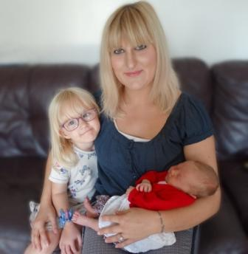
To make sure she stays healthy during the winter, her mum Katie Skilton made sure Clara had her free flu vaccination.

Clara with her mum Katie and baby sister Eryn.

Katie said: “I think there’s a lot of things that you can’t protect your children against but you can do something about flu.

“If there is a vaccination available I don’t see why you wouldn’t have it.”

Clara – who has just turned four – received the nasal flu vaccine at her GP’s surgery like other children who were aged two and three by 31st August.

Children in Reception and Years 1, 2, 3 and 4 are currently being given theirs by school nurses at vaccination sessions held in their schools.

Having your child vaccinated means you will be helping to reduce the risk of them catching flu and spreading it to vulnerable people in the family like grandparents.

ABMU’s Director of Public Health Dr Sandra Husbands said: “We want to make sure children are protected because their immune systems aren’t fully developed yet.

“This means if they do get flu they will find it more difficult to fight off the infection and could end up feeling really ill, especially if they have other health conditions like asthma causing further complications.

“Besides spreading it to their own families, there is also the risk that they could pass on flu to other children in school who in turn could spread it to their families.

“That’s why we try to make it as easy as possible for children to have their vaccination and we want to reassure families that the vaccine we use is safe and it works.”

For further information about the flu vaccination go to www.abm.wales.nhs.uk/flu
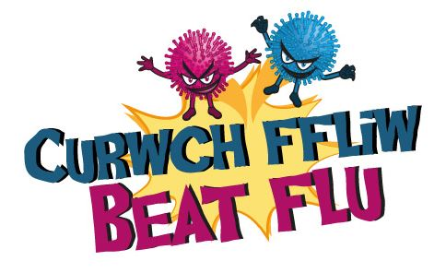

Is flu really that serious?

ABMU consultant in critical care Dave Hope, has spent over 25 years working in intensive care looking after the most seriously ill patients, many of whom have life-threatening conditions.

When talking about the power of flu he said: “When you work in intensive care (ITU) it’s not unusual to have several deaths a year from flu-related illnesses. Patients who arrive in ITU with flu-related illnesses often have a 30 per cent risk of dying.”

Last year 671 people in Wales were treated in hospital for flu related illnesses – 74 of these were in intensive care.

The free NHS flu vaccination is the best protection against flu and will soon be available from your GP surgery and participating chemists.

Every year, the number of people in the Bridgend, Neath Port Talbot and Swansea area who have their free NHS flu vaccination is rising.

If you’re in one of the following high risk groups please protect yourself by having your vaccination as soon as possible.
• aged 65 and over
• pregnant – any stage of pregnancy
• aged 6 months or older with a long-term health condition such as asthma, emphysema, diabetes, heart disease, kidney disease, liver disease
• immunosuppressed or living with someone who is
• morbidly obese adult (BMI 40+)
• a carer
• in long-stay residential care
• children aged 2 and 3 on 31st August, 2017 and 4 years old but not in school
• children in Reception & Years 1, 2, 3 & 4 at school (vaccination sessions will be held in school)

To find your nearest pharmacy giving the free NHS flu jab visit https://tinyurl.com/ycnynvd8

Source: Abertawe Bro Morgannwg University Health Board

