Cheers as UK’s Clinical Support Worker of the Year returns to show off his trophy
Thursday, 30 November 2017
Youngsters, their grateful families and delighted colleagues have given award-winning John Clifford a proper hero’s welcome at Neath Port Talbot Children’s Centre.

The paediatric physiotherapy technician has just lifted the Clinical Support Worker of the Year title at the Our Health Heroes Awards and he couldn’t wait to show off his award to some of the people who helped him win it.

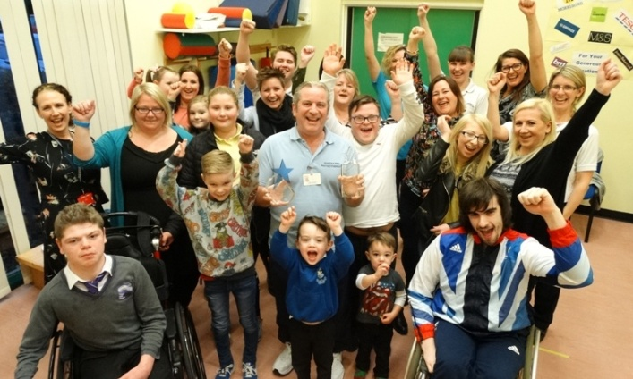
Already crowned Welsh winner, John then topped an online phone poll run by award organisers Skills for Health which saw him go head-to-head with other regional winners for the nationwide honour.

John Clifford’s family, colleagues and former patients joined him at Neath Port Talbot Children’s Centre to celebrate him being named the UK’s best clinical support worker.

Former miner John, who has worked at the centre since 1994, impressed the judges with his hard work and dedication to children with disabilities which is why he was so eager to share his success with them.

He said: “I love working here and it is a pleasure to come in every day. I have the best job in the world – the children I work with are my inspiration and the reason I do it.

“I am very proud but we are a team here and really I think everyone deserves an award, they are all Health Heroes.”

Along with his family and centre colleagues, grandad John, from Neath, was joined at a special celebration by former patients including wheelchair rugby player David Anthony who competed in the 2012 London Paralympics.

David said: “I owe my sporting career to John. I started with him, playing in goal with the Dragon Strikers, the football team he helped to set up 20 years ago. He has always encouraged me and given me confidence. John is amazing.”

Clinical lead paediatric physiotherapist Rebecca Kennedy nominated John and accompanied him to the London awards ceremony where he was named national winner.

She said: “We have been blown away by the support shown for John and that really is a result of the massive contribution that he makes here.

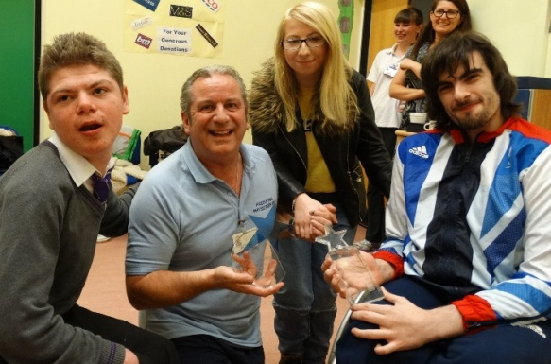
John Clifford shows off the trophies he won as Welsh and UK Clinical Support Worker of the Year to Kai Lewis, Casey Jenkins and David Anthony.

“As a team we are extremely lucky to have John onboard and it is fantastic now that other people outside of our hospital know just how great he really is.
“We are so proud to say that we have the best support worker in the UK!”

Source: Abertawe Bro Morgannwg University Health Board

