Award-winning nurse to host European event in Princess of Wales Hospital
Monday, 6 November 2017
An award-winning nurse who has shared her expertise around the world will host a major education event on her home patch in Bridgend next year.

An award-winning nurse who has shared her expertise around the world will host a major education event on her home patch in Bridgend next year.

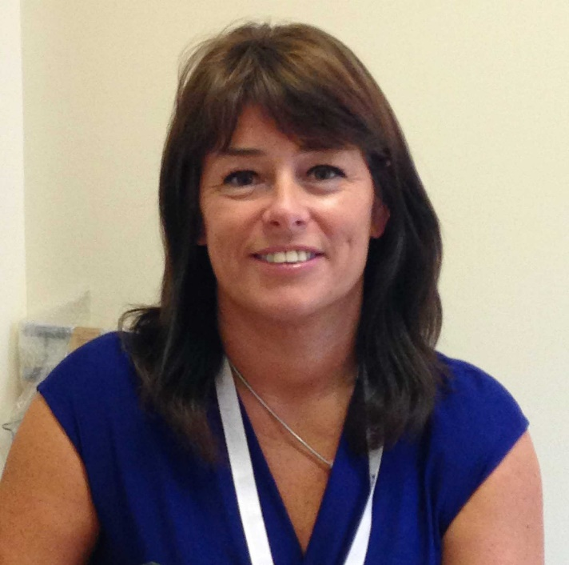
Louise Ebenezer has been the Parkinson’s disease nurse specialist (PDNS) at Princess of Wales Hospital for 15 years.

She looks after more than 500 patients from across the Bridgend county and parts of the Vale, including Cowbridge and Llantwit Major.

Louise (left) sees them in the twice-weekly Parkinson’s clinic at Princess of Wales Hospital, in community clinics and in their own homes.

But her skills extend beyond direct patient care as Louise is heavily involved with education – she is an honorary lecturer with Swansea University and runs one of just two PDNS courses in the UK.

Since 2012 she has also run PDNS courses in sub-Saharan Africa – the fourth of which took place in Ethiopia last year.

On top of all this, Louise is the nurse faculty member of the Neurology Academy, a UK educational forum which runs courses to help healthcare professionals understand more about Parkinson’s disease.

Her knowledge and experience led to her being asked to co-direct the Movement Disease Society’s (MDS) first European Parkinson’s Summer School for Nurses.

It took place in Torres Verdas, Portugal, earlier this autumn and was attended by 40 nurses representing 20 countries – mostly European but a few from Brazil and New Zealand too.

It was the first MDS summer school designed solely for nurses, whose role in Europe is different to that of their UK counterparts.

Louise said: “In other countries the nurses are managed by the consultant neurologist they work alongside.

“Parkinson’s disease nurse specialists in the UK lead the way as we work autonomously and many of us are independent prescribers.

“Once the person has been diagnosed with Parkinson’s or associated illness we provide all their care and medication – though of course we can consult the neurologist or physician with interest in Parkinson’s as needed.”

Louise said the summer school, which covered all aspects of the nursing management of Parkinson’s disease, had been a great success.

That led to her being invited to host and co-direct the second MDS summer school, which will take place in Princess of Wales Hospital’s Multi-Professional Education Centre (MPEC) next November.

Louise added: “It will be great to host such a prestigious event in the MPEC, which has fantastic facilities.

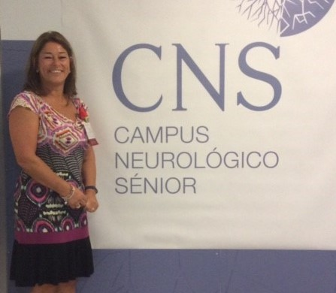
“It is recognition of the expert knowledge in Parkinson’s disease in Bridgend, and I’m really excited about it.”

Right: Louise pictured during the first summer school in Portugal

Meanwhile, Louise’s achievements have been honoured by the Parkinson’s Disease Nurse Specialist Association.

It presented her with the Special Recognition Award for Education at its national conference held in Warwick University.

The award is the second Louise has received from the PDNSA. The first, for innovative practice, was in 2014 – the same year she won the Carer of the Year Award in the Bridge FM Local Hero Awards.

Then in 2015, Louise was named Clinician of the Year at the annual ABMU Chairman’s Awards.

Louise said: “I do feel very proud but also very humbled when it comes to awards. You are only doing your job at the end of the day but it is always nice to have recognition for it.”

Source: Abertawe Bro Morgannwg University Health Board

