ABMU pair honoured at RCN Wales Nurse of the Year Awards
Friday, 17 November 2017
Two members of ABMU's nursing staff were both named as runners-up in their categories at this week’s prestigious RCN Wales Nurse of Year Awards.
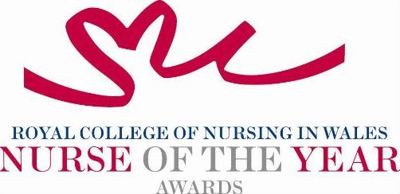
Eirlys Thomas, who is ABMU’s head of nursing, women and child health, was nominated for the Children and Midwifery honour for her long-standing commitment to developing a Children’s Rights Charter for young people across the health board.

Her vision came to fruition earlier this year with the launch of the first charter of its kind in the UK and her commitment and passion for children's rights has also led to the development of a youth board, ABMyouth, which is now up and running.

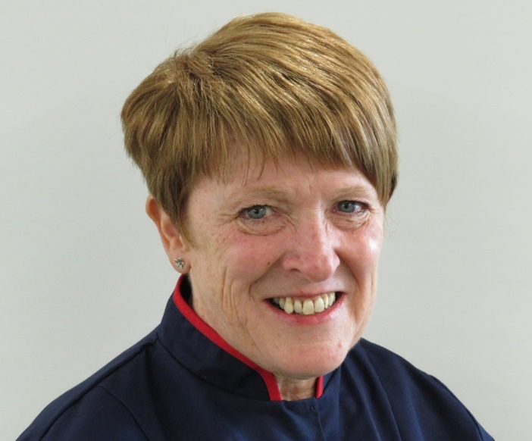
The judging panel felt that Eirlys (left) had visibly demonstrated that the young person’s voice will be heard, acknowledged and embedded in future practice development.

Meanwhile Cheryl Rowlands, operational team leader for the community resource team based at Trem-y-Mor, Bridgend, narrowly missed out on the Mentorship Award.

Her nomination recognised how invaluable her 17 years of district nursing experience have been in developing and improving the CRT team.

Among the innovations she has been responsible for is a buddy system to ensure that the team’s clinical lead knows where all staff are at all times as well as developing a student nurse placement package to ensure nurses at all levels are involved in the mentorship of others.

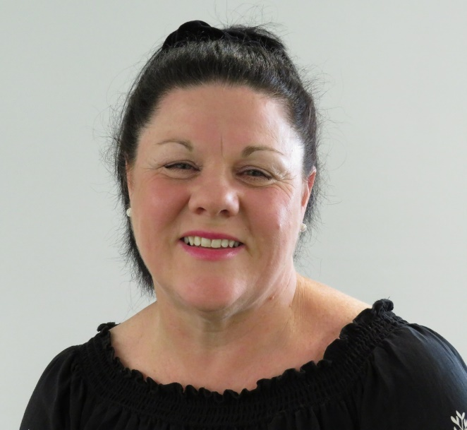
Judges were told how Cheryl (right) has consistently played a crucial role in the development of staff and colleagues in a community setting with the different approach to patients that it requires.

The awards, held at Cardiff’s City Hall, aim at recognising the best and brightest talents in Welsh nursing and all finalists in the 17 categories were praised for demonstrating a real passion for their profession.

The overall award and title of RCN Wales Nurse of the Year went to Louise Walby, a respiratory nurse facilitator from Cwm Taf University Health Board.

Source: Abertawe Bro Morgannwg University Health Board

