Walking tours to take closer look at hospital’s history
Thursday, 31 May 2018
Keen historians and photographers have got the chance to go behind the scenes at one of Swansea’s most iconic buildings.


Special walking tours have been organised at Cefn Coed Hospital as part of a special project to commemorate its remarkable history.

Anyone is welcome to come along with their camera or smart phone for the tours which will see visitors accompanied by professional photographer Lee Aspland and asylum architectural historian Tom Ford.

The walks are suitable for all levels of photography but participants must book in advance.

ABMU’s Heritage Group lead Martin Thomas said: “Everyone who takes part in the walks is invited to submit a photograph that captures their experience of the hospital and these will be considered for inclusion in a public exhibition to be held at Swansea Museum next January.”

The exhibition is one aspect of the multi-faceted project A Mental Picture: Celebrating the History of Cefn Coed Hospital 1931 to 2018. Supported by the Heritage Lottery Fund, the initiative has seen health board working with Swansea University and the museum to celebrate the hospital’s history.

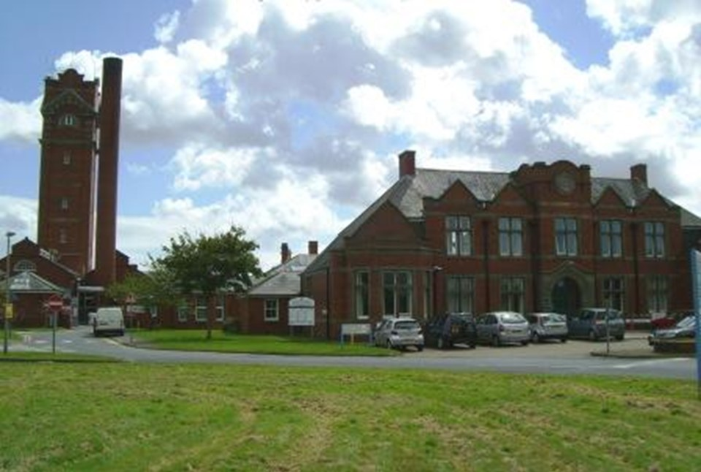
In addition to the exhibition, an interactive 3D model of the building is being prepared and staff have been recording their memories of the building.

Martin said the project aims to provide a legacy of information about the hospital which occupies an imposing position on a hill above Cockett.

Built in 1929, it was based on an older, Victorian design and, though it is not a listed building, it is one of the last remaining mental health hospitals of its era in the UK.

Gradually services have been transferred to modern purpose-built facilities more suitable for 21st century mental health care and the building has been decommissioned.

“So these tours really do provide a unique opportunity to see parts of the old hospital for a final time,” added Martin.

The tours are being held at 10am on 2nd June, 16th June, 14th July and 28th July.

Anyone coming along must wear closed-toe sturdy footwear and, as the tour will include outdoor areas, they will need to dress appropriately.

To book go to
https://www.eventbrite.com/e/a-mental-picture-photo-walking-tour-of-cefn-coed-hospital-tickets-46315459787?aff=efbeventtix

You can find out more about the Heritage Group on Facebook at https://www.facebook.com/ABMheritage/ or follow it on Twitter @ABMUHeritage

Source: Abertawe Bro Morgannwg University Health Board

