Patients benefit from doctors’ advice at the end of phone line
Tuesday, 15 May 2018
An overwhelming demand for GP appointments has led some local surgeries to adopt a new and better way of directing patients to the care they need.

Instead of making an appointment to see their GP, patients are now chatting to their doctor over the phone before a decision is made on the best way to treat them.
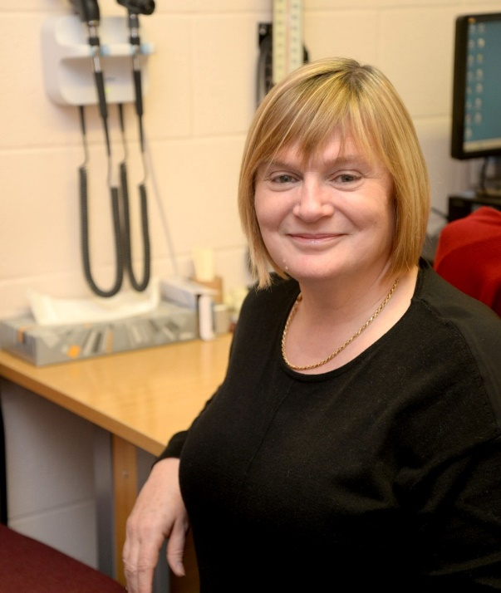
This could either be a traditional appointment with the doctor or being referred to another clinician such as a nurse, pharmacist, physiotherapist or audiologist, so their condition can be treated more quickly.

Skewen GP Dr Heather Potter.

When Telephone First was introduced in surgeries in Swansea, Neath Port Talbot and Bridgend, there was some concern from patients. But they are now starting to see the benefits of a system which actually improves access and cuts waiting times.

Telephone First was pioneered locally by Skewen Medical Centre in 2014 after a sudden rise in demand for appointments left GPs struggling to cope.

“Our old system worked beautifully for years but then in 2014 we suddenly experienced a massive upsurge in demand,“ said area clinical director Dr Heather Potter, who practises in Skewen.

“Various factors were involved – we had GPs leaving the system at the same time as a big rise in the numbers of patients requiring care for strokes, diabetes and heart attacks.

“It soon became obvious we had to do something. It came to a crisis point one Monday when one of our GPs did two full surgeries, made calls back to 90 patients and didn’t finish until 10.30pm.

“There just weren’t enough GP appointments to go round and we realised that it would be more efficient to assess patients’ needs over the phone before they came in, and that’s how Telephone First was born.”

Under the system, when patients ring the surgery, they are offered a call back from the doctor of their choice.

“When we started the new system the receptionists had a lot of complaints for three months and then people began to realise that it was more efficient. They could arrange call back times and appointment times to suit them,” said Dr Potter.

“If someone is in work, we can call them back during their breaks. If they need to come in to see us, they can arrange a time to suit them.”

The Telephone First system has also drastically reduced the number of missed appointments. “Our ‘did not attend’ rate was 30 per cent in the old system, now it’s down to 0.5 per cent, which makes much better use of GPs’ time,” said Dr Potter.

“Another advantage of Telephone First is that, depending on what the symptoms are, I can organise for the patient to have tests before I see them, and that increases efficiency for GP appointments.

“More than 60 per cent of our patients who ring up don’t want or need a face-to-face appointment, so it’s a fairer way of giving access, not just to the person who rings up first.”
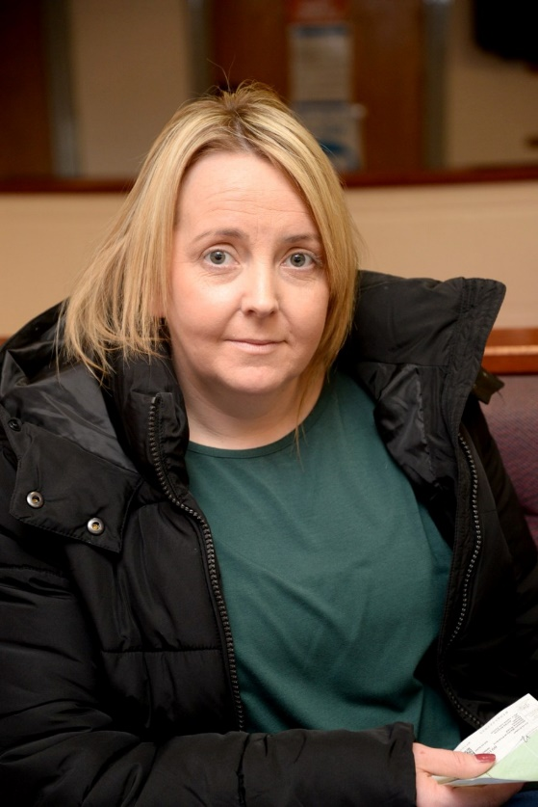
In fact, there is no need to ring the surgery first thing any more, as appointments can be made all day long and, with doctors on duty from 8am to 6.30pm, virtually all patients are dealt with on the day.

“Our receptionists have never asked people to ring back another day. They always get an outcome on the day,” said Dr Potter.

Many patients at Skewen are fans of the new way of doing things.

Nicola Edwards, (left) a mother-of-two from Skewen, said: “When I’m in work it’s easier to take a phone call than come to the doctor’s. They ring you back really quickly and if they need to see you it’s usually on the day.

“The old system wasn’t as good because sometimes you couldn’t get an appointment for a while, and you want to sort it out there and then.

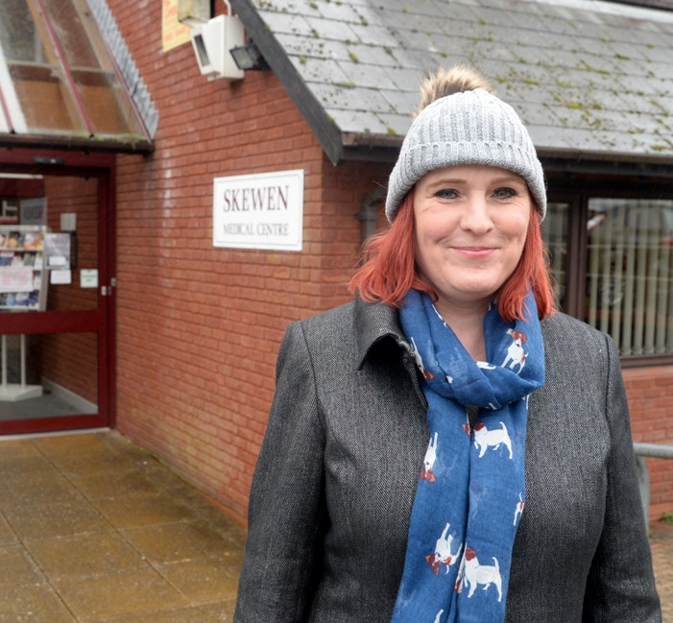
“It suits me fine. I’ve always been happy with the decisions and it’s reassuring because children seem to take priority.”

Other people are still worried about how the new system will work.

Community councillor Sarah Elias, (right) from Neath Abbey, says she has had a good experience of the service herself but reported concerns among elderly members of the community.

“I do understand the need for this system and I’ve found it very convenient for myself because I don’t have to take time off work.

“It’s also good that you can phone any time in the day whereas before it was only a couple of hours when you could make appointments.

“However, I do have reservations. A lot of older people have expressed their concerns to me and I worry that GPs will miss something if they don’t see them face to face. People aren’t always eloquent in describing what’s wrong with them and they don’t like to bother people.”

Dr Potter was keen to answer those concerns: “I have a set of safeguards – anyone under five, anyone with a lump or a rash, anyone with mental health issues, elderly patients with complex multiple issues, people who are not happy or hesitant on the phone - they all come in to see me straight away,” she said. “If anyone says they are very ill I can call them back within minutes.”

At present around 22 per cent of surgeries in the ABMU Health Board area carry out some form of telephone assessment.

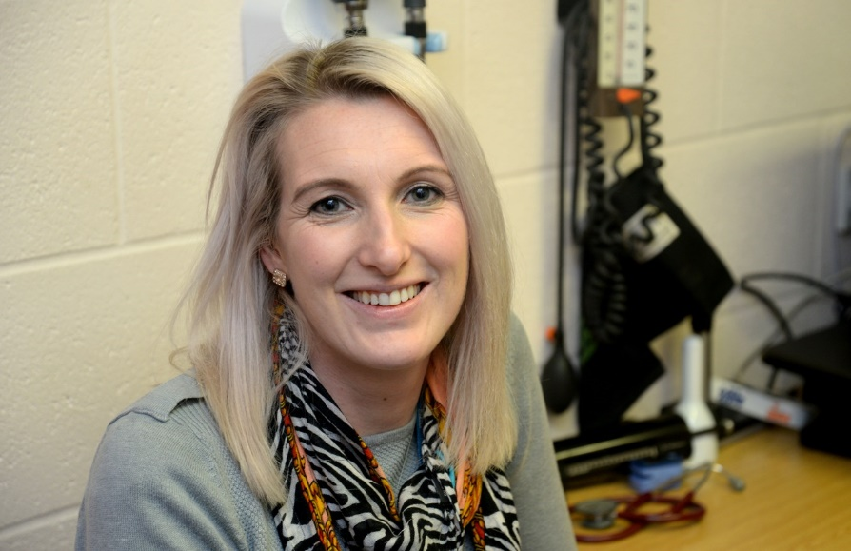
That is likely to grow and with that in mind, NHS primary care manager Samantha Page (left) has worked with local GPs and the Community Health Council to draw up a framework that outlines a good model of Telephone First, which sets out standards for practices to aspire to.

She said: “The framework is based on the excellent practice at Skewen Medical Centre. They are gold standards that put the patient at the heart of the model.

“If patients know their surgery is operating Telephone First, it gives them an assurance of the level of service they can expect.”

Under the new framework, for example, participating surgeries will provide enough call lines and call handlers to meet patient demand. Training will be given to all call handlers, who will be based in a quiet room away from public areas.

Call handlers are not there to give medical advice or make clinical decisions, although they are trained to recognise emergencies.

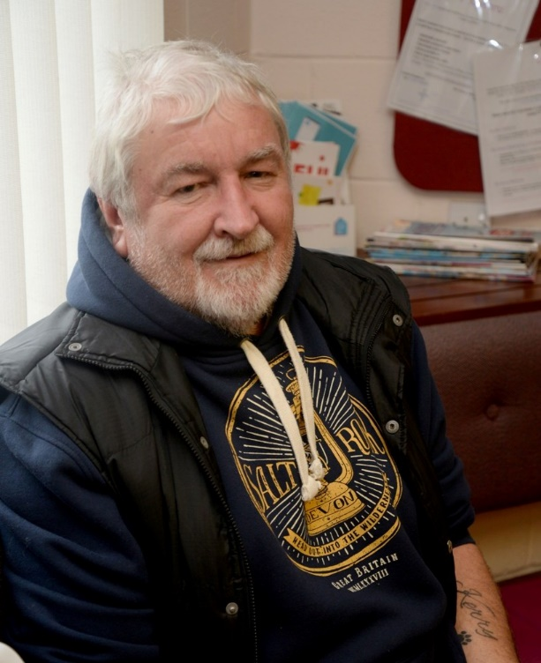
“This approach helps us support GPs to manage demand,” said GP cluster development manager Kate Kinsman. “Initially people may be reluctant to discuss their situation over the phone, however all surgery staff are trained to handle patient calls and need to gather the information to help GPs prioritise the urgency of the call back.”

Kerry Pritchard, from Neath Abbey, has used Telephone First

Patients are recognising the benefits of the Telephone First system. Kerry Pritchard, 63, from Neath Abbey, said: “I rang the surgery today after finding a lump on my leg and they answered the phone straight away. The doctor rang me back within half an hour and called me straight in. I think it’s marvellous.”

https://www.youtube.com/watch?v=7Nfkkwyfg7s

Source: Abertawe Bro Morgannwg University Health Board

