Nursing staff use conference to celebrate their past and look forward to future
Friday, 4 May 2018
Hundreds of nursing and midwifery staff from across ABMU united at a special event to share their skills and celebrate their profession.

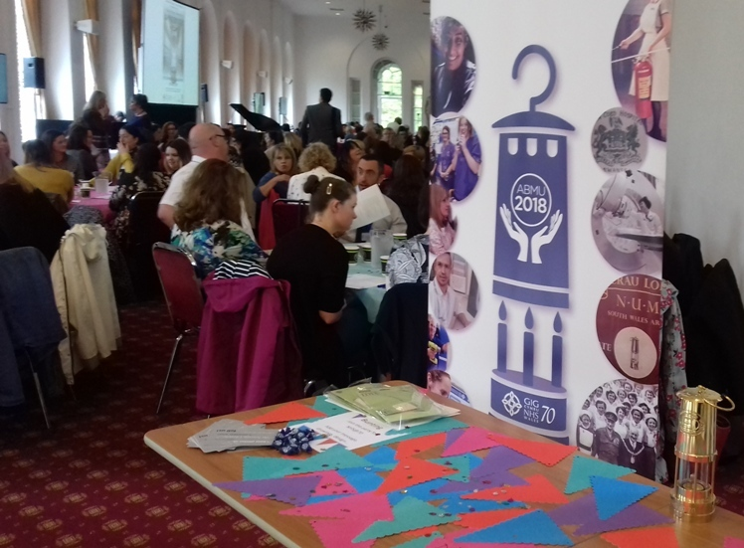
Inspired by the 70th birthday of the NHS, the conference was called Lighting the Future and took the health board’s symbol of the anniversary – a distinctive miner’s lamp - as its theme.

It saw around 200 nursing staff and midwives from across the health board unite to learn and discuss nursing achievements as well as how the profession can develop for the future.

The conference was organised by the health board and Swansea University and working in partnership was one of the key themes that a variety of speakers explored throughout the day.

ABMU’s interim Director of Nursing and Patient Experience Professor Angela Hopkins welcomed delegates and emphasised that their roles remain as important for the future of the NHS as they were when it was established back in 1948.

She said: “It is a privilege to be leading an occasion where we recognise the difference that nurses, midwives and health care support workers make each day in their contact and care for patients.

“In this very special year for the NHS I am so proud that we are able to demonstrate the improvements which we are continuing to develop with the University and colleagues in the social care sector for the population.”

The conference, held at Margam Orangery, reflected the close relationship between the health board and university and also provided an occasion for nurses to network and share best practice.

In a video address to delegates, ABMU’s Chief Executive Tracy Myhill urged everyone attending to use the event as an opportunity to develop their skills.

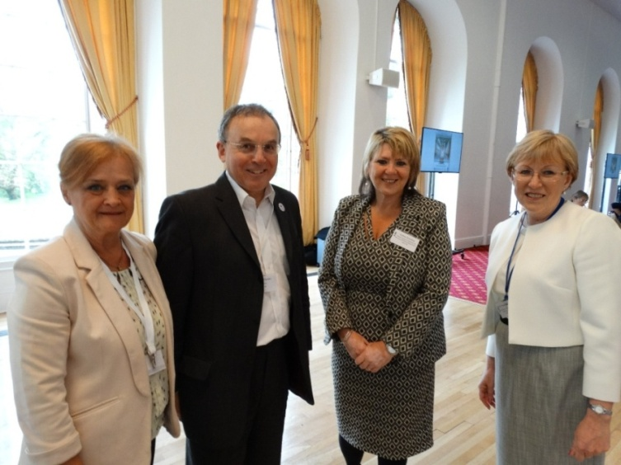
Diabetes specialist nurse Frances Purchase (left) who put together an exhibition of nurses’ uniforms with ABMU Chairman Prof Andrew Davies, Deputy Director of Nursing and Patient Experience Cathy Dowling and Prof Angela Hopkins, interim Director of Nursing and Patient Experience.

“We all need to keep learning, all of us, whatever we do. We know the world’s changing, the type of patients we see is changing, technology is changing and knowledge develops so quickly if we don’t keep learning we will go backwards,” she said.

Ms Myhill also thanked all the staff for their contributions: “Whether you are serving our patients, working with our communities or educating our staff, I appreciate it.”

The morning session of the conference included a key note address by Chief Nursing Officer for Wales Professor Jean White who discussed changes for the future healthcare in Wales laid out in the Parliamentary Review for Health and Social Care.

When Aneurin Bevan was setting up the NHS 70 years ago he couldn’t have imagined what is happening now. This is a great opportunity for us, it is good to change. We are working a health and social care system that is constantly evolving,” she said.
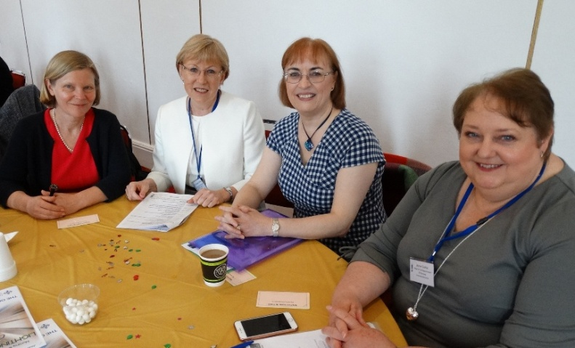
(From left)ABMU Vice-Chair Emma Woollett, Interim Director of Nursing and Patient Experience Prof Angela Hopkins, Chief Nursing Officer for Wales Prof Jean White and Jayne Cutter, Head of Nursing Department at Swansea University.

Other highlights included a presentation about how an integrated team has been able to develop better working relationships with primary care and acute services to ensure seamless treatment for patients suffering with lung diseases such as emphysema and chronic bronchitis.

Delegates also heard about the work of the Frequent Attenders Support Service which targets patients who present on a recurrent basis at Morriston and Princess of Wales hospitals’ Emergency Departments, as well as about latest developments in dementia care and falls prevention.

The afternoon session was chaired by Jayne Cutter, head of Swansea University’s Department of Nursing, and among its highlights was a World Café learning event which gave the delegates a chance to take part in a series of table-top discussions on different aspects of nursing.

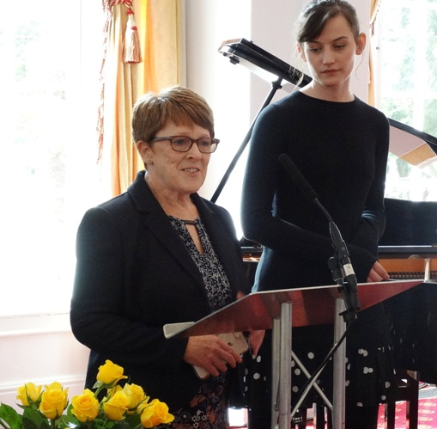
Professor Hopkins also picked up on the year of celebration in her presentation on leadership and advances in nursing since the establishment of the NHS in 1948.

ABMU Head of Nursing, Neonatal and Children’s Services Eirlys Thomas with ABMyouth Chair Sophie Millar.

On display throughout the day were 30 posters reflecting the three conference themes of working in partnership, innovations in care and building resilience in health care presented through a variety of topics, with the eventual winners chosen bydelegates.

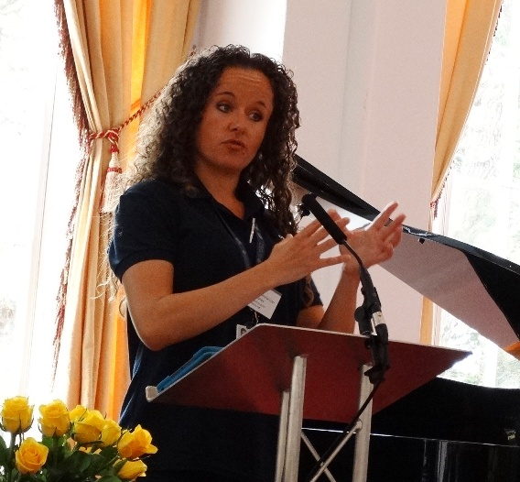
Physiotherapist Jade Bazylkiewicz Coates during her presentation on the development of an integrated team to help patients with respiratory conditions.

There was also an artistic element to the day to reflect the importance arts can play in the healing process, with poetry and music provided by the charity ‘Music in Hospitals’ as well as sessions from Performing Medicine, an initiative which provides arts-based training for health professionals.

The day was brought to a close by Olwen Morgan, interim Head of Nursing, at Neath Port Talbot Hospital who sang a moving solo arrangement of Anfonaf Angel – Guardian Angel – accompanied by Robert Jones, corporate matron.

Professor Hopkins added: “The day was a great success. It was very inspirational to see how much the delegates enjoyed learning and participating in what really was a wonderful celebration of nursing and midwifery.”
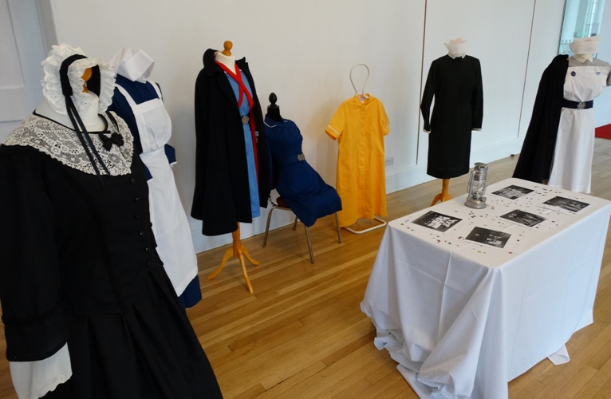
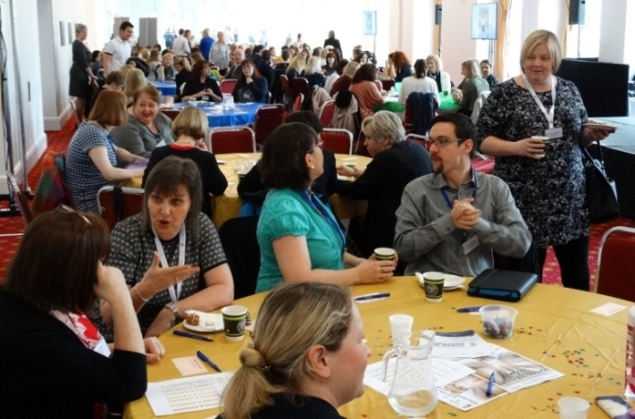

Source: Abertawe Bro Morgannwg University Health Board

