New service giving worried parents somewhere to turn
Wednesday, 9 May 2018
Swansea GPs are investing in a pioneering scheme to help anxious parents struggling with their children’s behaviour.

A number of parents have been going to see their doctors with depression and anxiety caused by their inability to cope.

In the past they might have been offered counselling or antidepressants, but now they can be referred to a specialist early years worker instead.
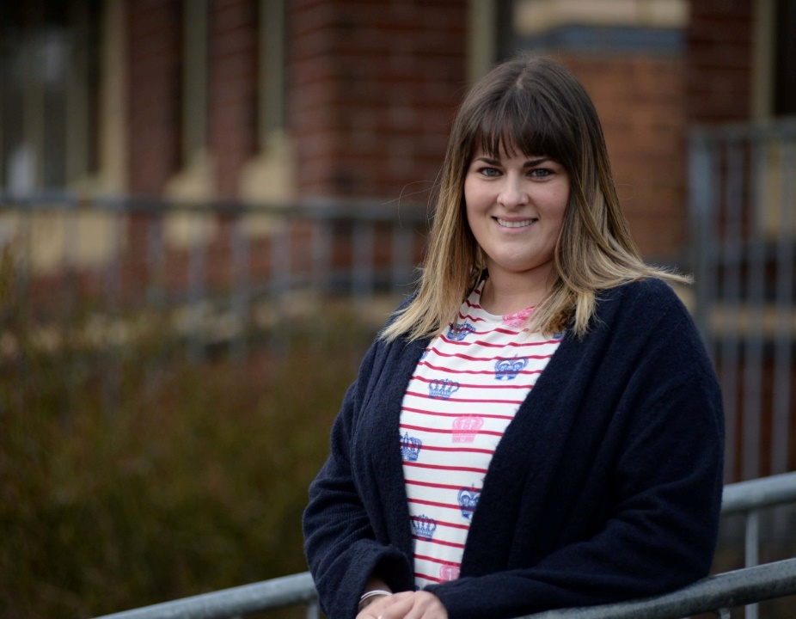
Jo Edwards (right) has been working with families in their own homes, giving them strategies to better manage and improve their children’s behaviour and reduce their own anxiety over parenting.

It is a pilot scheme that has been running for 18 months in the Penderi area and has been so successful that another worker has been recruited who will help cover the Llwchwr and Cwmtawe areas as well.

So far Jo has worked with 150 families, saving more than 700 GP appointments as a result.

“GPs or health visitors can refer families to me,” said Jo, “and because seeing me is what the doctor prescribes, families are ready to engage and the dropout rate is very low.

“I try to look at their strengths and get them to tackle problems one by one so that they don’t feel overwhelmed and focus too heavily on all the things they want to change. We work on boundaries, routines, rules and rewards and on reinforcing positive behaviour.

“I also go into schools and nurseries to work with the children, looking at feelings and emotions and how to express them more effectively.

“I can signpost families to more intensive support if they need it or to group support and workshops if they feel isolated. I work with families for 12 weeks on average but it is a bespoke service, there is no blanket approach.

“The idea is to ensure a sustainable change, not just a quick fix, that has benefits for parents’ confidence and family life generally,” she said.

The remit of the role is flexible too to reflect the fact that this is a pioneering service, believed to be the first in Wales and the UK.

“We originally thought that all our referrals would come for families with under-fives but we are actually working with children up to the age of 11,” said Jo.

“The feedback we’ve had has been good. All the people we’ve seen said they would ask for our help again rather than going to their doctor.”

Sue and her partner Paul were referred to Jo when they sought help over the behaviour of their seven-year-old daughter Mia.

“We had trouble getting her to go to school, she was crying, hysterical, having panic attacks, and stopped eating,” said Sue, 40.

“She started saying she wanted to kill herself. We were at our wits’ end and I was an emotional wreck.

“Jo gave us strategies, like being firm and not giving in to Mia. We had a reward chart and held a meeting to decide house rules. Mia enjoyed that because she had an input into it.

“Mia won stickers for following the rules and could trade the stickers for rewards like going bowling. Jo was giving us confidence as parents and Mia was becoming more confident as well.”

Jo said: “From the word go it was obvious that Mia was a very loved child but she’d been overindulged, which had reinforced some of her anxieties and she needed some boundaries to make her feel safe and secure.”

Sue added: “She is a completely different child now, much more outgoing. Jo worked wonders with Mia but the help she gave me as a parent was just as important.”

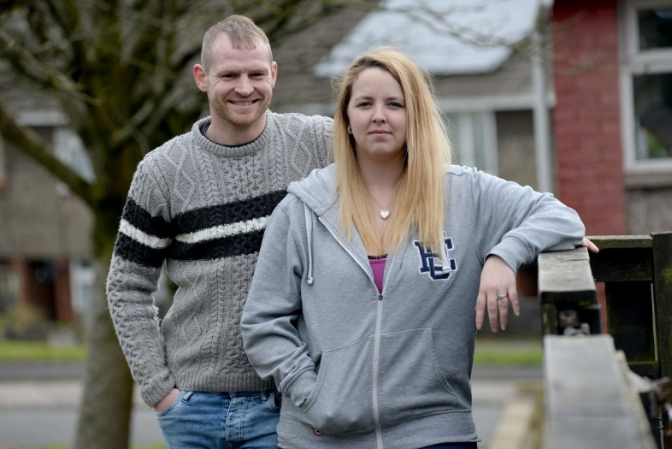
While most parents are happy to engage with Jo, Stephanie Griffiths admits she was reluctant at first.

She said: “I had my back up when I met her. I didn’t want someone telling me what to do.”

Stephanie and her partner Barry (left) were having difficulty dealing with their four-year-old son Ashley’s behaviour.

She said: “He’s like a little bull. He lashes out at people, he can’t control any anger or frustration. He will eat anything – glass, Playdoh, grit. The school are finding it very hard to work with him because every boundary they’ve put in place hasn’t worked.

“We are now pressing for an assessment with an educational psychologist to see if he has got ADHD.”

Said Jo: “We haven’t managed to reduce Ashley’s challenging behaviour, so I am now supporting Stephanie and Barry to communicate more effectively with the school, to ensure steps are being taken for Ashley to be assessed for any potential additional needs.”
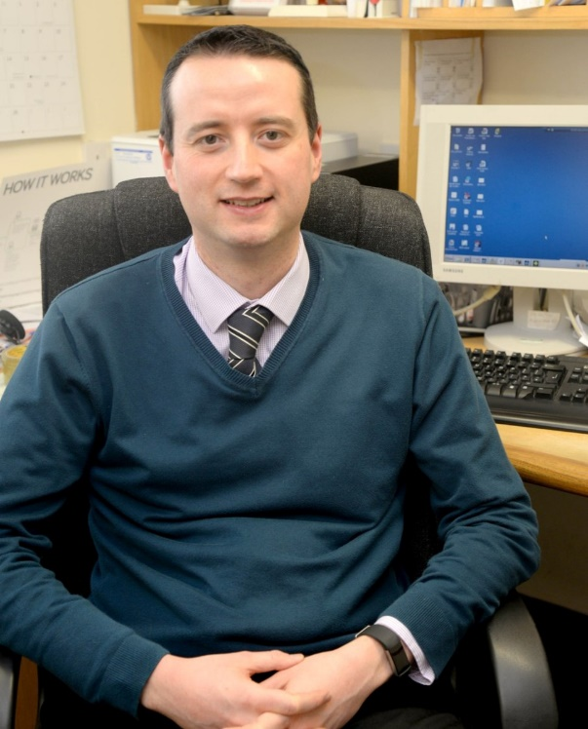
Stephanie added: “Normally I would go in with all guns blazing, but I feel safer with Jo in the meetings. She has helped me push for the right things in a more positive way.”

Dr Daniel Sartori, lead GP for the Penderi cluster (right), said doctors were delighted with the results of the new service.

“Before these roles were created, GPs had little or no option over where to send parents who came to see us because they were worried about parenting and we felt frustrated because we had nowhere to refer them,” he said.

“Now if a family comes to see me with a young child who has behavioural problems or developmental issues, I can send them to see Jo. The feedback has been very good from parents, they find Jo very helpful and in the most cases Jo has been able to sort out their issues herself.

“It has been such a success in our area, I hope it will be taken up by local health boards as a model for other areas.”

The creation of Joanne’s role was the result of a partnership between the Penderi GP cluster, ABMU health board and the local authority, Swansea Council.

“It’s a joined up way of working for the benefit of children and parents and I’m really glad the service is expanding and that GPs are choosing to invest in it,” said Debra Morgan, ABMU planning and partnership support manager.

“The idea came out of research into ways of reducing health inequality, which showed that the best way to give children the best possible outcome in later life was to invest in their early years,” she added.

“It also has the potential to make a positive impact on the next generation and with this service we are definitely moving in the right direction.”

Since 1st April 2018, two workers have been providing the child and families wellbeing service, covering surgeries in the Penderi cluster of GPs, the Llwchwr cluster and the Cwmtawe cluster.

This includes Brynhyfryd Surgery, Fforestfach Medical Centre, Cwmfelin Medical Centre, Cheriton Medical Centre, Manselton Surgery, Gowerton Medical Centre, Penybryn Surgery, Princess Street Surgery, Talybont Surgery, Ty’r Felin Surgery, Llansamlet Surgery, New Cross Surgery, Strawberry Place Surgery, plus Clydach Primary Care Centre and Sway Road Surgery (both part of the new Cwmtawe Medical Group).

https://www.youtube.com/watch?v=t3KEm6eAdto

Source: Abertawe Bro Morgannwg University Health Board

