Medical and dental staff share views on future of healthcare
Friday, 11 May 2018
A new conference which brought together doctors and dentists from across ABMU and primary care was such a success it is now set to become an annual event.

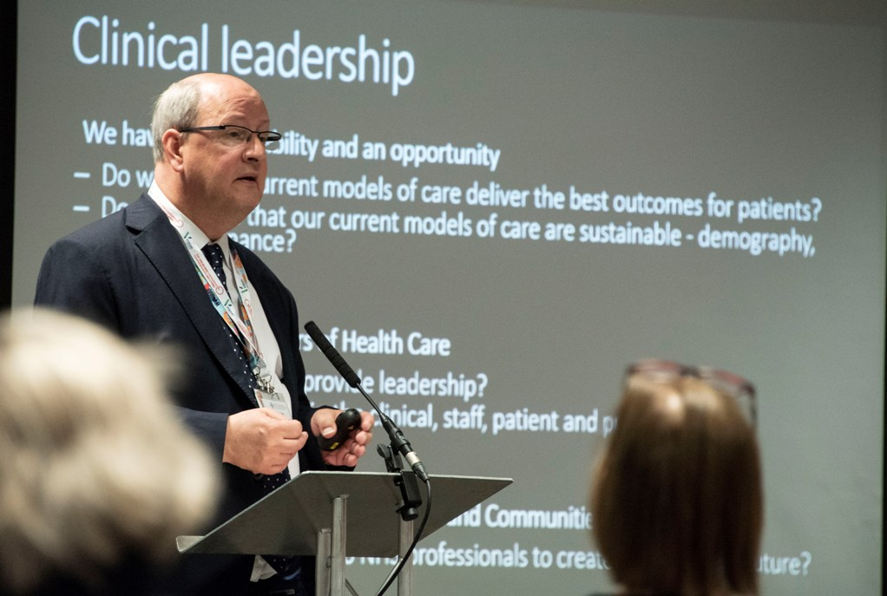
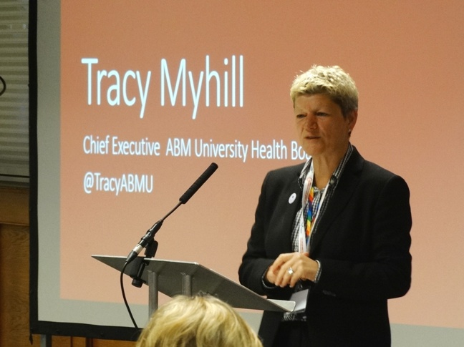
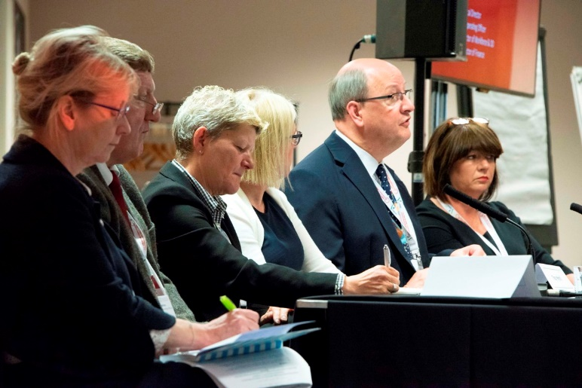
The inaugural Medical and Dental Conference gave health professionals the chance have a say in how population health and healthcare provision in the region develops and to discuss the issues that affect them in their work for and with the health board.
Delegates included doctors and dentists at various stages of their careers within secondary care along with cluster network leads and clinical directors from primary care.
The event was held in partnership with the Welsh NHS Confederation and BMA Wales and featured workshops designed to share good practice and input from a range of speakers.
These included ABMU's Executive Medical Director Professor Hamish Laing (left) who spoke about the importance and challenges of clinical leadership.
He said: “This conference was an important opportunity for medical and dental staff at all levels of their career to have a voice and help us shape the future direction of the health board.
“Our priorities are to improve the health and wellbeing of our population and to provide high quality, cost-effective healthcare when it is needed, in a changing and challenging environment.
“Our medical and dental staff touch members of our communities at all stages of their lives, which is why their views are so important.”
The conference began with an address by ABMU's Chief Executive Tracy Myhill (right) who emphasised the importance of engaging with medical and dental staff.
She said: “We want to make sure we focus on those matters which improve population health and make the greatest difference for our patients.
“This conference was really important to help us all understand the challenges we face to address these important requirements placed upon us.”
She also took part in a question and answer session alongside Prof Laing, and ABMU executives Hazel Robinson, Chris White and Lynne Hamilton. Chaired by Vanessa Young, Director of the Welsh NHS Confederation, this panel session gave delegates the chance to put the team on the spot.
As this first conference took place as the NHS marks its 70th anniversary, the engraved miner's lamp – ABMU's symbol of the year of celebration – was on display throughout the conference as delegates attended sessions.
Other speakers included BMA Wales National Director Rachel Podolak who talked about the importance of strong engagement between medical and dental staff and health boards so they not only have career fulfilment but also deliver the best outcomes for patients and communities.
Vanessa Young, from the NHS Confederation in Wales described the current landscape for the NHS in Wales.
Value-based healthcare - which aims to improve the quality of care and outcomes for patients while making the best use of resources - was an important element of the conference

ABMU's Lynne Hamilton, Chris White, Tracy Myhill, Hamish Laing and Hazel Robinson during the question and answer session chaired by Vanessa Young.
Dr Sally Lewis, newly appointed national clinical lead for value-based care, explained what it involved, why it is important and how it is being put into practice in NHS Wales.
In the afternoon many of delegates reconvened for the Value Based Healthcare and Clinical Variation Symposium at the same venue and were joined by other health professionals as the renowned international expert, Sir Muir Gray, supported by Dr Lewis and Professor Laing, gave a masterclass on putting the principles of value-based healthcare into action.
The symposium brought together doctors, GPs, nurses and therapists, those in trainee/graduate positions including specialist registrars, physician associates, managers and medical trainees as well as colleagues within finance and service change roles.
Professor Laing added: ”Both the elements of the day provided a great opportunity for our medical and dental staff to demonstrate the importance of their clinical leadership and, along with other staff and partners, to get new insights into how we can ensure a sustainable future for our health and care services.
“We are now very keen to make sure that the conference becomes an annual event and a regular highlight in our calendar.”

Source: Abertawe Bro Morgannwg University Health Board

