Mayor’s boost to help cardiac patients as tribute to his friend
Friday, 18 May 2018
A fundraising mission to provide a lasting legacy for a popular rugby player has raised more than £9,000 to help cardiac patients and their families.

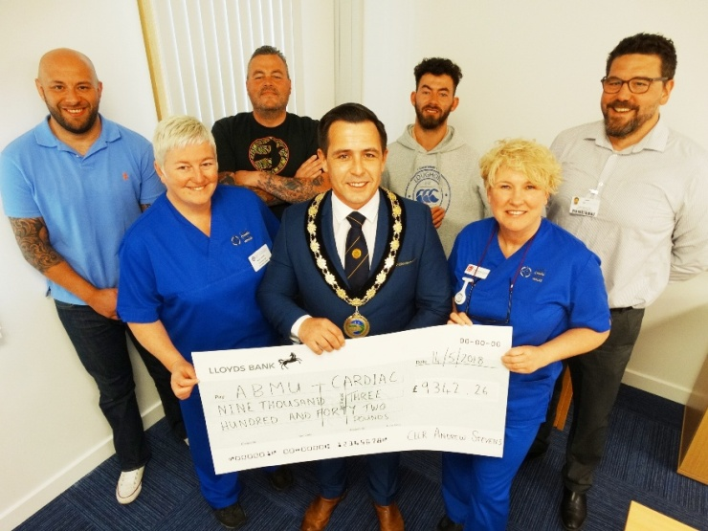
Mayor of Gorseinon Andrew Stevens used his year in office to collect as much money as possible in memory of his close friend Richard Thomas who died last June aged just 29.

Outgoing Mayor of Gorseinon Andrew Stevens (centre) with arrhythmia nurses Nerys Ubsdell and Wendy Churchouse with (back, from left) Jon Bowen, Dai Thomas, Jason Thomas and Jonathan Gates.

Former soldier Richard, known to his many friends at rugby clubs across South Wales as Decky, represented the army at rugby and running. He was diagnosed with a form of cardiomyopathy in 2011 after breaking his sternum playing rugby.

After holding a variety of fundraising events, Andrew’s final official engagement saw him handing over a cheque for £9,342 to staff at Morriston Hospital.

Now the money raised in Decky’s memory will be used to promote awareness of the condition and to support the families of patients who live with it.

Andrew said: “While I truly wish it was under different circumstances, choosing this charity was an easy decision to make.

"Not only will it raise awareness of cardiomyopathy, but will also provide a long-lasting legacy to one of the kindest and bravest of friends.

“I started off with a goal of £2,000 and I never thought I would raise this much. I am absolutely delighted.​

“Ever since I first told Decky's closest friends and family about my plans the amount of support they have given me has been overwhelming.

“This is a testament to the type of person he was and what a difference he made to everyone's lives.”

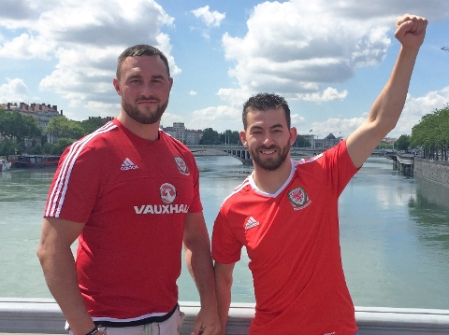
Andrew was joined at the presentation by his friend and Decky’s former team-mate Loughor RFC captain Jon Bowen, Decky’s dad Dai and brother Jason.

Decky (left) with his brother Jason Thomas.

Specialist arrhythmia nurse Wendy Churchouse and arrhythmia nurse Nerys Ubsdell received the cheque on behalf of the team.

Wendy said: “Thank you for this magnificent donation to a very worthwhile cause.

“It is such a shame that a family lost someone so precious which has led them to do this but all the people who have helped raise this money should be very proud.

“This is an amazing achievement in tragic circumstances and we are very grateful to you all for supporting this service.”

Dai said: “If this can be used to save even one person’s life and prevent their family going through the pain I have gone through it will be worthwhile.

“This has been horrendous. As a parent you always think you will be there as a protector, to pick your children up when they need you but I couldn’t help Decky.

“I want to see more information available to explain this condition to families.”

His son Jason paid tribute to his brother and to his friends who supported the fundraising.

“Decky would have done the same if this had happened to any of his mates and I know he would be very, very proud of the boys.

“The support we’ve had has been amazing and we’re so pleased it will help other patients,” said Jason.

Andrew originally handed over a cheque for £8,900 to Jonathan Gates, of the cardiac team, at his annual Mayor’s dinner but by the time he came in to the hospital to meet staff a few days later the total had been boosted by another £500 - with the prospect of more cash to come in future.
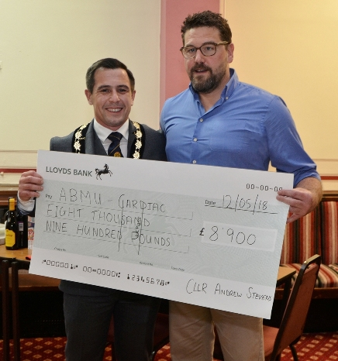
One of the main money-spinners for Andrew’s fund was a touch rugby tournament held at Loughor RFC where scaffolder Decky had been a regular for many seasons.

Andrew Stevens handing over his original total to Jonathan Gates at his Mayor’s dinner in Gorseinon.

It was such a success that Andrew and other close friends plan to make it an annual event which will continue to raise funds for the same good cause.

Andrew added: “Every time we take part in an event we think about Decky and share our memories of him – it is a way of keeping him with us and knowing this money will go to help other people like him is a real comfort to us.”

Source: Abertawe Bro Morgannwg University Health Board

