Japanese visitors check out community dental service
Tuesday, 22 May 2018
A team of experts from Japan have been in Swansea and Port Talbot as part of a fact-finding mission.
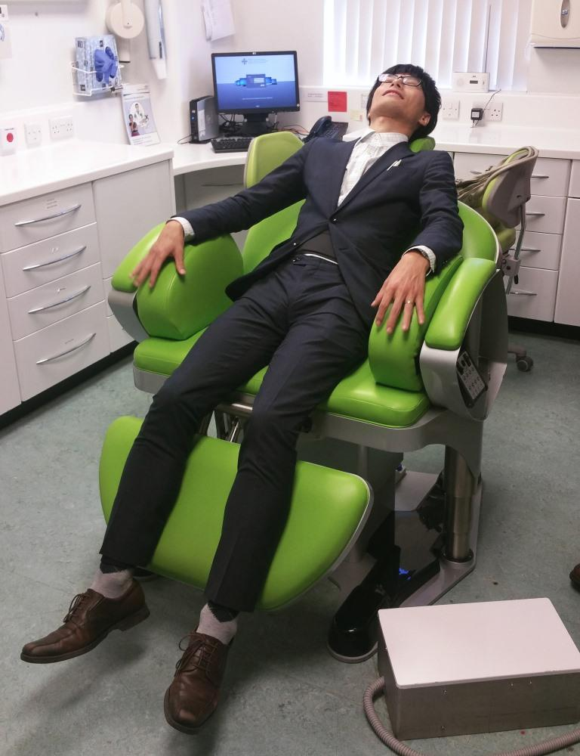
Dr Masumi Muramatsu and colleagues from Sapporo City University were hosted by the ABMU community dental service to learn about improving oral health for patients in hospital and older people living in care homes.

Left: One of the visiting team checks out the bariatric chair at Port Talbot Resource Centre

Dr Muramatsu said: “There is much to learn from the approach taken in Wales to improving oral health for vulnerable patients and older people.

“We have no such combined unified approach and I am hopeful to replicate the same model in Japan.”

Dr Muramatsu and her team spoke to nurses in Morriston’s intensive care about improving mouth care for dependant patients in hospital.

They also went to Brynfield Manor Care Home in Langland where they met resident David Allen Petheridge.

Mr Petheridge explained how the staff were very supportive in ensuring he had access to good mouth care.

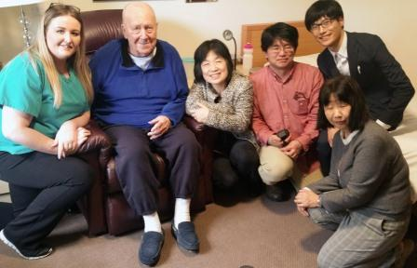
In Port Talbot Resource Centre they looked at the bariatric and wheelchair tipper facilities for treating vulnerable patients who are unable to access general dental services in the community.

Right: With David Allen Petheridge and (left) Brynfield Manor Care Home’s mouth care champion

They also visited Morriston’s restorative dental department and the oral and maxillofacial surgery laboratory before a whistle-stop tour of the learning and development facilities at the Morriston Education Centre.

Rosalyn Davies, service improvement and operations manager with the community dental service, met Dr Muramatsu while presenting at a conference in Phoenix, Arizona, in 2014.

“Dr Muramatsu visited us last year to see our work and followed that up with another visit this year, when she brought a team with her.

“In Wales we have a single mouth care bundle for use in hospitals and in care homes, something they don’t have in Japan.

“They were impressed, not just with the way the mouth care programme was applied across Wales, but also with ABMU Health Board and the link between primary and secondary care.

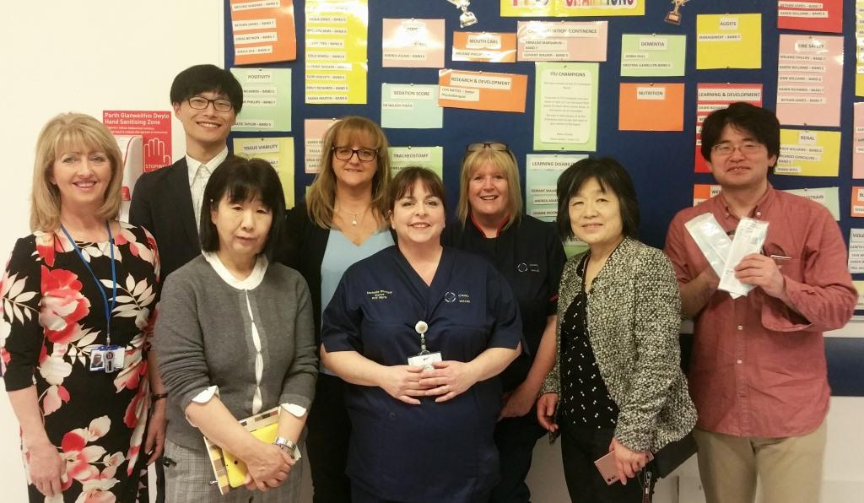
“The Wales model to improve oral health is a seamless approach between secondary and primary care services, ensuring consistency and sustainability in reducing harm from poor mouth care.”

Left: The visitors meet some of the Morriston ITU team

Paola Browne, dental programme support officer for the Public Health Wales 1000 Lives campaign, said: “Opportunities to learn and share experiences are invaluable to improving patient care.”

Source: Abertawe Bro Morgannwg University Health Board

