Hospital unit launches new name to reflect the areas it serves
Friday, 25 May 2018
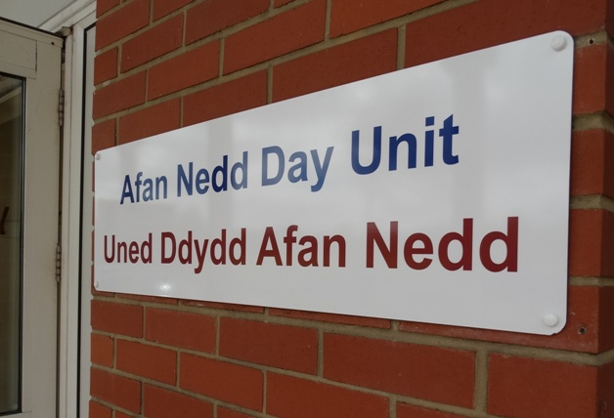
A unit which provides multidisciplinary care for a variety of conditions has been given a new name, courtesy of the patients who use it.

The Elderly Day Unit at Neath Port Talbot Hospital is now called the Afan Nedd Day Unit and already boasts new signage for visitors.

Unit manager Lynne Hall said: “The day unit has undergone a lot of change over the past few years and we were keen to lose the label of elderly as many of its patients were not over 65 or didn’t feel they fitted the category.”

After listening to their patients’ concerns, the team decided on a name change and asked for suggestions from the public and staff.

“This new name has come from the people who use the unit and work there. The staff and patients already feel more comfortable and are keen to use the name which really encompasses the areas the unit serves,” she added.

The unit, which is open from 8.30am to 4.30pm Monday to Friday, serves as an important link between primary and secondary care. Led by ward manager Lynne, the team is made up of staff nurses, HCSWs, physiotherapy, occupational therapy and a technical instructor.

As it is on the main hospital site, it has easy access speech and language therapy and dietetics and can call on specialist nurses in dermatology and wound care.

Medical input is provided via dedicated sessions from consultants who specialise in care of the elderly and an associate specialist doctor.

The unit is home to a successful falls prevention service and has a very well established nurse-led transfusion and infusions service and works closely with the Acute Clinical Team to offer rapid medical assessments and intravenous treatments including antibiotics and diuretics. These services help patients avoid hospital admission.

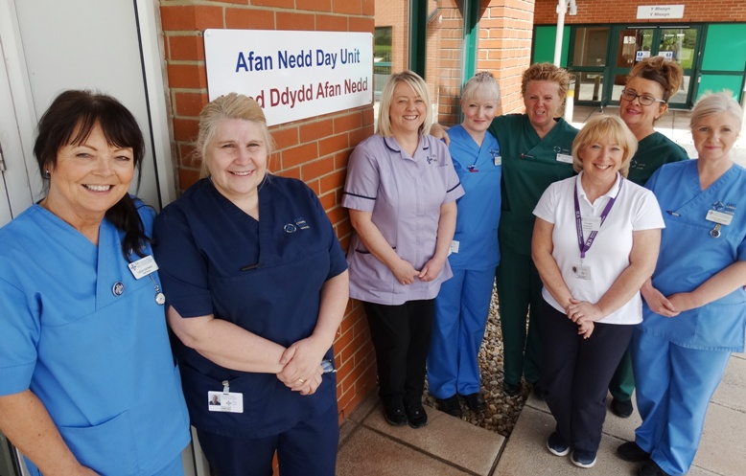
Ward manager Lynne Hall (second left) with members of the team at Afan Nedd Day Unit.

It also hosts the Rapid Diagnosis Centre which offers a one-stop shop for potential cancer patients who might otherwise slip though the net or face delays getting treatment.

Patients can be referred to the unit from any allied health care professional. It encourages self-referrals from people who have fallen or are at risk of failing and the team is happy to offer anyone advice on falls management.

Contact the unit’s reception desk on 01639 862604 or the confidential nurses’ office line on 01639 862605

Source: Abertawe Bro Morgannwg University Health Board

