Extra staff bringing personal touch to dementia patients’ care
Tuesday, 22 May 2018
An initiative which sees ABMU staff working with families to develop tailor-made therapy programmes for older mental health patients at two ABMU hospitals has been strengthened and expanded.

Following on from a successful pilot project, four new recruits – an occupational therapist and three OT technicians – have joined the team based at Tonna Hospital to develop personal therapies to suit individual patients.
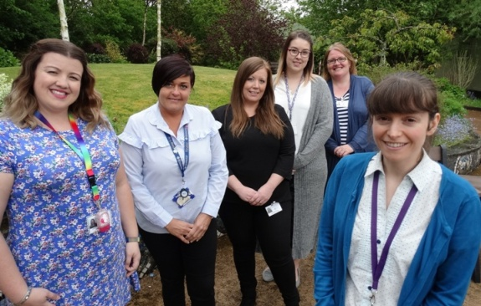
OT technicians Rebecca Taylor, Joanne Hollyman, Donna Parfitt-Bailey and Hayley Stephens with occupational therapist Karen Geraghty and specialist occupational therapist Jessica Denicola at Tonna Hospital (Missing from the picture is Daniel Beuse-Evans)

They are involved in a detailed personal assessment process which looks at each patient’s abilities and as well as working closely with family members to find out more about their background and interests.

“The family’s support and the information they can give us about a loved one is absolutely crucial when it comes to finding the right kind of therapy,” said specialist occupational therapist Jessica Denicola who led the pilot carried out in Tonna’s Suite 4.

All the patients involved have dementia which resulted in behavioural changes and a reduction in their ability to understand or carry out activities. This can lead to frustration and aggression which has a knock-on effect on staff wellbeing and morale.

“However, by finding out what had been important to them in their lives and by careful assessment of what they were able to do, we can provide a meaningful day for a patient,” she said.

The intervention plans they draw up are carried out by the OT technicians under guidance of an occupational therapist and aim to provide stimulation and a more meaningful day.

For example one patient who had been an enthusiastic chef took part in simple cooking-related tasks like mixing flour which engaged and relaxed him. Another sports-loving patient was encouraged to catch a rugby ball while memory boxes filled with items from home, picture books of families or pets or familiar music are all used successfully with patients

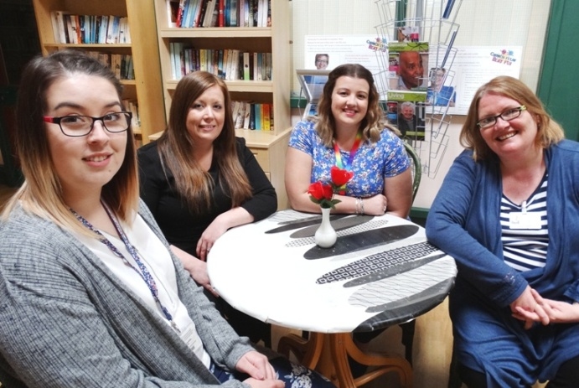
OT technicians Hayley Stephens, Donna Parfitt-Bailey and Rebecca Taylor, with occupational therapist Karen Geraghty who have just joined the team.

By the end of the pilot not only was there a reduction in the number of falls among patients on the ward but also a drop in incidents of violence and aggression and fall in staff sickness levels.

Now, with the new team members on board, the expanded team is continuing its good work at Tonna and Ward G at Neath Port Talbot Hospital.

OT technician Rebecca Taylor worked on the original project and is thrilled to be a full- time member of the team. “I wanted to stay here and carry on what we had been doing. I had seen the difference it made to patients’ lives,” she said.

One grateful family member said she was so pleased with the occupational therapy intervention her step-father received she would have been happy to pay for it.

She said: “Family visits were better because he was more affectionate and on occasion was even able to identify us and call us by our names.”

The daughter of another patient said she was delighted to see her father’s ability to concentrate and hold conversations improve as a result of the mental stimulation the therapy provided.

She said visits were much more positive and, as his memory improved, her father was happier and much less frustrated.

“I am forever grateful for bringing my dad back to me,” she added.

Occupational therapist Karen Geraghty said: “Patent-centred care is at the heart of all we do. We work with families to provide accessible and appropriate therapies – a bespoke service is absolutely essential, whatever we do is based on an individual’s needs.”

New OT technician Donna Parfitt-Bailey said: “I love working directly with patients, the one-to-one work is the most rewarding aspect of the role. Having regular contact like that means we are able to find out and understand what their needs are.”

Her colleague Hayley Stephens added: “It is very satisfying and we are always happy to see the activities making a difference. When we see a smiling face – a patient or their family – that is wonderful.”

Jessica and the team’s hard work saw them shortlisted in the Improving Patient Safety Award at last year’s NHS Wales Awards and now following its success, ABMU has rolled out the service for older mental health patients in Swansea and Bridgend localities.
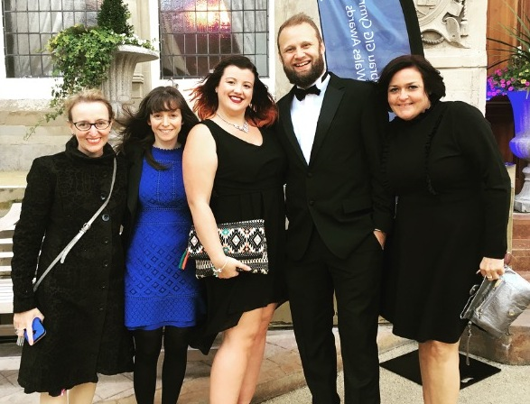
Members of the team attending the NHS Wales Awards last year after being shortlisted in the Improving Patient Safety category. (from left) Rebecca Hanmer, Jessica Denicola, Rebecca Taylor, Daniel Beuse-Evans and Joanne Hollyman.

Jessica added: “We are delighted to see that the work we have carried out here has helped shape and develop practice across the health board so that more patients and their families can benefit.”

Source: Abertawe Bro Morgannwg University Health Board

