Double challenge to help boost speech therapy services
Tuesday, 8 May 2018
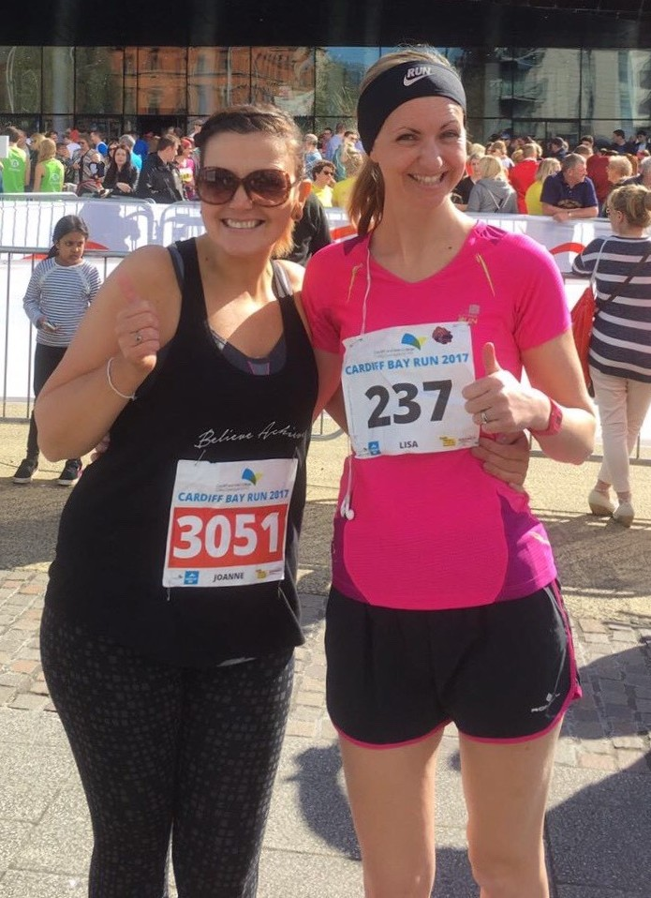
Two eager runners are getting ready to hit the road to help boost services for adults with learning disabilities.

Speech and language therapist Lisa Chapman wants to raise funds for an assistive technology clinic which is being set up within the Cardiff adult learning disabilities team run by ABMU

Lisa used to work for ABMU’s adult learning disability services in Neath Port Talbot, Swansea and Cardiff as well with paediatric services in Neath Port Talbot and Bridgend.

She said: “A fantastic group of very talented health professionals are currently developing an assistive technology service which aims to offer much-needed support specifically for adults with a learning disability.

“To provide a well resourced and fully supported service, more funding for equipment such as tablets, environmental controls and software is needed so we are doing what we can.”

To help her raise some of those funds and boost the profile of the service, Lisa has enlisted the help of fellow runner Joanne Freeguard, who works at Port Talbot Resource Centre.

Together the pair are going to run the Liverpool Rock n' Roll Marathon on Sunday 20th May. But once that is over Lisa’s fundraising will continue.

“I have set myself a double challenge – taking part in two marathons on two continents for two fantastic speech and language causes that mean a lot to me both professionally and personally, “ she added.

In October she will be running the Standard Chartered Nairobi Marathon to raise money for Yellow House, a Kenyan charity which aims to increase recognition of speech and language therapy while providing a free service to anyone who needs it.

Anyone who would like to support Lisa and Joanne’s efforts should click here

Source: Abertawe Bro Morgannwg University Health Board

