Day room makeover aims to help tackle PJ paralysis
Thursday, 3 May 2018
Elderly patients at Singleton Hospital are now able to relax and spend time with their families away from the ward in comfortable new surroundings.

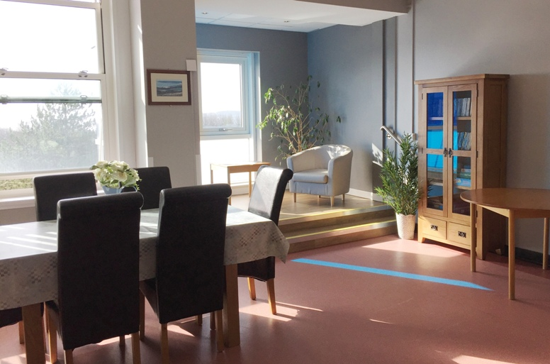
The day room at Ward 3 has been given a dramatic makeover and now boasts a new decor, dementia-friendly furniture, along with plants and wall art.

It is hoped it will now play a key part in the #EndPJParalysis campaign which aims to to raise awareness of the importance of getting patients up and about and moving.

Research shows that elderly patients in a bed begin to weaken just one day after admission and 10 days bed rest can lead to up to 10 years’ loss of muscle mass.
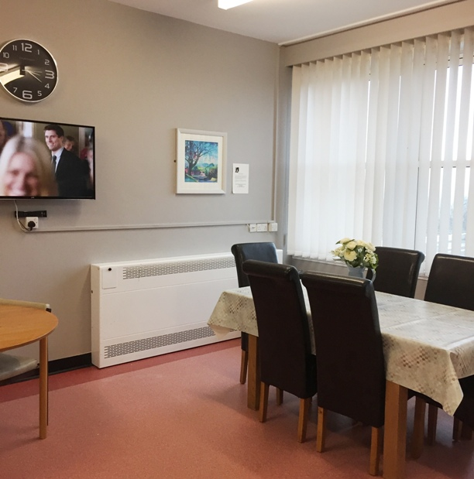
To reinforce ABMU’s ongoing commitment to getting its patients up and moving, the health board is taking part in a UK-wide challenge which runs until June and aims at achieving one million patient days of relevant patients being up, dressed and mobilised over a period of 70 days.

Making this day room an attractive location for patients to spend time will help the ward tackle what is known as pyjama or PJ paralysis. It is also somewhere where they can sit with their families and see grandchildren.

The room’s transformation was carried out thanks to members of Singleton’s Patient Advice and Liaison Service (PALS) who enlisted help from a local supermarket and Gower College Swansea.

Emma Davies, of PALS, said: “Before this project, the room wasn’t really used, it looked a bit drab and needed some attention. We hope by making it more attractive and comfortable it will be somewhere patients want to spend time.”

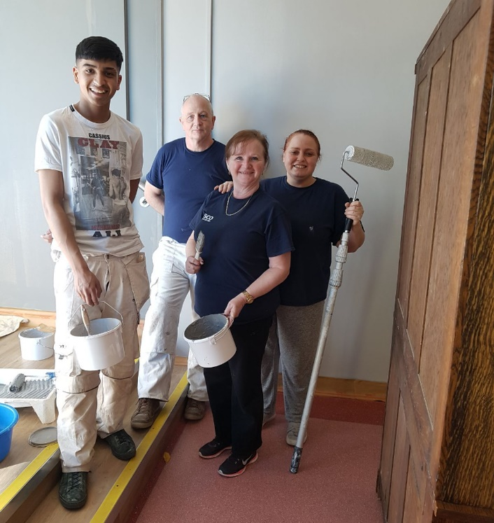
Emma explained: “We had seen how Tesco had been able to help the Acute Clinical Team in Bonymaen run a healthy eating campaign last year so we got in touch with the local store’s community champions to see if they would be able up for a slightly bigger challenge.”

The new-look room, with its panoramic view over Mumbles, has games, jigsaws and books as well as a new television with a built-in DVD provided by the store, along with a CD player and accompanying CDs.

Volunteers from Gower College Swansea and Tesco hard at work in the day room.

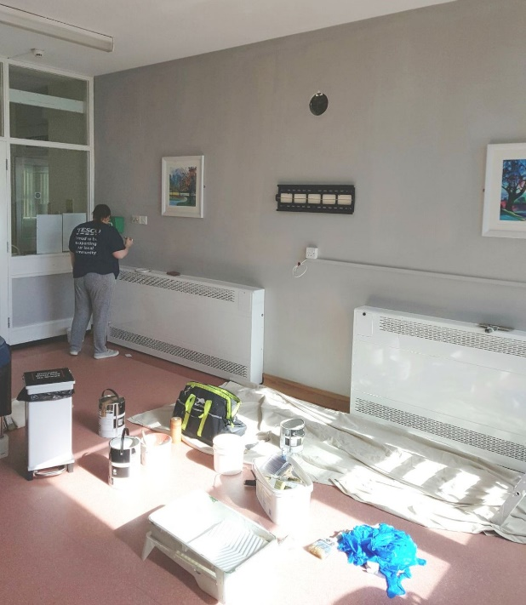
Emma said: “We are so delighted with how it turned out.

“The community champions sourced all the furnishings and accessories and got the college on board with the painting and decorating.”

The store has been fundraising on the ward’s behalf and staff and the PALS also got involved by holding a Valentine’s Day cake sale which raised more than £500 towards the day room project.

Emma added: “Everybody worked so hard to get this done. We are so grateful to Donna Costa and Karen Dean from Tesco and all the staff on Ward 3 for making this makeover such a success.”

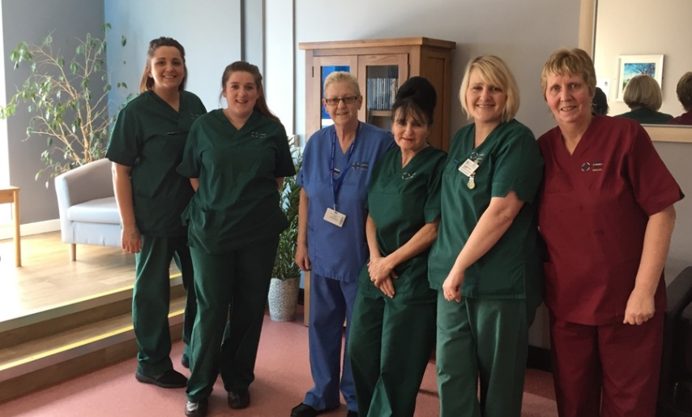
Singleton Hospital Director Jan Worthing added: “This is a very worthwhile project which has helped breathe new life into the day room.

“Congratulations to everyone who got nvolved.

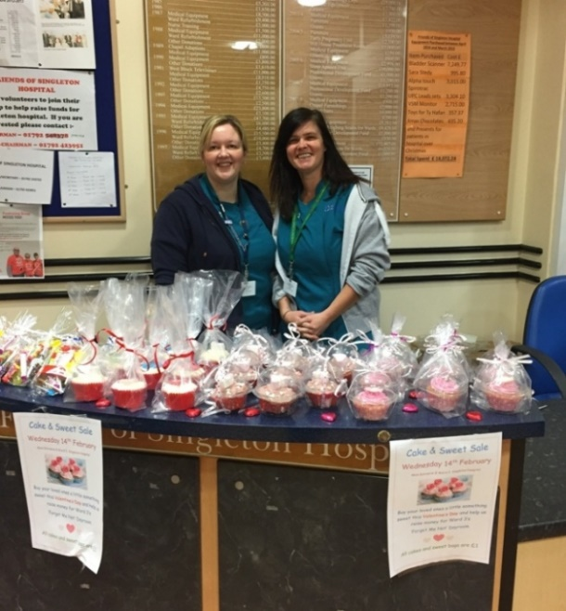
“Anything we can do that will encourage our patients to get up and move about, to lead as normal a life as they can while in hospital, is very welcome. “

Some of the members of Ward 3 staff who were involved in the project and (right) Sarah Butcher and Emma Davies, of Singleton PALS, when they held a cake and sweet raffle to raise funds for the project.

Source: Abertawe Bro Morgannwg University Health Board

