Voice care session hits the right note with singers
Tuesday, 2 May 2017
Warming up is important before exercising – and choristers at an event in Port Talbot have found out why the same is true before singing.
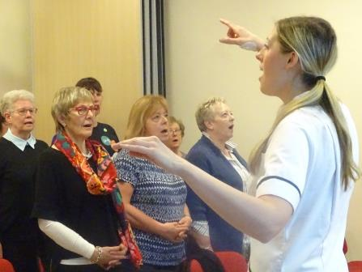
To mark this year’s World Voice Day, Neath Port Talbot Hospital’s speech and language team hosted a workshop with a difference aimed in particular at local choristers.

Gina Rooke puts some of the singers (including Jean Tucker, second left) through their paces

More than 30 of them came along to find out how they can look after their voices, particularly as they get older.

It was organised by speech and language therapist Gina Rooke who said she was delighted with the way the choristers really got into the spirit of the occasion.

It was the first event of its kind held in the hospital and hit so many right notes with those who attended that Gina hopes it will not be the last.

One of those present, Jean Tucker of the Swansea Excelsior Ladies Choir, said: “I thought it was brilliant, absolutely brilliant.

“It was very clear, very informative, and delivered with a lot of warmth and knowledge.”

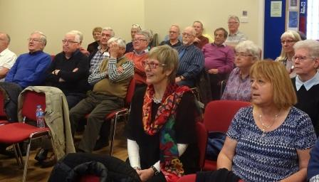
The aim of World Voice Day is to demonstrate the enormous importance of the voice in our daily life.

It’s a global event which has taken place every April 16th since 1998, first in Brazil and then the United States before spreading internationally.

Gina said: “This year’s World Voice Day was about the ageing voice and the importance of a vocal warm-up.

“We decided to host a workshop for members of the public to come along, people who are interested in knowing a bit more about voice, especially people who sing in choirs.

“We had more than 30 attend from five different choirs in Bridgend, Neath Port Talbot and Swansea.”

Gina made a short presentation on the effects of ageing on the voice, and what people could do to help theirs stay healthy for as long as possible.

This was followed with the showing of a short film by the British Voice Association (BVA) about the importance of vocal warm-ups – which the choristers then put into practice.

Gina said: “We did some sustained notes, some lip trills and tongue trills, and a breathing activity to try to relax and encourage breathing lower down in the abdomen.

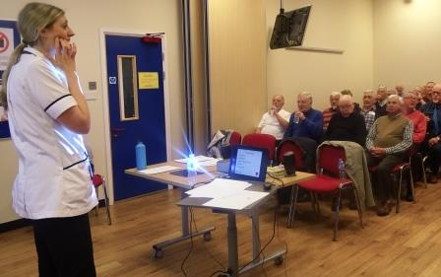
“Everyone who came along was really up for taking part, and it was fantastic.”

There was also a question and answer session, while bottles of water donated by Nestle were given to those attending, to emphasise the importance of hydration on the voice.

Copies of The Voice and Ageing, an information leaflet provided by the BVA, were also handed out. It explains how people can maintain a healthy voice in later years.

Jean said she would definitely be practising the warm-up exercises herself and taking them back to the Swansea Ladies Excelsior Choir.

She added: “Even with aging, it is possible to keep your voice flexible and these exercises can be an everyday thing to do.”

Gina said she’d had no idea how successful the event would be, but it had gone down so well she would definitely look into organising more.

“We will think about what changes we could make to make it appropriate for other people – but it is something we would really like to do again.”

You can watch a short video about this story below - double click it to view in full-screen.
https://www.youtube.com/watch?v=_kjgkgZzkTM

Source: Abertawe Bro Morgannwg University Health Board

