Staff show a healthy interest in keeping us all smiling
Friday, 19 May 2017
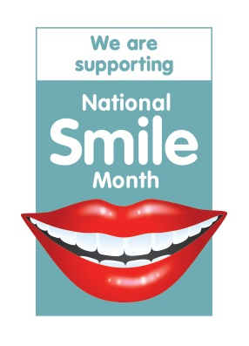
There were smiles all round as ABMU staff teamed up to launch a special event highlighting oral health.

National Smile Month aims to promote and raise awareness of how important it is to look after your teeth and health visitors, dental nurses and the Designed to Smile team will be working together across ABMU to support it.

As they meet families and youngsters throughout the month – which runs until 15th June - they will be sharing its key messages reminding people to:
- Brush their teeth last thing at night and on at least one other occasion with a fluoride toothpaste;
- Cut down on how often they have sugary and acidic foods and drinks; and,
- Visit their dentist regularly, as often as recommended.
Lead health visitor for public health Jane O’Kane, who chairs ABMU’s Health Teeth Steering Group, said: “National Smile Month gives all of us health professionals a great opportunity to remind people just how important oral health is.

“When we are out and about doing our normal visits we will be passing on information and advice about how to keep teeth healthy.”

ABMU’s dental health manager for the Designed to Smile programme Mandy Silva added: “The programme encourages children to develop and maintain good oral health from an early age and since it began in 2009 there has been a 12 per cent reduction of tooth decay in 5-year-olds in Wales.

“However, we want to continue this good work and that’s why National Smile Month, which gets us all thinking about oral health and how we can improve, it is so useful.”

To help staff get the message across they will be equipped with posters and the distinctive Smiley, which was chosen as the logo for the month because poor oral hygiene is the reason why many people avoid showing their teeth when they smile.
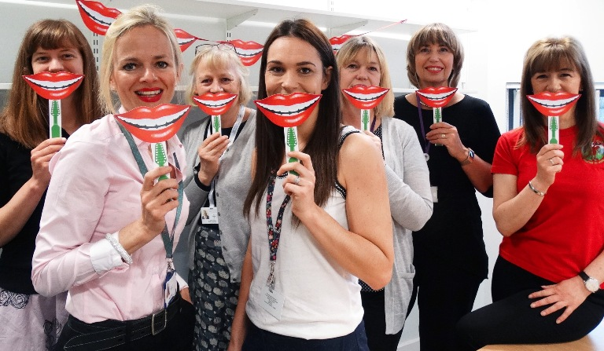
“We want to do what we can to make sure our children grow up with plenty to smile about when it comes to their teeth,” added Jane.

To find out more about National Smile Month please visit www.smilemonth.org

Locum consultant in dental public health Mary Wilson, lead health visitor for public health Jane O’Kane, health visitors Mary George, Rachel Kerswell, Jo Lamb and Paula Davies with Mandy Silva, dental health manager for the Designed to Smile team at the launch of National Smile Month.

Source: Abertawe Bro Morgannwg University Health Board

