Spreading the word on mental health problems
Tuesday, 9 May 2017
To mark Mental Health Awareness Week a variety of events are taking place around Swansea.
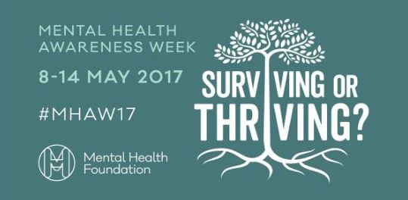
They are all aimed at reminding the public that mental health problems can affect anyone, regardless of background, and offering information about how to get help and advice to deal with them.

Lily Bidmead, of the Patients’ Council based at Cefn Coed Hospital, has been working with community group Think Again, which is made of people who have experienced mental health issues.

Together they are hoping to use the week to try to eliminate the stigma surrounding the subject.

She said: “We have a programme of events planned for the week. We were keen to go to places like supermarkets where people go as part of their ordinary lives.

“We will be in Pontarddulais all week, on Tuesday we are in the foyer of Asda in Gorseinon, Wednesday in Crest at Cwmbwrla Day Centre in Swansea and Thursday in the foyer of Tesco Llansamlet.”

Bringing the week’s event to a close on Friday will be a walk from the Junction Cafe at Blackpill along the seafront to end at Verdi’s in Mumbles. The walkers will set off at 11am and anyone is welcome to come along and join them.

Lily said: “The theme of this year’s week is Surviving or Thriving and we will have people available who know all about that because they have experienced mental health challenges themselves and will be there to offer advice and support.

“Sometimes you may not have to go to a GP, you just need some help and information about how to cope and that is what we hope this week can provide.

“Everybody can have their problems and we want to show people that there is help out there.”

Source: Abertawe Bro Morgannwg University Health Board

