Morriston first hospital in Wales to join online access guide
Tuesday, 23 May 2017
Disabled people going to Morriston Hospital can now find their way around it before they have even set off from home.

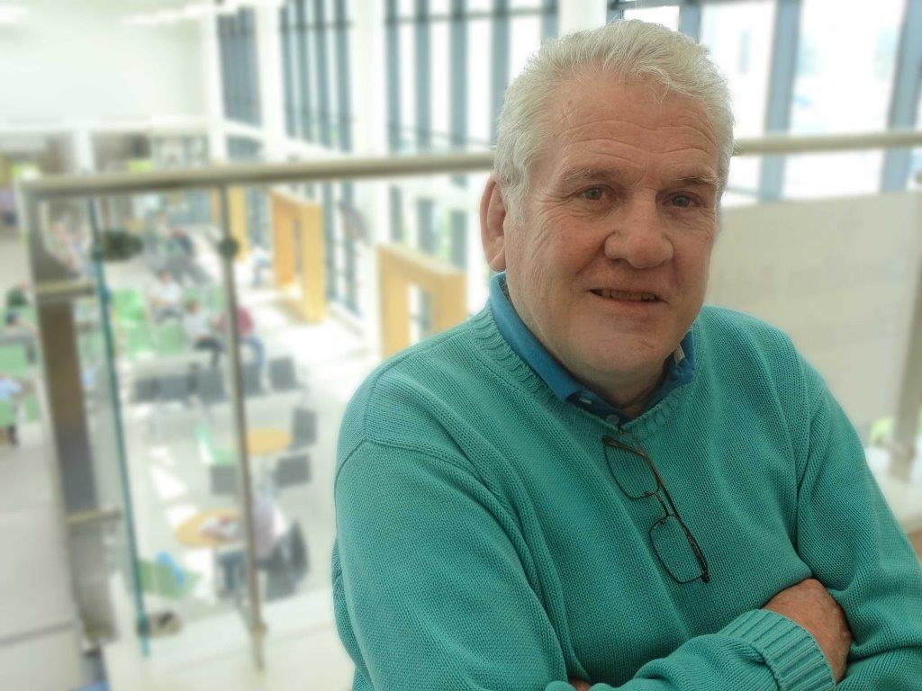
The hospital has become the first in Wales to sign up to an online guide which tells people everything from how far the car park is from the main entrance to where the lifts and disabled toilets can be found.

Disability Reference Group member Brendan Campbell at the Morriston Hospital launch

Working in partnership with DisabledGo, ABMU now aims to extend the access guides to cover all its hospitals as well as community sites.

DisabledGo provides free, detailed information about the accessibility of different venues around the country.

It uses icons to denote site-specific details such as ramps, disabled toilets, and whether there is a hearing system in place, as well as wider accessibility information. It also includes photographs of the features covered.

Although it will be particularly helpful to disabled people, their carers, family and friends, the guide is also useful to anyone who wants to find out more about the place they will be visiting.

Morriston was the first of ABMU’s hospitals to be featured because of the many new developments there, including the opening of the £60 million outpatient department in 2015.

The original idea for an online accessibility guide was suggested by ABMU’s Disability Reference Group, which comprises around 30 groups representing a full range of disabilities.

ABMU Assistant Director of Strategy and Partnerships, Joanne Abbott-Davies said: “Morriston is the first hospital in Wales to join DisabledGo.

“It came about after the Disability Reference Group pointed out the new building was such a massive change from the old outpatient system it would be good for people to acclimatise themselves before they went.

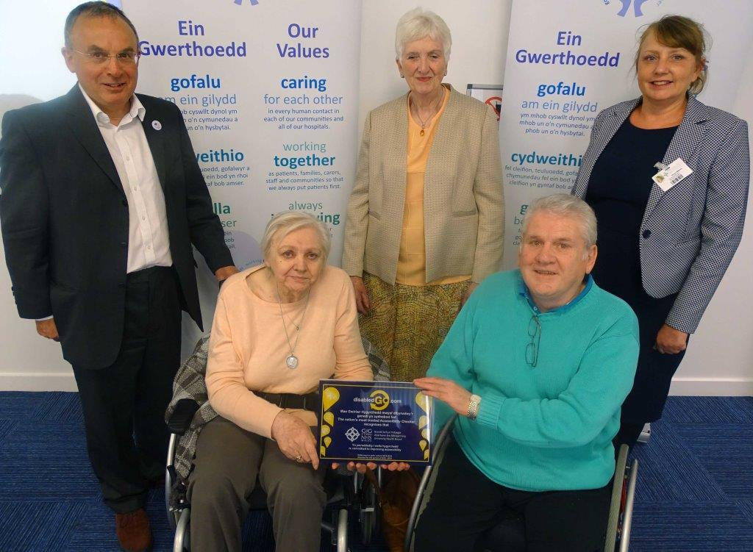
“We have a link on the Morriston Hospital section of the ABMU website that takes people to the hospital’s page on DisabledGo. We also hope to include details with appointment letters.

“We are encouraging people to plan ahead so they can make the best of their visit.”

With the DisabledGo plaque are (l-r): ABMU Chairman Andrew Davies; Jean Williams, Catherine Coombs and Brendan Campbell from the Disability Reference Group; and Morriston Nurse Director Nicola Williams

The Disability Reference Group, which helped with the design of the new outpatient department, was represented at the DisabledGo launch at Morriston Hospital.

Group member Brendan Campbell, who is also secretary of Swansea Access for Everyone, said: “I come here on my own. I’m a wheelchair user and I drive my own car.

“But if I wasn’t sure what the hospital was like I’d bring somebody with me.

“Well, if you look at the DisabledGo site you can work it out and you might decide you can go there on your own with no problem.”

If people have any questions or concerns after checking out the hospital on DisabledGo they can contact Morriston’s PALS – Patient Advice Liaison Service – team, who will be happy to help.

ABMU Chairman Andrew Davies said: “I’m delighted Morriston Hospital and ABMU Health Board are the first in Wales to work with DisabledGo.

“We put huge effort into making sure our services are accessible to everybody. We know that services that are accessible to disabled people are better services for everyone.”

Morriston’s Nurse Director Nicola Williams added: “I’m so proud we’re the first hospital in Wales to have this access guide. I think that’s a fantastic achievement for Morriston and ABMU.”
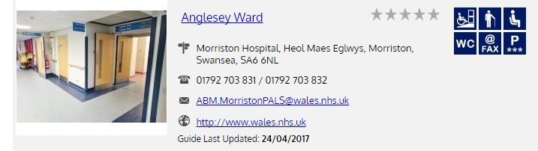
One of Morriston’s DisabledGo pages, linking to detailed information for the wards

Work is ongoing to improve the links to DisabledGo on the various sections of ABMU’s website. There are also plans to extend the service to other health board hospitals and community sites.

DisabledGo Executive Director Anna Nelson said: “Our hope is that Morriston Hospital and the health board will inspire other similar organisations in Wales to follow their lead and have this information for disabled people, wherever they might live.”

Source: Abertawe Bro Morgannwg University Health Board

