Four health board projects shortlisted for NHS Wales Awards
Friday, 19 May 2017
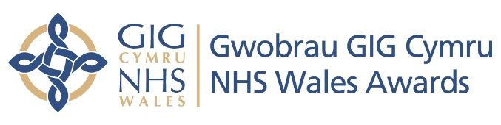
ABMU Health Board is celebrating after four of its projects made the finals of this year’s NHS Wales Awards, announced today.

The health board is up for the following awards:
- Improving Health And Wellbeing and Reducing Inequalities (supported by Welsh Local Government Association) where two projects have been shortlisted - work on Improving pulmonary rehabilitation services for our patients across ABMU and the low FODMAP diet as an effective treatment for IBS in Primary Care
- Improving Patient Safety (supported by Welsh Risk Pool) for work on Enhanced therapeutic environment for patients to reduce incidences of aggression and improve staff morale
- Improving Quality Using Improving Quality Together (IQT) Methodology for work on Managing antibiotics wisely
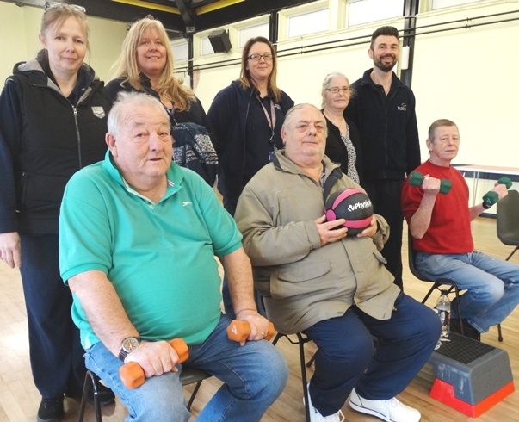
Specialist respiratory nurse Catherine Stracy, occupational therapist Tracey Eldred, rehabilitation technician Claire Williams and fitness instructor Lewis Pengilly from ABMU’s pulmonary rehabilitation team with patients Maria Christian Bob Watson, Alyn Clarke and Mick Brookes.

ABMU’s Interim Chief Executive Alex Howells said: “We are delighted and very proud that once again our staff’s dedication and innovative work has been recognised at the awards

“To have four projects reach the final stages of such a prestigious event is a great achievement and it really does reflect how hard colleagues are working to develop and improve the care we give our patients.

“Congratulations to everyone involved in getting this far and good luck for the final.”

Now in its 10th year, the annual NHS Wales Awards celebrate the work of organisations and teams across Wales in delivering excellent care and the winners will be announced in a ceremony on 21st September 2017.

The judging panel of NHS experts had the tough task of selecting the 21 finalists in seven award categories.

The next stage is for the judging panels to visit each finalist to find out more and see first-hand the benefits they’ve brought to patients.

The NHS Wales Awards are organised by 1000 Lives which is the national improvement service for NHS Wales delivered by Public Health Wales.
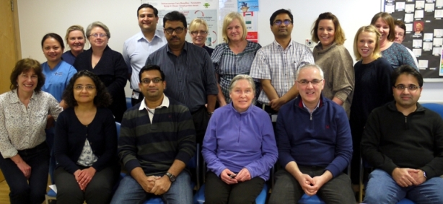
For a full list of finalists please visit www.nhswalesawards.wales.nhs.uk.

The neonatal team at Singleton Hospital involved in the
Managing antiobiotics wisely project

Source: Abertawe Bro Morgannwg University Health Board

