Dental nurse Natalie takes to two wheels to support Ty Olwen
Tuesday, 16 May 2017
When fair-weather cyclist Natalie Jewell headed into a bike shop to ask about maintenance classes she never thought she end up pedalling to Paris.

Although she liked using her bike she would only manage at best a few miles a week but all that’s changed.
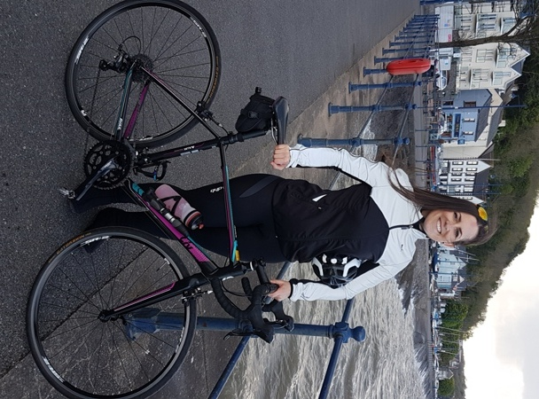
Now ABMU dental nurse Natalie says she has been bitten by the bike bug. She regularly clocks up big distances which is just as well as she is set to ride 340 miles from Paris to Swansea later this summer to raise money for Ty Olwen.

“I only went into the bike shop to find about more about how to look after my bike. By the time I left I had ended up agreeing to join a cycling club.

“That was about eight months ago and it has all gone from there,” she said.

“I am definitely a keen cyclist now but I haven’t done anything as huge as this before. I did do 75 miles the other day as part of my training and I absolutely love it,” she said 30-year-old Natalie, who is from Swansea.

Natalie, who works in the Dental Teaching Unit at Port Talbot Resource Centre, is taking part in the four-day charity mission in August to raise money for the hospice at Morriston Hospital.

“All the riders taking part in the ride chose which charity they want to support and for me it had to be Ty Olwen.

“Two of my grandparents were cared for there before they died and the staff were just fantastic.

“I cannot express how wonderful this unit and its staff are. They treat both their patients and the families with dignity, care and more compassion than I ever thought possible,” she said.

She is now hoping to raise £1,500 for the Ty Olwen Trust to help the staff continue to provide outstanding care.

“If you have ever had a friend or loved one affected by cancer or been affected personally or just feel like supporting a great cause your help would be very much appreciated,” she added.

To help her towards her target Natalie has organised a special Ladies’ Night fundraiser at the Clockwork Magpie cocktail bar in Swansea’s St Mary’s Street on Friday, 9th June.

For more details about the event call Natalie on 07870824249 or to sponsor her go to https://www.justgiving.com/crowdfunding/natalie-jewell-1

Source: Abertawe Bro Morgannwg University Health Board

