Charity steps in to transform day room for cancer patients
Thursday, 18 May 2017
Cancer patients are now able to relax in more pleasant surroundings after a Singleton Hospital day room was given a makeover.

Thanks to a charity donation, the communal room on Ward 12 has been completely refurbished and now boasts bright and comfortable new sofas and armchairs, dining table and chairs.

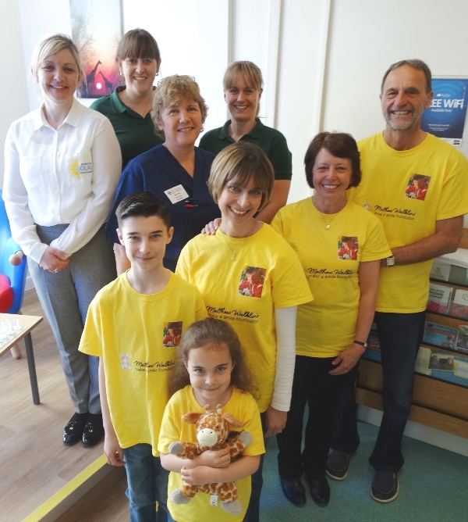
There are also new blinds to help give patients and their families more privacy when using the room.

The transformation was made possible by Blackwood-based charity Matthew Walklin’s Make a Smile Foundation which is dedicated to improving additional facilities and services for Welsh cancer patients.

Pictured are Golau fundraising coordinator Michelle Barrett, Macmillan Team lead physiotherapy specialist Kath Elias, senior ward manager Helen Rees Macmillan occupational therapy lead Joanne Horton, with Michael and Lorraine Walklin, Joanne, Dafydd and Catrin Poole.

The new-look room, complete with bracket for the wall-mounted TV, is already a big hit with patients who are now using it regularly as somewhere to go with visitors or to get away from their beds.

Macmillan occupational therapy lead Joanne Horton said: “The change to the room has made a massive difference to the experience for people affected by cancer on Ward 12.

“The day room was drab and under-utilised and often used to store equipment. It is now a busy room and enables people to have a more comfortable experience, allowing them time away from their bedside.“

She said as therapists they always try help patients stay as independent as possible. She added: “This room now supports our rehabilitative approach to patient care. Without the help of the charity this development would not have been possible.”

Joanne, along with senior ward manager Helen Rees, was on hand to meet representatives from the charity when they came along to see the completed day room.
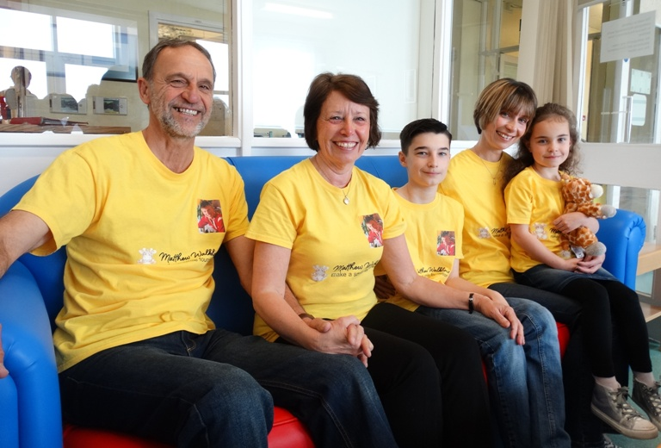
Matthew’s parents Michael and Lorraine Walklin, who is the charity’s chair, were joined by his sister Joanne Poole and her children Dafydd and Catrin (pictured on one of the new sofas) for a close-up look at how the area has been transformed.

They also added a print of a giraffe, which is used in the charity’s logo, to complete the decorations.

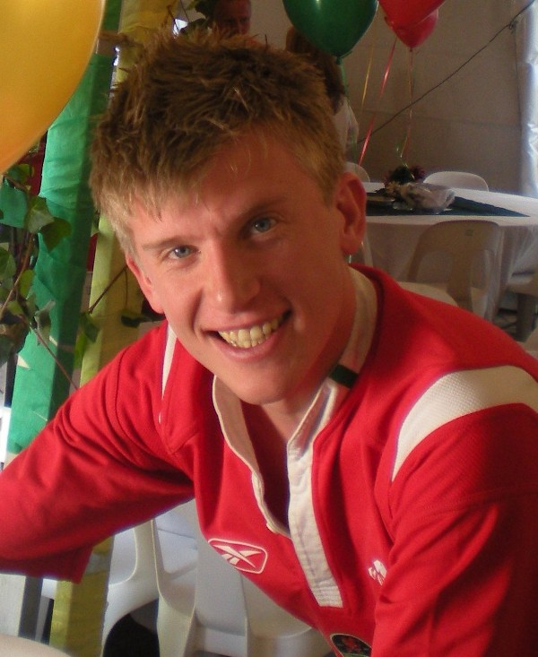
Former Swansea University student Matt (right) was 27 when he died after being diagnosed with an unusual form of testicular cancer.

During his treatment he was determined to leave a lasting legacy by encouraging his family to set up the charity in his name.

Its aim is to provide items to improve the comfort and welfare of cancer patients while they undergo treatment and enable them to maintain contact with friends and family.

His sister said: “Matthew always felt it was very important for patients to remain positive and to find ways of helping them take their mind off what is happening to them.

“He told me ‘I know I will never be able to cure cancer but I can make people smile when they are going through their treatment’ and that is what we are trying to do here today.”

His mum Lorraine added: “Our charity has wonderful committee members and we all work together to provide things that will make a difference like this project. It is fantastic to see how welcoming this room now looks.

“It feels very appropriate that we have helped Singleton because Matt was a student at the university and he loved Swansea.

“His friends placed a bench in his memory on the seafront in Mumbles and it is fitting that people using this day room can look out of the window and see Mumbles.”

The charity raises money for its projects through sponsorship events and donations, including one high-profile stunt by 12-year-old Aleksandar Simic who collected £1,200 towards the day room refurbishment by having his long hair cut off.

To complement the improvements ABMU’s own charity, the Golau Cancer Foundation which raises money to support the South West Cancer Centre at Singleton, will be providing a drinks vending machine for patients and their visitors.

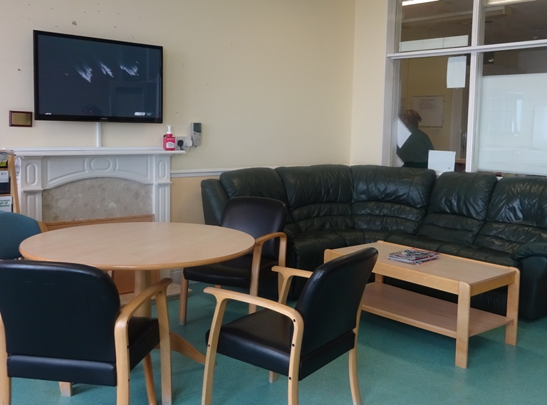 | 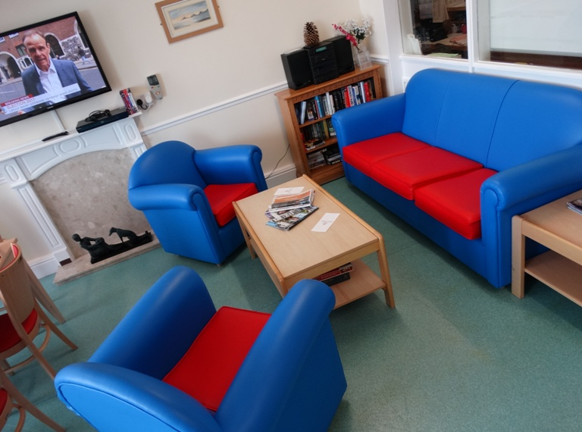
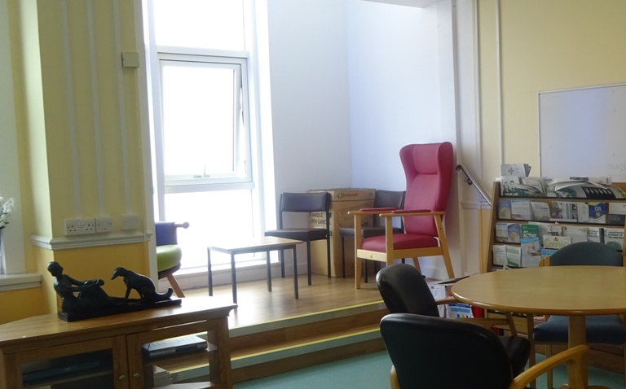 | 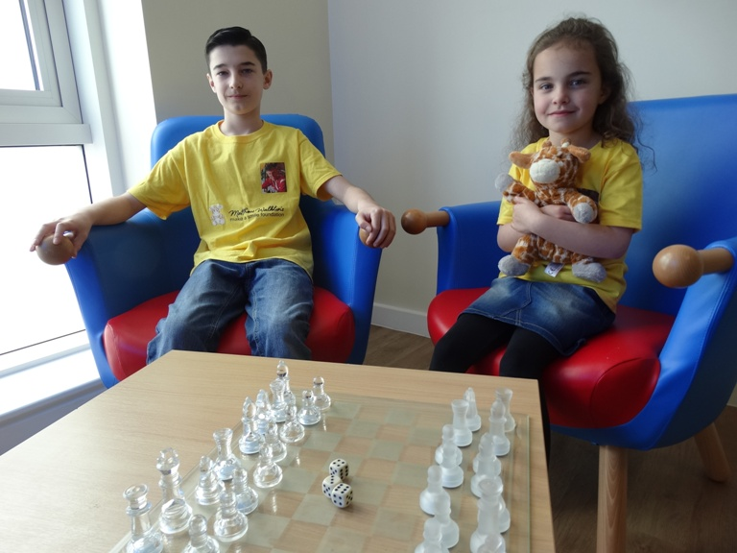

(Top left) the day room before its transformation and (top right) after with new furniture, blinds and TV bracket.
(Above, left) the window area as it looked before the makeover and (right) Dafydd and Catrin Poole try out the comfy new seating.

Source: Abertawe Bro Morgannwg University Health Board

