Boost for Morriston ward in memory of cardiac patient
Wednesday, 17 May 2017
The family of a heart patient have returned to the Morriston Hospital ward which treated him to hand over a donation in his memory.
When Eirian Evans died last October his loved ones asked for donations in lieu of flowers to support the Cyril Evans Ward which looks after cardiac patients.

They have now presented a donation of £1,100 to ward manager Louise Jenvey. The money was not the first boost his family have given the team.
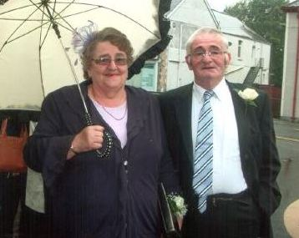
Mr Evans, of Crwbin was a well-known figure in the Carmarthenshire farming community and had been a patient on the ward following heart surgery three years ago.

He was so grateful for the care he received then the father-of-five organised a fundraising evening in aid of the ward which collected £2,500.

Eirian Evans pictured with his wife Delyth.

His daughter Rhian Griffiths said: “He had wanted to do what he could to support the ward when he was alive. As a family we were very grateful to all the staff who looked after him, they were marvellous, so we decided to do something else to say thank you to them.”

Receiving the cheque, Louise said: “We’d like to thank his family very much for thinking of us at such a sad time. Mr Evans was a great supporter of the ward and a true gentleman as a patient.

“All of us on Cyril Evans Ward would like to say how sorry we are for his loss and how grateful we are for his family’s generosity.”

​

Source: Abertawe Bro Morgannwg University Health Board

