Youngster hears birds singing for the first time after Morriston op
Tuesday, 7 March 2017
A youngster from Swansea is able to hear birds singing in the trees for the first time after having surgery at Morriston Hospital.
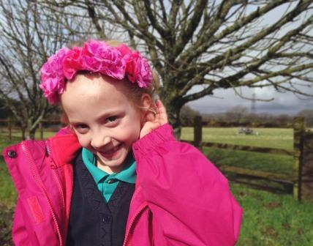
The procedure seven-year-old Carys Pritchard underwent may have been straightforward but the difference to her life has been amazing.

Carys had otitis media with effusion – better known as glue ear, a common childhood condition – in both ears.

It’s caused by a build-up of fluid in the middle ear, which means the three tiny bones that usually carry sound vibrations from the eardrum to the inner ear are prevented from moving freely.

Carys had two grommet insertions – a very small tube placed in each ear to help drain the fluid.

Because she also had problems with her adenoids that caused breathing difficulties and made her snore, surgeons removed these too.

Now Carys is exploring a whole new world of sounds she had never experienced before.

The youngster lives in Llansamlet with parents Helen and Tim Pritchard and brothers Ieuan, aged 11, and nine-year-old Gethin.

As Ieuan had previously undergone two grommet operations, Helen and Tim were quick to notice Carys was having problems.

Helen said: “Carys wasn’t hearing very well at home, in school or when she was in Brownies, and she was prone to ear infections. So it was really affecting her day-to-day life.

“She struggled with her reading too because she couldn’t hear the words properly – my son was exactly the same.

“A couple of years ago she failed a hearing test in school. She waited a while to have the operation but since having it she has been brilliant – her hearing is great.

“We got used to raising our voices around her so she could hear us. Now she complains we’re all too loud in the house and tells us to quieten down.

“Because she had her adenoids removed her snoring has stopped too. Now she tells me off for snoring!”

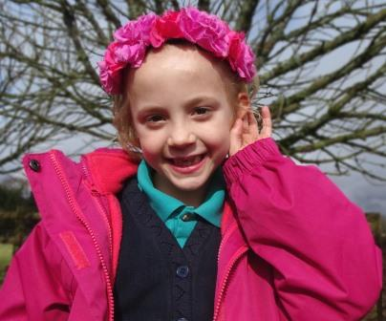
Helen said Carys was a happy little girl anyway but being able to hear had made a huge difference.

“She says she can hear the birds singing in the trees when she’s in bed.

“She can hear things from her room that she couldn’t hear before – simple little things that we all take for granted but which Carys has picked up on.”

All three children have been in Morriston Hospital at different times – Ieuan to have his grommet operations, Gethin when he had suspected meningitis and Carys when she fell and needed stitches.

Helen said the hospital staff had been fantastic.

“Everything was explained to Carys while she was in pre-assessment. The play leaders helped put her at ease and the anaesthetist came out and told her what would happen.

“After her operation she couldn’t go to the playroom so the staff brought her a DVD player so she could watch films in bed.

“The NHS gets a lot of criticism but I think it’s nice to just be able to say thank you.”

Source: Abertawe Bro Morgannwg University Health Board

