With over 300 suicide deaths a year 'Help is at Hand'
Monday, 20 March 2017
Hundreds of people die by suicide every year in Wales but help is now at hand in the form of a useful guide launched today.

This media release was issued by Public Health Wales and Swansea University.

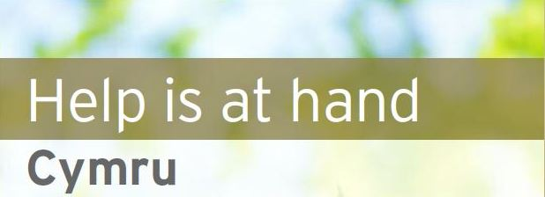Hundreds of people die by suicide every year in Wales but help is now at hand in the form of a useful guide launched today.

Bereavement by suicide or other sudden unexplained death can be particularly difficult for people, who often need both practical and emotional support in dealing with their loss.

“ Help is at Hand” Cymru has been produced as a useful self-help guide for people living and working in Wales. The guide includes sections on practical matters, experiencing bereavement, sources of support and how friends and colleagues can help. It will be sent to various people who come into contact with those bereaved through suicide such as funeral directors, General Practitioners, the police and coroner’s officers and it will be available free of charge on the Public Health Wales, Cruse, Papyrus, and Samaritans website.

Vaughan Gething, Cabinet Minister for Health and Social Services said:

“ I would like to thank the National Advisory Group on Suicide and Swansea University for updating this excellent resource. I hope it will provide support to people who find themselves in the tragic position of losing a loved one through suicide.

“ I am also pleased that the guide provides advice for healthcare professionals. Nurses, GPs, psychiatrists, ambulance staff and all other NHS staff can be affected by such deaths and it is important they have access to support."

Dr Ann John, Clinical Associate Professor in Public Mental Health at Swansea University Chair of the National Advisory Group and Public Health Wales lead for suicide prevention said:

“ There are around 300 suicide deaths a year in Wales and for each one of these, it has been suggested, on average six people are deeply affected. These include family, friends and colleagues together with members of the public and professionals involved. People bereaved by suicide often need considerable support but may find it difficult to seek or obtain help. The booklet is a self-help resource developed for people bereaved through suicide or other unexplained death- parents, friends, colleagues- and for those helping them. “

Nicola Abrahams of the Jacob Abrahams Foundation said:

"As a parent I was disappointed not to be given any supportive literature when my son took his own life. Having subsequently been aware of Help is at Hand I know I would have found it extremely helpful."

The ITV Wales Wales This Week programme will air at 8pm this evening 20th March 2017.

“Help is at Hand” Cymru can be found in English and Welsh on the Public Health Wales website at www.publichealthwales.org
Notes
- In 2011 the National Advisory Group on Suicide and Self-harm Prevention to the Welsh Government, chaired by Public Health Wales, tasked itself with creating a Wales and Welsh version of Help is at Hand, a resource for people bereaved by suicide or other sudden traumatic death. This has now been updated with further content.
- The original guide was developed by Professor Keith Hawton and Sue Simkin at the Centre for Suicide Research, University of Oxford, in collaboration with an advisory group. It was first published in 2006, supported by funding from the Department of Health, and drew on a bereavement pack previously developed by the Centre and published by the Royal College of Psychiatrists.
- “Help is at Hand” Cymru incorporates suggestions from the evaluation of the original publication and comments from the Wales National Advisory Group. Members of the advisory group who contributed to this Wales version include representatives from the Samaritans, Papyrus, Mind Cymru, Welsh Government, Cruse Bereavement Care, and Public Health Wales. Welsh Government funded the project.
- Swansea University is a world-class research-led university located in beautiful parkland with views across Swansea Bay close to the Gower Peninsula, the UK’s first Area of Outstanding Natural Beauty. The University was established in 1920 and currently offers around 500 undergraduate courses and 150 post-graduate courses to 15,921 undergraduate and postgraduate students. Go to www.swansea.ac.uk. Swansea University is a registered charity. No.1138342.
Source: Abertawe Bro Morgannwg University Health Board

