Undersea setting helps bring smile to faces of young patients
Monday, 13 March 2017
Young surgical patients at Morriston Hospital can now recover from their operation in a brightly coloured undersea world.
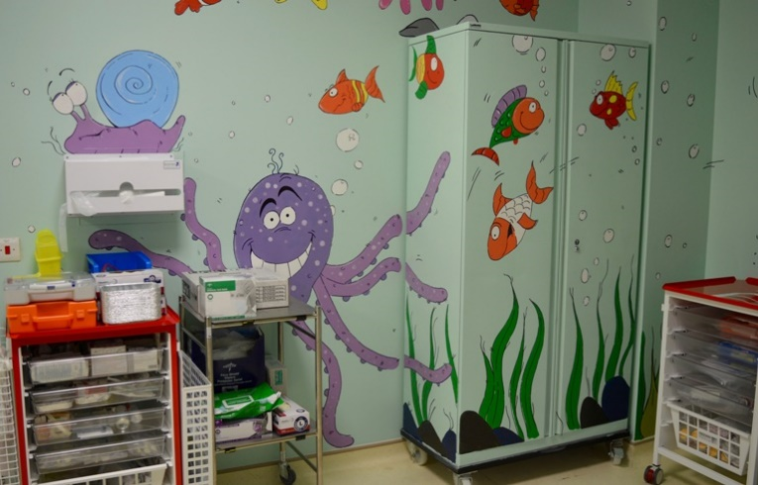
The stark, functional clinical areas in the paediatric recovery unit have been completely transformed by volunteers who created a whole army of friendly sea creatures with pride of place taken by a smiling blue whale.
The artwork was carried out by a team of staff from Tesco stores across Swansea Bay along with some of the unit’s own staff.

And the youngsters who use it are already loving their new surroundings, according to recovery team leader Helen Phillips.
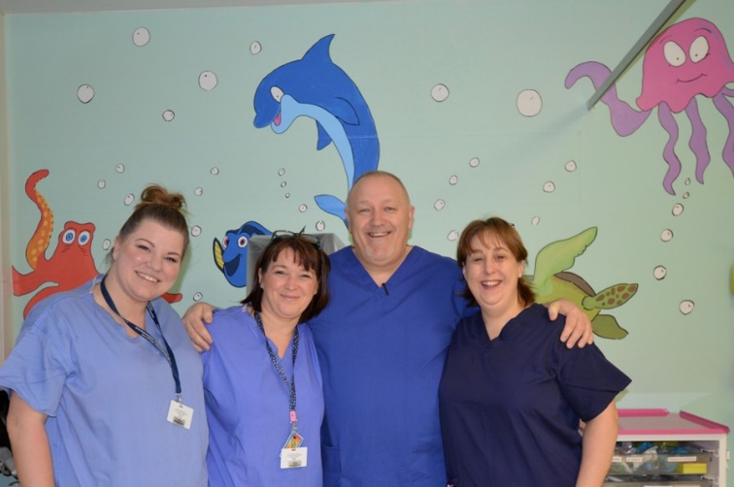
Helen Phillips (right) with recovery team members staff nurse Laura James, team leader Vikki Russell-Curtis and speciality manager Stuart Hughes
Helen said: “At the time, the paediatric recovery unit was quite clinical and had very little in the way of colour or interest for children waking from anaesthetic.
“I asked for raffle donations so we could buy some stickers for the walls. But the Tesco Community Team then got back to me with this fantastic offer.
“The transformation has been incredible. It’s so much nicer and child-friendly now, with children, parents and staff all commenting on it.
“I can't thank the Tesco Team enough for all their hard work - the whole experience has been amazing.”
The makeover at the unit, where young patients recover from anaesthetic following surgery, took place in over just one busy weekend with eager volunteers painting the cartoons created by artists in the group.

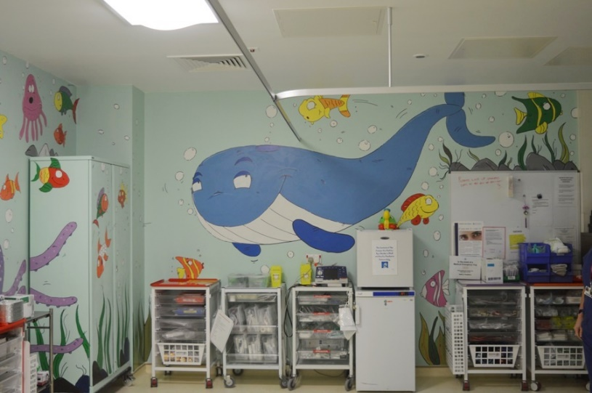
Before and after the work to transform the unit.
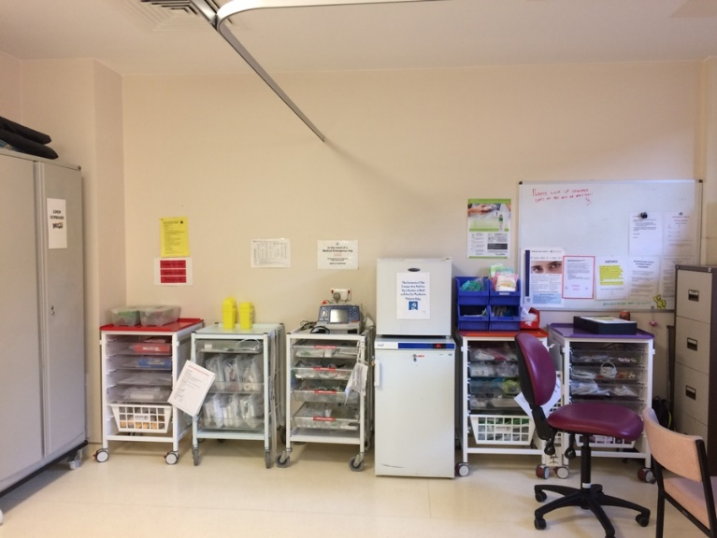

Source: Abertawe Bro Morgannwg University Health Board

