Team work triumphs as awards celebrate the partnerships helping patients
Tuesday, 14 March 2017
The care provided to patients in the community by ABMU staff and their colleagues from Swansea Council has been celebrated at a special event held at Singleton Hospital.

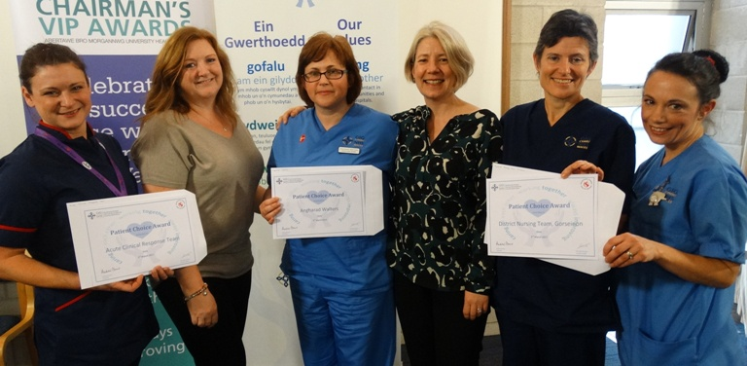
ABMU introduced its Patient Choice Awards in 2015 to give patients, carers, relatives and visitors the chance to say thanks to a member of staff or team they feel have made a real difference and provided outstanding care.

But, for the first time, the latest awards recognised the partnership and collaborative working going on across Swansea to help patients being cared for in the community.

Staff nurse Angharad Walters and representatives of the Acute Clinical Response team and Gorseinon district nursing team receives their awards from Debra Williams.

Social workers and carers stood alongside district nurses, GPs and therapists to receive their awards handed out at a ceremony attended by delighted colleagues, team leaders and patients.

The event was a true celebration of collaboration and partnership, said ABMU’s Nurse Director for Primary Care Vicky Warner.

Among the successful staff working in medical centres, integrated hubs and clinics were the members of the Acute Clinical Response team and district nursing team based in Gorseinon.

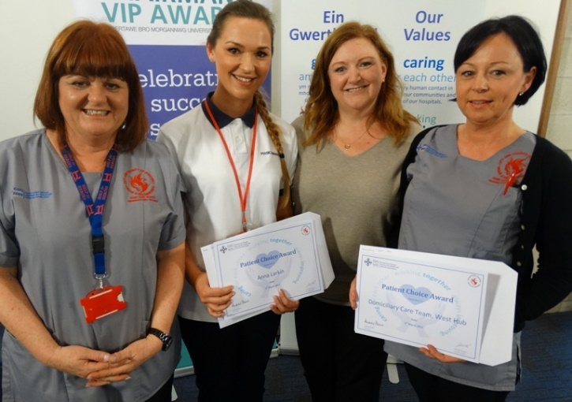
Along with staff nurse Angharad Walters, they were nominated for the compassion, professionalism and understanding they showed when dealing with one grateful family.

The partnership working displayed health and social care provided by physiotherapist Anna Larkin and the Domiciliary Care Team (left with Debra Williams) was also rewarded by grateful patient who said they had made a huge difference to his family’s life.

“I was impressed by the powerful effect of the double-badging – Swansea Council and ABMU - on the team’s uniforms.

“It was quite evident that the individual carers were very proud to wear the uniform and it was clearly very effective in building a sense of team identity. It makes me proud to be a Swansea citizen,” he wrote in his nomination.

Patient Kay Coleman was at the ceremony to thank her GP Russell Clark in person for the ways he has helped transform the care she receives when she attends his Sway Road Surgery in Morriston.

“Early last year I saw Dr Clark and he changed my life for the better. He provided a hearing loop at the surgery and, despite being so very busy, has not complained that it took longer to see me as I am deaf.
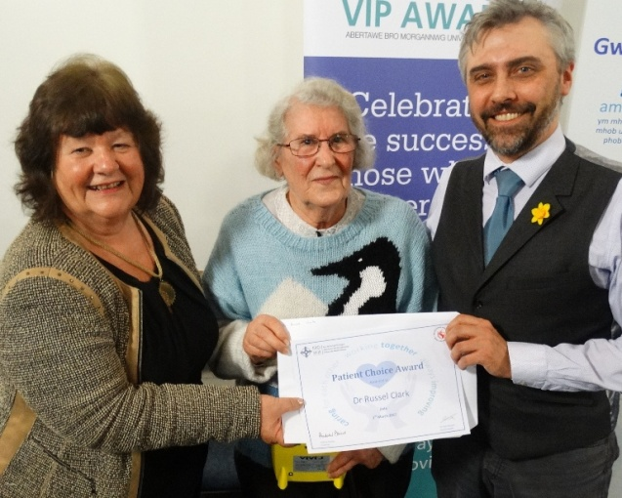
“He made it easier for me to get appointments and by allowing me to make them ‘over the counter’ at a suitable time for my transport needs.

“I am so grateful for the care and compassion, a true doctor-patient partnership,” she said.

Patient Kay Coleman (centre) with GP Russell Clark and Councillor Jane Harries.

Occupational therapist Jamie Maund-Daly used her expertise to advise a patient and earned an award in return.

“Thank you, thank you, thank you. By suggesting the changes in my home you have given me my life back.

“Here’s to you helping many more people feeling trapped in their homes. There was definitely someone looking down on you when you chose your career,” they wrote.

Another winner was social worker John O’Brien (below) for the help given to the family of a patient in the weeks leading up to her death.

Her daughter said: “I am immensely grateful to you for keeping me so well informed and for your great kindness, concern and assistance in arranging practical matters.

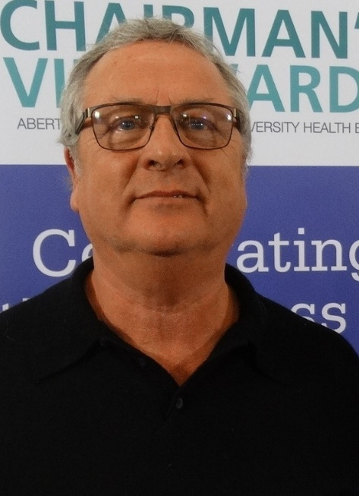
“You really did help to make a very difficult time easier.”

The 33 awards were handed out by Councillor Jane Harris and ABMU board member Debra Williams, who both paid tribute to the efforts of the staff for their care and co-operation.

“It is important for patients who use these services to see that we have people from different specialities talking to each other. The staff who are getting these awards are working in a very challenging time and deserve this recognition,” said Councillor Harris.

Debra Williams added: “This has been an amazing and humbling ceremony. I want to thank you all for your work and your collaboration. It is much appreciated.”

Other winners were Neil Wilson, Matthew Shephard, Rebecca Bushrod, John O’Brien, Andy Benford, June Phillips, Clare Whatty, Sarah Edwards, Hayley Magorrian, Angharad Walters, the West Hub, Kelly Jenkins, Dr Kerrigan, Carolyn Faulkner, Dr Pope Dr Porter and Dr Hawkins, Anna Nowak, Central Hub team, Dr Paul Harris, Mark Smith, Rachel Gillett, Diane Hall, Jackie Coates, Integrated Gower team, Continence Prescription Service, Reablement Team, Ceri Rodd, Alison Powell, Long-Care Team, Cwmfelin Medical Centre, Kirsty Rees and Kate Ashton.

Source: Abertawe Bro Morgannwg University Health Board

