Talented staff in running for top medical teaching awards
Friday, 24 March 2017
ABMU staff have been recognised for their talents at training health care professionals of the future.

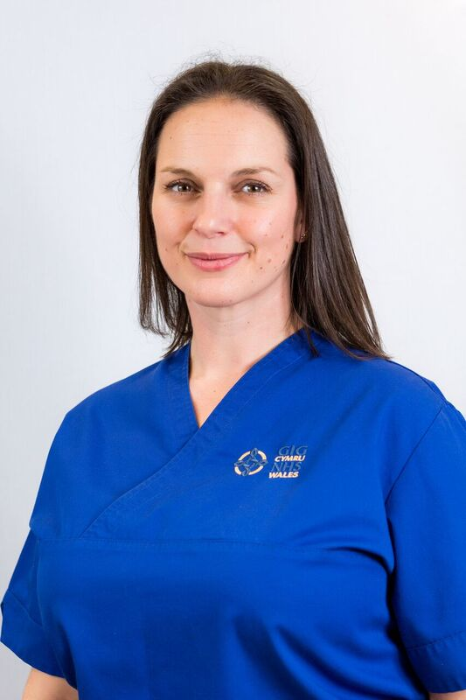 | 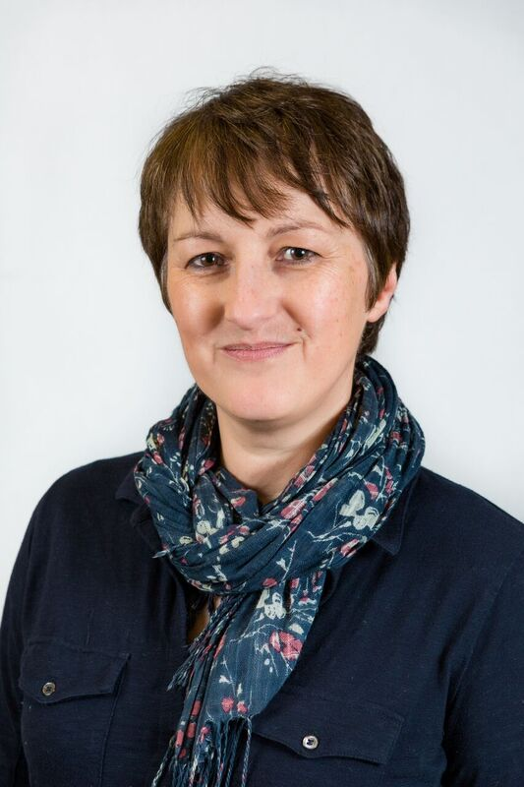
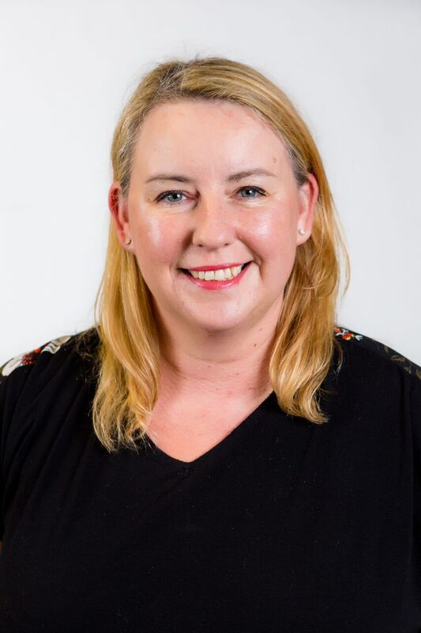 | 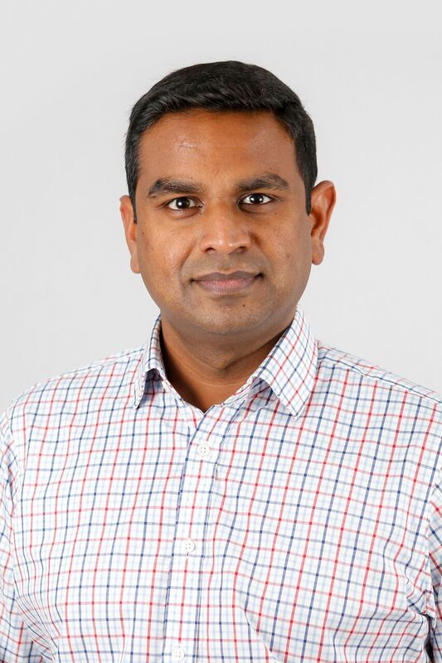
Four colleagues have been shortlisted in various categories for this year’s prestigious BMA Cymru Wales/BMJ Clinical Teacher of the Year Awards.

Advanced nurse practitioner Cheryl John and Dr Jayne Dawkins are up for the Clinical Teacher of the Year award while Collette Hill is nominated for the Teaching and Learning Innovation Award and paediatric consultant Pramodh Vallabhaneni is shortlisted in the Rising Star category.

Cheryl works in the emergency department at Princess of Wales Hospital Bridgend and has developed her skills in education and training alongside her clinical experience. Within this role, she has found time to teach Cardiff University medical students who are on clinical placement.

An associate specialist in emergency medicine with ABMU, Jayne is Director of Clinical Assessments at Swansea University Medical School. She also teaches on the physician’s associate programme in Swansea and has been instrumental in shaping assessments in the university.

Practical and diagnostic skills lead at Swansea University Medical School Collette, a nurse by background, quickly identified ways to make it easier for clinicians to assess students in practical and diagnostic skills. Her development of an in-house app has proved exceptionally useful and invaluable to both students and staff alike.

Pramodh was appointed to take over paediatric speciality teaching in the GEM programme and has become a driving force in developing the clinical attachment. He has also introduced new initiatives which have made the placement a popular one with students, as well as introducing students to paediatric medicine.

The BMA Cymru Wales, with BMJ, established the awards to recognise the critical importance of clinical teaching in hospitals and the community, and to celebrate the excellent teaching standards in Wales.

The winners will be revealed at ceremony in Cardiff on Wednesday 29th March.

The awards are hosted by the medical schools at Cardiff and Swansea, as well as the Wales Deanery, and the event ends with the overall Clinical Teacher of the Year Award chosen from the winners of the individual institutions’ awards.

Cheryl John (top left), Jayne Dawkins (top right),
Collette Hill and Pramodh Vallabhaneni.

Source: Abertawe Bro Morgannwg University Health Board

