School nurses win award for protecting community
Tuesday, 21 March 2017
ABMU school nurses are celebrating after winning an award for their efforts to protect the local community from influenza.

The team of 41 nurses, who are based in the community and look after pupils in 218 schools, won a Public Health Wales Beat Flu award for their work increasing the number of eligible children vaccinated against influenza.

In 2016/17 the nurses vaccinated over 17,000 children, an increase of 12% on the previous year.

The influenza vaccination for children and teenagers (Fluenz) comes in the form of a safe and effective spray which is squirted up the nose.
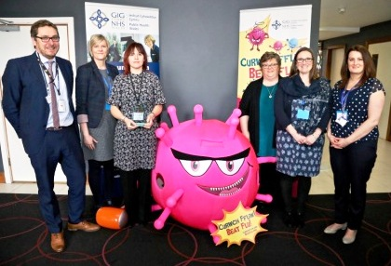
Pictured: Irfon Rees, Deputy Director, Public Health Division, Welsh Government with members of school nursing team (l – r) Clare Donoghue, Victoria Bailey, Joanne Jones, Elizabeth Churne and Mari Roberts.

Having the flu vaccination is very important for children explained ABMU Lead for School Nursing, Susan Anne Jones MBE.

Susan said: “It's important for any child or young person with a chronic condition that puts them in a high-risk group to be vaccinated as flu is likely to be more debilitating for them.
“It is important for children in the primary school programme themselves to avoid flu but evidence also shows this age group is the one which spreads the flu bug in the community. So being vaccinated helps to protect the whole community and especially the older generation who can be very poorly if they are infected. Remember it's just a nasal spray...no needle involved!”

Last season, school nurses were concerned by the lower than expected uptake in the vaccination the previous year, and realised the main problem was with the returning of signed consent forms giving permission for vaccination.

Operational Team Leader Vicky Bailey, along with the team embarked on a campaign raising awareness of the vaccination; handing out information and talking directly to pupils, parents and guardians.

“We realised the signed consent forms weren’t being returned for a number of reasons. Some parents weren’t aware the vaccination was available and why it’s important pupils have the vaccination. On other occasions pupils had either forgotten to give the form to their parent / guardian or to bring the signed form with them.

“By talking directly to parents and guardians we were able to explain how this simple, safe and effective spray could not only protect their child but also others members of the family. We also found it helped pupils to relax when they realised it isn’t an injection,” she said.

In case of further queries or concerns, the team left contact details at all schools so parents could phone them directly.

On vaccination days, where consent forms were forgotten the nurses phoned parents to gain consent, ensuring those pupils who wanted the vaccination didn’t miss out.

After hearing about the team’s success Susan said: “It is a very intense period of work to ensure we deliver the vaccinations ahead of flu starting to circulate in the winter. I'm so proud of all involved and grateful to our partners who are essential to support us to make the programme a success.

“The school nurses are all delighted to be recognised and truly deserve the award bearing in mind this is just one element of the public health role they fulfil supporting school aged children. They are our heroes!”

In the 2016/17 season the following children were eligible for the flu vaccination:
- Children aged 6 months and older who are at extra risk from flu because they have a long-term health condition, such as diabetes, heart or lung disease
- All children aged 2 and 3 years old on 31st August 2016 and 4 years old but not in school.
- All children aged 4 – 7 years old (reception class and years 1, 2 and 3 in primary school).
Further information about the flu vaccination can be found at www.abm.wales.nhs.uk/flu

Source: Abertawe Bro Morgannwg University Health Board

