Police bring fight against crime to Princess of Wales Hospital
Wednesday, 15 March 2017
Police have once again joined forces with ABMU as part of an ongoing crime prevention initiative across the main hospital sites.

Following on from a successful launch at Morriston Hospital, officers headed to Princess of Wales Hospital to raise awareness with patients, visitors and staff.

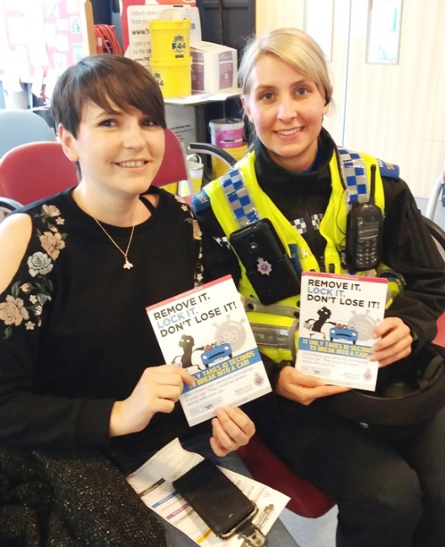
Members of the local neighbourhood policing team were on hand to give out crime prevention information while security staff joined the initiative by placing leaflets on vehicle windscreens in the staff car park.

ABMU’s Assistant Director of Strategy Des Keighan said: “This was the second vehicle crime prevention initiative and not only targeted visitors as they came into the hospital but also featured a leaflet drop on staff cars to highlight good practice for vehicle security

PCSO Bethan Owen provides information about car crime to visitor Aisha Chick

“Working with South Wales Police we will be looking to highlight a number of issues over the coming months.

“These include targeting violence and aggression, theft and home security when you are in hospital for an extended stay or on holiday.”

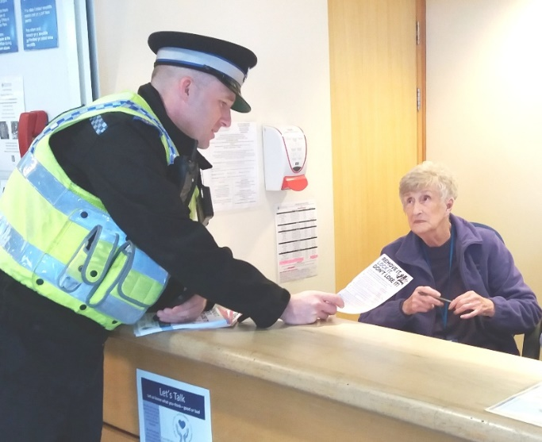
PCSO Richard Thomas hands out leaflets to reception staff at Princess of Wales Hospital

Debra Elward, crime prevention advisor with Bridgend Police, said: “While car crime isn’t an issue within the hospital, today’s event was all about raising awareness about how patients, staff and visitors can protect their property and why it is so important not to leave articles on display.

“We are keen on developing our partnership with ABMU.”

She also emphasised why crime prevention events like this were so important to the community.

“Prevention is far more cost effective than the cure so hopefully by raising awareness we will help stop patients or staff having to face the effects of car crime in future,” she added.
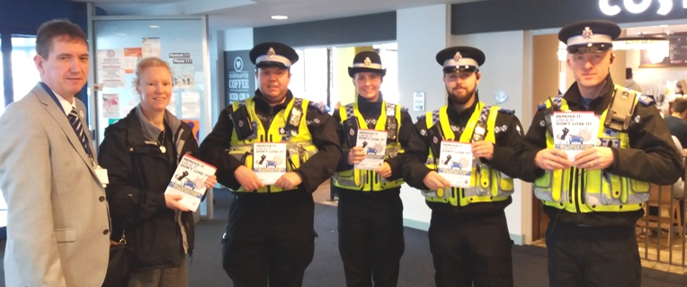

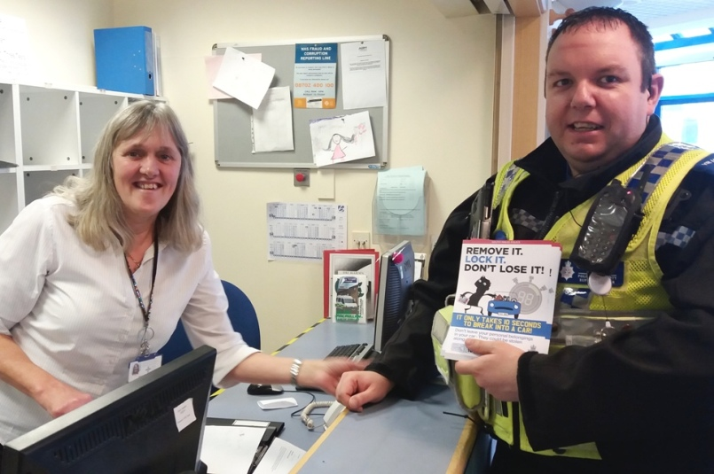
ABMU’s Assistant Director of Strategy Des Keighan and South Wales Police Crime Prevention Advisor Debra Elward with PCSOs Richard Thomas, Joel Hopkins, Bethan Owen and John Pegler and (right) outpatients receptionist Wendy Cook with PCSO Pegler.

Source: Abertawe Bro Morgannwg University Health Board

