Pilot project giving elderly patients a helping hand with independence
Thursday, 30 March 2017
An innovative project has been helping elderly patients stay more independent and active during their time in Neath Port Talbot Hospital.

Now the team involved in setting up an enabling service are about to share their findings after a successful four-month pilot scheme on the hospital’s Ward C.

Neath Port Talbot locality lead of occupational therapy Rob Workman said: “We know patients can quickly become institutionalised when they are in hospital. The provision of different levels of support by staff can not only increase this dependence, it can also limit rehabilitation and increase their length of stay.

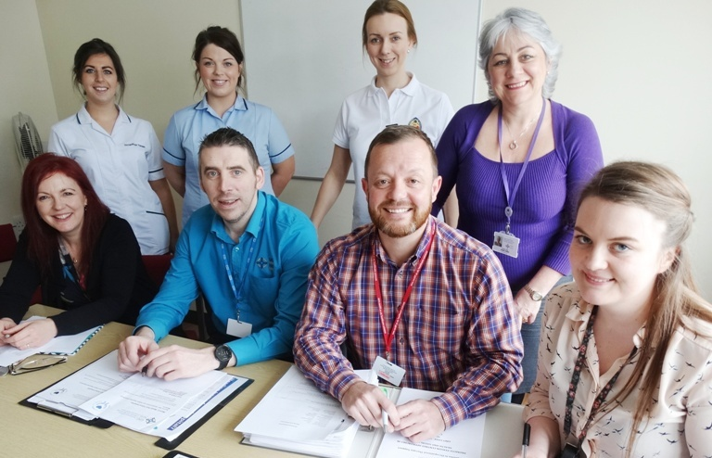
“We have had a multidisciplinary team working together since November to change the way we cared for those patients who were more able so we could give them more opportunities to engage in functional activities.“

Neath Port Talbot Hospital staff who were involved in the pilot enablement service including Rob Workman (sitting, second right).

During the project patients were screened by staff as soon as they came on the ward and those suitable for the enablement service were provided with therapy by members of this team.

This included encouraging them to get dressed, socialise away from their beds and become more involved in decisions about their discharge.

Funding for the pilot scheme was provided by Hospital Director Claire Birchall who was eager to see how an enabling service could benefit patients. It paid for Amy Jones to be seconded from her role as ward healthcare support worker to work as an enabling assistant.

Amy said: “I have thoroughly enjoyed being involved. Having already worked on the ward I knew the staff and was able to bring those relationships to the project. It has been a really positive experience.”

As part of the project the team set up a very popular breakfast club for patients who were able to leave their beds at mealtimes so they could enjoy being able to do routine tasks like pouring their own coffee and spreading their toast again.

Patient Meirwen Borthwick-Jones said: “It made us feel more human."

Another grateful patient said she “felt less ill” because she was able to wear her own clothes around the ward.

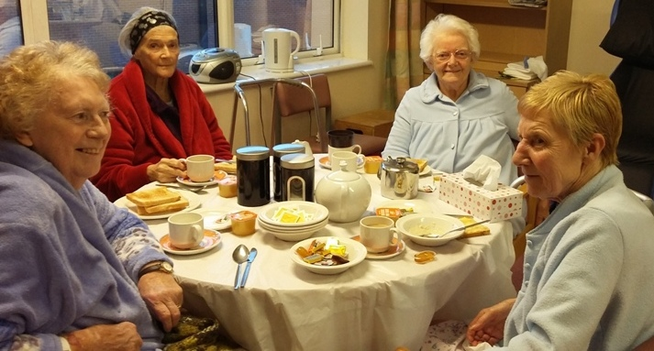
Rob said: “This isn’t all about therapies coming in and dealing with patients, this is about everyone working together on the project and finding what we can do to help them.”

A group of Ward C patients enjoying their breakfast club.

Besides Amy, the enablement team’s clinical staff were physiotherapist Sheree Breckon, occupational therapist Laura Moreton, pharmacist Aoife Flannagan and ward sister Allyson Hazel.

Also involved in the project were representatives from the hospital’s management and finance teams as well as the Patient Experience and Advice Service who have been collating feedback from patients and their families. This will be now included in a round-up of data to be presented to management this week.

“We will now be analysing our experiences for a full evaluation. However, initial data collection suggests that this has had a really positive impact on the patient experience on the ward.

“Eventually we would like to see if it is feasible to offer an enabling service on a more formal basis and for it to be rolled out to other wards,” said Rob.

Site manager Susan Jones said: “This has been such a beneficial experience for both patients and staff. There has been a positive impact on the length of time patients remain in hospital and on the amount of care they require at home.

“The patients have told us what a difference this approach has made to them and how they feel confident to manage at home. This has certainly been a whole team approach which has yielded very positive results.“

Source: Abertawe Bro Morgannwg University Health Board

