Patients turn to verse to express their loving gratitude
Wednesday, 29 March 2017
A book of poems co-written by patients at Morriston Hospital has been dedicated to the memory of one of its creative forces.

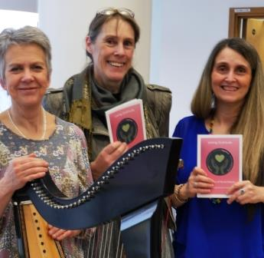
Loving Gratitude is a collaboration between patients in the hospital’s renal unit and award-winning poet and songwriter Cheryl Beer.

Pictured during the Loving Gratitude launch are (l-r) harpist Delyth Jenkins, ABMU arts in health coordinator Prue Thimbleby and poet Cheryl Beer

It came about as part of ABMU’s arts in health programme, which looks to incorporate the arts into all health board services for the benefit of patients as well as visitors and staff.

Arts in health coordinator Prue Thimbleby teamed up with renal services lead nurse Liz Baker to organise a project which would see Cheryl Beer work with patients having dialysis at Morriston Hospital.

Cheryl visited 56 patients over an eight-month period during their treatment, working one to one.

Prue explained: “She sat down to chat with patients, then took snippets of what they said and read it back to them as poetry.
“The patients didn’t actually put pen to paper. They talked to Cheryl and she took phrases and sentences so it became a poem between them.

“Often when Cheryl read the poem back to the patient they said things like ‘that’s exactly right – you have captured it perfectly’. It is effective because it is a shared writing process.

“It was incredibly successful and people have really embraced it – staff as well as patients.”

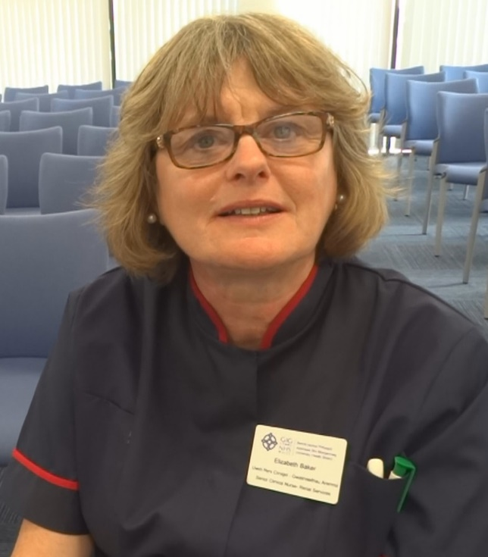
During the project a theme began to emerge – the overwhelming gratitude of patients towards their family and carers, to the medical teams, to having access to treatment and, ultimately, the gift of life.

Sadly, Liz Baker passed away last month after a short illness, just weeks before Loving Gratitude’s official launch at Morriston Hospital.

Barry-born Liz (left) was a nurse for 38 years, 32 of them spent at Morriston Hospital.

During this time she established and built up the network of renal services across South West Wales.

More recently, Liz led on the modernisation of facilities for rental patients in Morriston Hospital. She also helped develop an MSc syllabus at Cardiff University.

The anthology, subtitled The Poetics of Renal Dialysis, is dedicated to Liz’s memory.

The dedication reads: “Liz loved all the arts, especially poetry, and was instrumental in collating the poetic expression of the patients in her care into this collection.

“As a consummate nurse who loved her work, Liz never lost sight of the simple and precious things in the lives of the patients she served.”

Her family and friends were invited to the launch.

Liz’s sister Angela Baker said: “This wonderful book of poetry is a fitting tribute to our dear sister Liz, who dedicated her life to the care of her patients.

“She has left an incredible legacy with her work to improve the health and wellbeing of patients undergoing renal treatment across South and West Wales.”

A video explaining the project has also been filmed.

Prue said: “It captures what staff and patients thought about the project - how it enhanced their experience of coming to hospital and gave staff new insights into better supporting patients.”

Copies of the book are available from Prue (Prue.Thimbleby@wales.nhs.uk) for £3, with proceeds supporting future arts projects for renal patients.

Source: Abertawe Bro Morgannwg University Health Board

