Nurses’ efforts put them in the running for top awards
Friday, 17 March 2017
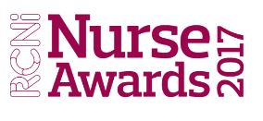
Two ABMU nurses have been shortlisted for honours at this year’s prestigious RCNi Awards which celebrate excellence in nursing care.

Melanie Davies, sister at Morriston Hospital’s Ward G is in the running for the learning disability nursing award in recognition of her hard work helping to develop an acute learning disability bundle for wards.

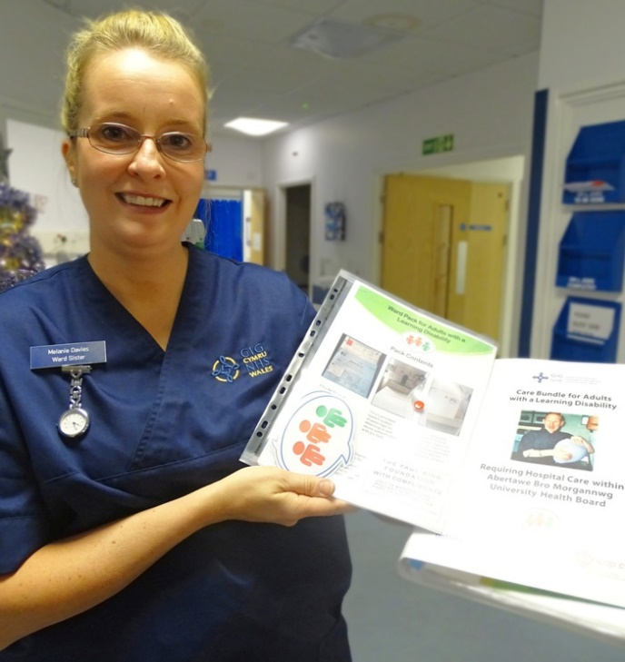
Melanie (pictured with one of the ward packs) is passionate about raising awareness of the needs of people with a learning disability when they come into hospital and has been closely involved in the development of the ward packs which have been rolled out across ABMU.

The packs contain guidance for staff as well as visual aids to help identify vulnerable patients.

She said: “I am a general nurse and I feel honoured to have got the final of award for learning disability nursing award.

“Over the past six years I have worked within ABMU delivering training to staff of how to care for patients who are admitted into hospital with a learning disability.

“This ensures they receive care of the high quality, that staff see the person not the disability and that reasonable adjustments are made so that their stay in hospital is a positive one. ”
Also up for an award is Johanne Vass, Macmillan sarcoma specialist nurse practitioner, who has been shortlisted in the innovations in your specialty category.

She set up a nurse-led one-stop diagnostic clinic for patients with suspected sarcoma – cancer of the soft tissue – held weekly at Morriston or Neath Port Talbot hospitals and in Hywel Dda University Health Board. This has not only improved the service for patients but also helped to free-up consultant time.
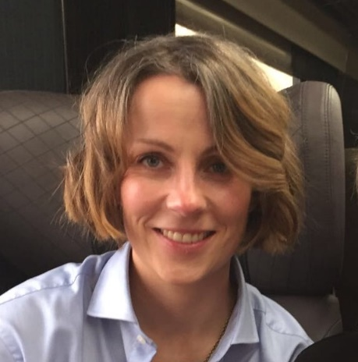
Johanne (right) said: “I am very pleased to have reached this stage of the awards.

“Since it was piloted in 2011 the clinic has seen 2,300 patients – I see up to 16 patients a week.

“Of the patients who attend, 60 per cent will be discharged, with advice, after assessment with the nurse.

“The other 40 per cent will go on to see a sarcoma radiology consultant and then, as appropriate, are either discharged or receive timely specialist treatment with early, relevant support and information.”

Johanne is hoping to add to her success last year when she won the Innovation Excellence Award at the 2016 Macmillan Excellence Awards.

The winners will be announced at a ceremony held at the Westminster Park Plaza Hotel in London on Friday 5th May.

Source: Abertawe Bro Morgannwg University Health Board

