New recruits celebrate success of apprenticeship scheme
Wednesday, 8 March 2017
ABMU has been marking Apprenticeship Week by giving a warm welcome to its first health care support worker apprentices as they start on their new careers.

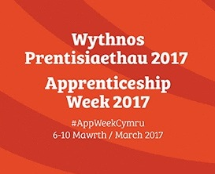
They are among a group of 30 young workers who have just joined the health board during its second successful wave of apprentice recruitment.

The HCSW apprentices are working on wards across Morriston Hospital while studying for a nationally recognised level 2 qualification.

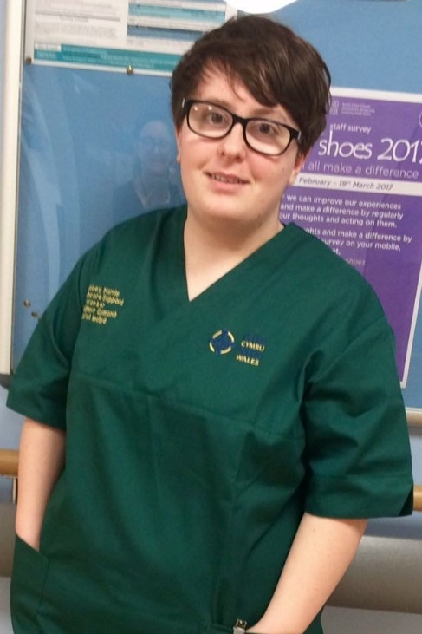
They include Stacey Harris (left) who said she was very excited to be starting her training. “I am looking forward to working alongside more experienced staff to learn the skills I need.”

Morriston Hospital’s Nurse Director Nicola Williams said: “I am thrilled to have them as part of my team. The apprenticeship will give them the skills, experience and a qualification to be able to apply for future roles and stay within the NHS.”

Other apprentices have been taken on in a variety of departments including pathology, outpatients, audiology, IT, neurophysiology, sexual health, pharmacy and patient feedback.

The aim of the health board’s apprenticeship scheme, which began in October, is to recruit staff and provide them with the skills, knowledge and experience to apply for permanent positions with ABMU.

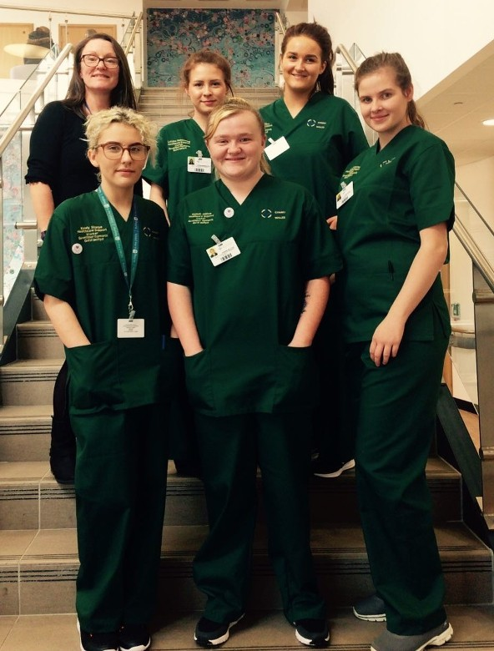
Learning and organisational development manager Ruth Gates (pictured right with HCSW apprentices at Morriston Hospital) said: “There are more than 80 qualification frameworks covering the 300 roles that we have in the NHS, so there really is something for everyone.”

She explained that apprenticeships develop new and existing staff, help make the most of a support workforce and can:

- improve patient care by demonstrating commitment to a career path;
- provide opportunities and recognition for all staff (clinical and non-clinical) including the development of transferable skills, resulting in increased flexibility of the workforce;
- support the expansion of national standards across the NHS; and,
- provide flexible training programmes and increased organisational efficiency and effectiveness.

ABMU is working closely with Neath Port Talbot College’s Pathways Training Team to develop appropriate qualification frameworks to recruit apprentices as well as offer existing staff opportunities to develop their skills.

There are three levels of apprenticeship:
- Level 2 – 12 months (Intermediate) Apprenticeship - equal to 5 GCSEs
- Level 3 – 18 months (Advanced) Apprenticeship - equal to 2 A Levels
- Levels 4 to 7 – 24 months (Higher) Apprenticeship - equal to a Foundation Degree
From next month the Government will be introducing an Apprenticeship Levy for large organisations to fund training for new recruits through the apprenticeship scheme and for existing staff. ABMU will be paying into this so is looking to change the way it recruits more apprentices.

Ruth said: “We are working with a number of departments across the health board, local schools and colleges to promote the opportunities that are available.

“There are also free training opportunities through the apprenticeship route for existing staff, with more than 100 staff enrolled on training in areas such as leadership and management, business administration, customer services, human resources, engineering and team leading.”

For more information about apprenticeships please contact Ruth Gates on 01792 530631 or email ruth.gates@wales.nhs.uk

Source: Abertawe Bro Morgannwg University Health Board

