Help us reduce £4 million waste medicines bill
Monday, 27 March 2017
Patients are being asked to help save millions of pounds each year in wasted medicines which end up being destroyed unused.
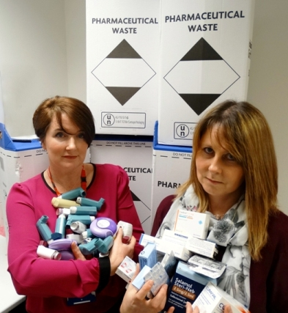
An estimated £4 million worth of prescription medicines are destroyed each year in Swansea, Neath Port Talbot and Bridgend because they aren’t needed.

In many cases, these were drugs ordered on monthly repeat prescriptions, stockpiled unused in people’s homes or returned to local pharmacies for disposal.

Last year ABMU spent £97.6 million on medicines prescribed by GPs and other community clinicians.

Unfortunately around £4 million of those drugs were wasted: £1.2 million worth left unused in patients’ homes; £1.4 million worth returned to community pharmacies and there was about £650,000 worth of unused drugs in care homes.

Unused medicines can’t be reused. They can’t go to another patient or be sent to a poorer country. Strict quality control rules around how they are stored and managed mean the only option is to destroy them if they aren’t needed after they’ve been dispensed.

Sometimes medicines aren’t used because patients don’t feel they are effective, or don’t like some side effects. If this happens it’s essential that their prescriptions are reviewed, to amend or remove medicines which are no longer suitable.

But in a lot of cases, many patients continue ordering all their medicines on repeat each month, even if they only use some of them from time to time.

ABMU Pharmacist and Prescribing Advisor Vanessa Morton, and Pharmacy Technician Liz Lloyd believe it’s because patients mistakenly think if they don’t order everything off a repeat prescription every time, the item will be removed.

In fact, patients don’t have to order all their medicines every month if they have enough. They only need to order what they need, and can be assured that items not needed won’t be removed from their repeat list.

It has emerged that the worst-offending group of wasted drugs are inhalers, some costing upwards of £42 each.

Other types of drugs which are consistently returned unused or underused include painkillers and laxatives.

Liz said: “Part of our job is to review waste in pharmacies and then plan how it can be minimised. It’s quite shocking to see what is actually wasted throughout ABMU.”

Vanessa said:

“We’re both part of the medicines management team, and we work with GP practices and with the local community pharmacies to look at whether the prescribing they are doing is appropriate.

“We need to be looking in all areas to try and improve this. And it’s the whole community which needs to be looking at this, not just us as pharmacists and doctors. It needs to be the patients that help us as well.

“We’ve got waste coming back in absolutely shocking amounts to community pharmacies. A pharmacy we recently visited, within six weeks, had six or seven big boxes of waste coming back from patients.”

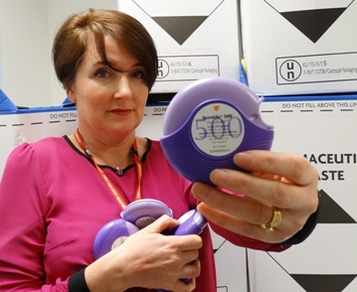
She said a recent audit looking at waste returned to pharmacies across ABMU identified a particular inhaler as the drug which contributed the highest single cost to the waste medicine bill. Used for COPD and asthma conditions, it has a price tag of £42.

She said:

“People are ordering it month-on-month and not necessarily using it. And it’s coming back to the pharmacies unused. I’ve seen six or seven boxes of it come back unused from patients when we’ve done patient visits to their home.

“A lot of people think when they have their prescriptions on their repeat prescription they have to collect them every single month. Now that’s not the case. They are not going to disappear off your repeat.

“The GP won’t take that off your repeat at all, it’s there for you. It’s just making sure that you don’t build up that waste. Just pause it for a couple of months and then restart it.”

She explained:

“Lots of medicines are ‘when required’ rather than every single day. These types of medicines don’t need to be ordered for most people every single month. Just get them when you need them. And it will help to go towards reducing some of this waste.”

Judith Vincent, Clinical Director for Pharmacy said:

“It is important that everyone involved, from the GP writing the prescription through to its dispensing, and more importantly the patient, understands why the medicine is needed, has agreed to its use and understand how to take it effectively.
“Medicines which are not used, or not used as intended, mean that patients will not gain their benefit and in addition unused medicines generate a significant amount of waste as they cannot be re-used.

“We all have a part to play in reducing medicine waste. As well as the actions above, there are other things you can do to help to reduce medicines waste overall, not just in the community, but in hospitals too.”

Some key messages for patients:

- Only order what you need on your repeat prescription. Pause reordering a medicine you don’t need right now; and only re-order it when you do
- Don’t stockpile medicines at home – it can lead to confusion, they can go out of date and can be dangerous if they fall into the wrong hands
- Get to know your medicines and how to take them. Speak to your pharmacist or doctor if you have any questions and take advantage of medication review appointments – regular review is essential and helps you get the best from your medicines
- Ask your community pharmacist to undertake a Medicines Use review with you – this is a free, confidential service
- Tell your GP or pharmacist if you are having problems with any medicines or do not need them anymore, or are not taking them.
- More expensive medicines are usually no better than cheaper alternatives – money saved by using the most cost effective medicines goes back into the NHS so more people can be treated
- Use healthy lifestyles to look after your health as best you can – medicines are not always the answer
- Help us protect our antibiotics by only using them when essential. Resistance is a serious threat now and in the future, so don’t expect antibiotics for simple coughs, colds and sore throats – you probably don’t need them and could end up with unwanted side effects
- If you go into hospital take your medicines and the most recent list of repeat medicines from your GP with you. You should also include any medicines you buy over the counter and herbal medicines/vitamins
- On the ward the pharmacy team will introduce themselves to you and will look after your medication requirements during your stay. They will provide any help you require to ensure you understand all of your medicines.

Source: Abertawe Bro Morgannwg University Health Board

