First in Wales Children's Rights Charter puts young people centre stage
Tuesday, 21 March 2017
Children are being put centre stage with the launch of a pioneering new charter setting out their rights when they use ABMU services.

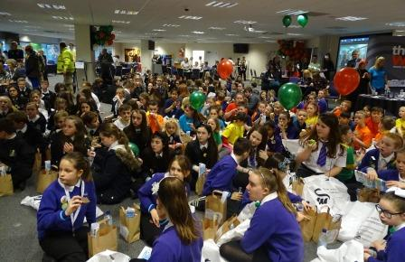
They have worked with the health board and its partners to develop the charter, based on the United Nations Convention Rights of the Child.

It’s the first of its kind in Wales and the first in any health organisation within the UK.

The UN Convention sets out what children need to survive, grow and fulfil their potential.

Information, safety, respect and privacy and confidentiality are among the rights covered by the charter.

ABMU’s Children’s Rights Charter was launched at an event in Swansea this week, attended by around 200 children from schools across Bridgend, Neath Port Talbot and Swansea.

There was a full programme of activities, while guests were treated to a fantastic medley of Les Miserables songs by pupils of Ysgol Maes Y Coed in Neath.

As well as the charter, the event also saw the launch of ABMyouth, an advisory panel made up of young people aged 13-22 from across the health board area.

They will find out the views of children and young people about health services provided by ABMU, and ensure those views are passed on to the board to bring about improvements.

Guests at the launch included Chief Nursing Officer for Wales, Jean White, who described it as an exciting development.

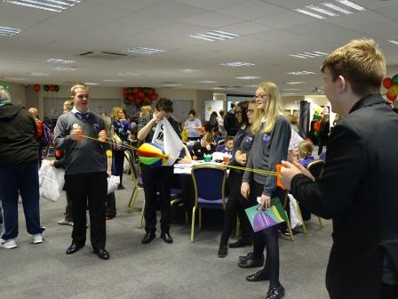
She said: “We want to see the rights of every child and young person in Wales respected so they can fulfil their potential.”

A draft ABMU charter was launched at the health board’s second annual Children’s Conference in November 2014.

Youth councils from the Bridgend, Neath Port Talbot and Swansea areas helped develop it, along with children and young people receiving care and paediatric nursing, play and community staff.

Head of Nursing for Neonates, Children and Young People Eirlys Thomas said: “Following the conference we did some further consultation with the children and young people.

“We prepared several further drafts of the charter before finalising it ready for today’s launch.

“As part of the process we also set up ABMyouth, and have already recruited 10 members aged between 14 and 21, and we are looking for others to join.

“It’s early days yet and we will be drawing up a work programme and terms of reference, but they are all very enthusiastic and committed to ensuring we meet children’s rights.”
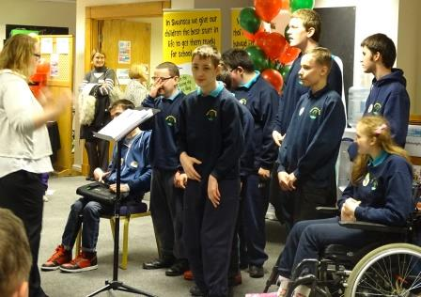
ABMU has worked with the Wales Observatory children’s rights unit at Swansea University as well as third sector organisations and local authorities to develop the charter.

ABMU Chairman Andrew Davies said: “As Chairman, I gave a commitment in 2013 that we would draw up a charter for children as part of our policy of being a rights-respecting organisation.

A Les Miserables medley courtesy of pupils from Ysgol Maes Y Coed

“I am delighted to see this commitment being put into practice and us putting children at the heart of our services.”

Professor Rory Farrelly, ABMU Director of Nursing and Patient Experience said: “This is an exciting time for children in the health board area as we have committed to set out clearly what they can expect when they use any of our services.

“These standards were develop by putting children first and allowing them to decide how they should be presented.

“As a children’s nurse it makes me proud that ABMU is leading the way with this approach.”

ABMU non-officer member and Neath Port Talbot Council for Voluntary Service Executive Director Gaynor Richards has been closely involved in developing the charter.

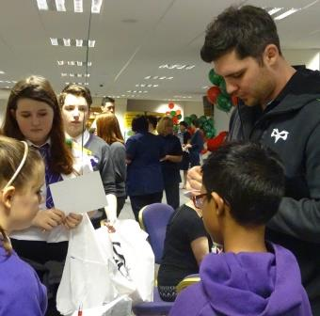
Speaking at the launch she said: “This is one of the most important days in the history of the health board.

“Seeing all the children here today makes it very real that ABMU has made a commitment from the highest level to put young people at the heart of the services we deliver to them.”

Right: Ospreys star Rob McCusker signs autographs for young fans at the launch

However, Eirlys Thomas explained the launch was far from being the end of the process.

“Really, now the hard work starts. It’s making sure that the children’s agenda is firmly on the health board’s list of priorities.

“We want to develop ABMyouth and we need to assess where we are in terms of implementing children’s rights in all healthcare settings.”

You can find our Children’s Rights Charter page here

Source: Abertawe Bro Morgannwg University Health Board

