Dom Squad shapes up to waist reduction challenge
Tuesday, 21 March 2017
A team that helps reduce medicines waste now aims to reduce waist sizes in support of a worthy cause.

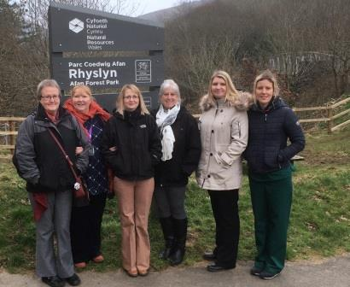
Nicknamed the Dom Squad, they are six colleagues working in medicines management within the domiciliary care service for Neath and Port Talbot.

They wanted to improve their fitness and set themselves a walking challenge to help get into shape.

As they are frequently in contact with people, families and carers affected by dementia, the Neath-based team decided to raise awareness and money at the same time.

The result is a half-marathon walk in the scenic Afan Valley next month, with proceeds going to the Alzheimer’s Society.

Jane Chilvers, Donna Jones, Eithwen Morgan, Terry Saunders, Rachel Davies and Hannah Waters (pictured l-r above) have set up a JustGiving page with the aim for raising £1,000 for the charity.

On Saturday 29th April they will walk 13 miles, setting out from Rhyslyn and walking along the Afan Argoed track to Cymmer and back – then continuing on to Cwmavon for a well-earned celebratory lunch.

Donna explained: “We all wanted to get fitter – part of our work involves medicines waste management but we felt we needed a little waist management!

“We did struggle for motivation and decided we needed a challenge.

“We felt making a commitment to raising funds for a cause dear to our hearts would give us all the motivation we needed.

“Although we looked at different organised walks, in the end we decided to do our own.”

Domiciliary care involves supporting people to live in their own homes, and as part of this work the team is often in contact with those with dementia as well as their families and carers.

“But also we have personal experience of friends and family who have had to live with dementia,” said Donna.

“It’s something people didn’t really want to talk about in the past but they’re much more open about it now.

“Everyone will come into contact with dementia at some point in their lives.

“Perhaps not directly but it will have an impact on their family and social circle. So it’s about raising awareness as well as funds.”

The team is based in Cimla Hospital, where they will be hosting a cake sale for colleagues on Wednesday 5th April to help boost the total they raise for the Alzheimer’s Society.

If you want to support the Dom Squad’s half marathon walk, go to: https://www.justgiving.com/fundraising/Dom-Squad2017

Source: Abertawe Bro Morgannwg University Health Board

