Children’s centre staff celebrate double donation
Thursday, 16 March 2017
Panto favourites are still doing their bit to help bring a smile to children’s faces, long after the curtain came down on their latest show.

A total of £1,200 raised during Jermin Productions’ run of Dick Whittington at the Princess Royal Theatre in Port Talbot has been donated to the Children’s Centre at Neath Port Talbot Hospital.
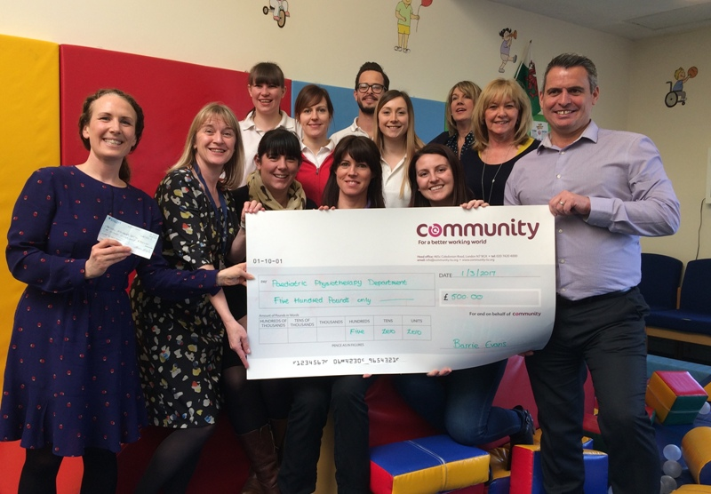
Clinical lead paediatric physiotherapist Rebecca Kennedy (left), head of speech and language therapy Alison Clarke and therapists and staff from the children’s centre receive the cheque from steelworker Barrie Evans, branch secretary of Community Union.

Tata Steel nominated the centre to receive funds raised by actors and staff and the donation is being used to buy equipment for its young patients.

The centre was also given an extra boost by steelworkers when Barrie Evans and Alun Davies, from the Community Union, visited to present a cheque for a further £500 from union funds.

Rebecca Kennedy, clinical lead paediatric physiotherapist, said: “We are enormously grateful to Tata for nominating the centre and to Jermin Productions for their efforts and support during the pantomime season.

“The funds raised will be put to great use, purchasing new equipment that will support the therapy provision offered to children attending the centre.

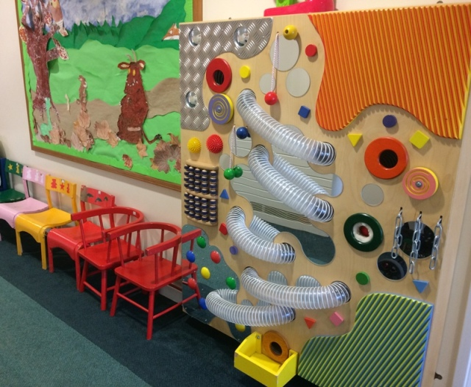
“It is always rewarding to hear that our services are valued in the community and we are pleased to able to work as part of such a positive partnership.”

Branch secretary Barrie said: “It’s great to work in partnership. The union, steelworkers and their families are grateful for the support they have received from ABMU and the children’s centre.”

Head of speech and language therapy Alison Clarke said: “Barrie was so generous with his thanks for the health board for its support and also reflected on how the therapists at the children’s centre had provided excellent care to children and the families of local steelworkers.”

Alun, who is the union’s regional organiser, added: “We look forward to continuing to support the centre in the future.”

Source: Abertawe Bro Morgannwg University Health Board

