ABMU specialist helps breast cancer patients in Africa
Friday, 3 March 2017
A specialist from ABMU will be helping women in Africa who suffer from a debilitating condition caused by breast cancer.

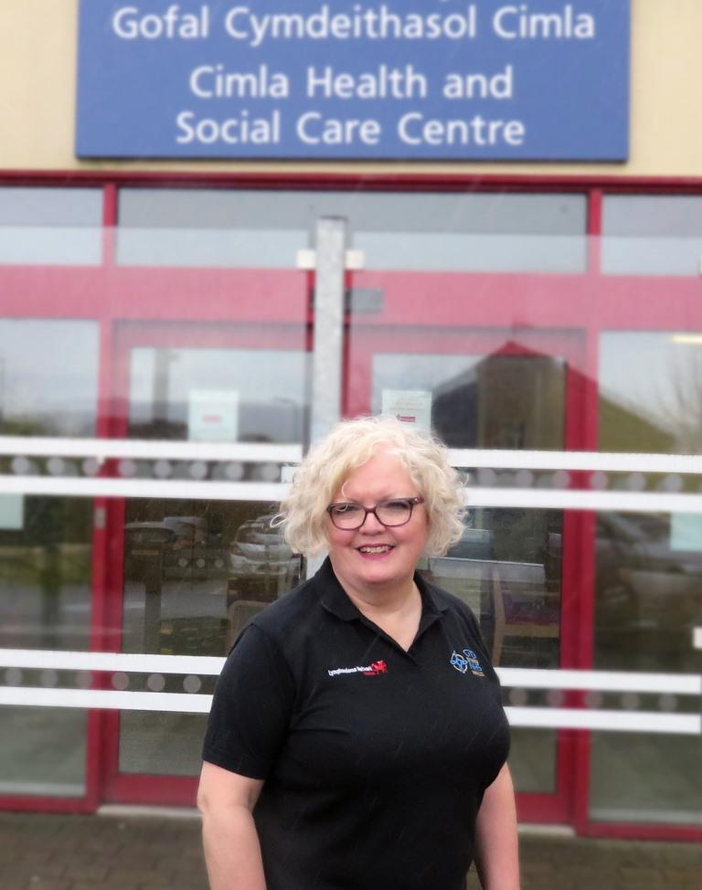
A specialist from ABMU will be helping women in Africa who suffer from a debilitating condition caused by breast cancer.

Elizabeth Coveney (pictured) was asked to join a team from Velindre Cancer Centre which will spend a week in Sierra Leone, setting out this weekend.

The team, made up of breast surgeons and oncologists, invited Elizabeth to join them because of her expertise in lymphoedema.

This is chronic swelling that develops because the lymph nodes or vessels are damaged or blocked, leading to a build-up of fluid in the tissues.

It is caused by damaged or removed lymph nodes following cancer treatment or surgery, as well as non-cancer conditions.

The accumulation of lymph fluid can lead to swollen limbs that leak fluid, decreased mobility, pain, anxiety and depression and frequent admission to hospital with cellulitis.

Elizabeth is based at Cimla Hospital in Neath and is the National Paediatric Lymphoedema Lead in Wales.

She and the team will be leaving for Sierra Leone on Saturday (4th March), returning eight days later.

Elizabeth said: “Women in Sierra Leone present with breast cancer in the advanced stage which means they have also developed lymphoedema.

“The team realised it would be useful to have someone with them who specialised in lymphoedema.

“I have never done anything like this before. The invitation came out of the blue but I knew straight away I wanted to do it.”

Elizabeth said she aimed to teach clinicians in Sierra Leone some simple self-management strategies that they in turn could teach their patients.

One is a self-bandaging technique that women can use for support and comfort at night.

“You won’t get outstanding results but it will give some relief for the weight of the arm, which can feel very heavy. It may also help stop it progressing as quickly,” said Elizabeth.

“This is relief they wouldn’t otherwise have had, and it’s something they can do for themselves.

“I will be taking some bandaging material, which the women can wash and reuse so they should last for a very long time.

“I am delighted to have this opportunity to support my colleagues in Sierra Leone in the management of this very debilitating and disabling condition.”

Source: Abertawe Bro Morgannwg University Health Board

