Roger named national NHS star for going beyond the call of duty
Friday, 22 June 2018
A very special award has been bestowed on a Morriston Hospital worker who has helped transform the lives of countless children over the years.

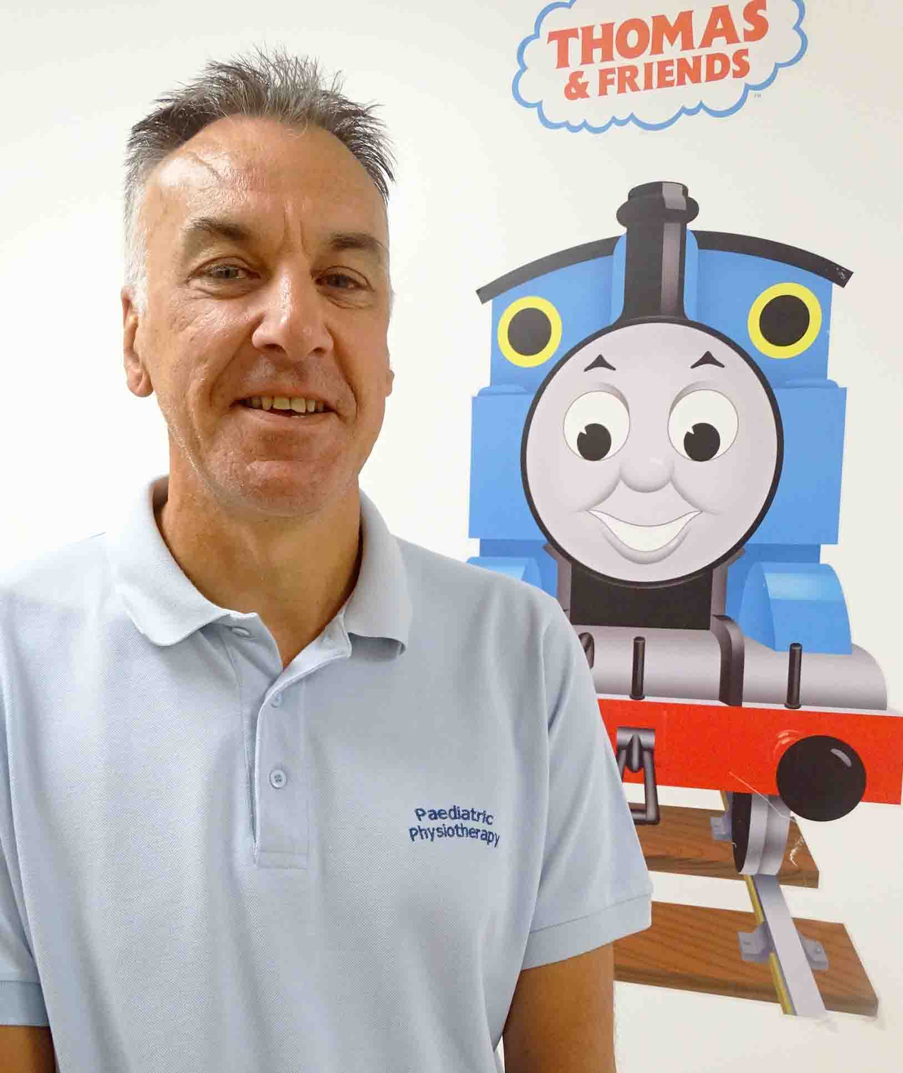
A very special award has been bestowed on a Morriston Hospital worker who has helped transform the lives of countless children over the years.

Paediatric physiotherapy assistant Roger Hurford has been recognised as a national star as the NHS prepares to celebrate its 70th anniversary.

The NHS Confederation announced its Health and Care Top 70 Stars during its annual conference and exhibition in Manchester this month.

Roger was invited to the event, along with ABMU’s clinical lead paediatric physiotherapist Rebecca Kennedy, who nominated him.

Roger joined the NHS in Swansea 20 years ago, starting out as a healthcare support worker in the renal department.

But for the last 16 years he has worked with children admitted to the paediatric ward – where he has certainly made a difference.

Rebecca said: “Roger develops a real bond with the children and their families.

“He often goes beyond the requirements of his job role to support the youngsters to get back home.

“In recent months he has supported colleagues looking after children whose behaviour is very challenging.

“He is highly skilled in managing these situations, which he does by discovering the children’s likes and passions – I’ve even seen him sing Elvis songs and do all the dance moves.”

Modest Roger said he knew Rebecca had nominated him for the award, although he wasn’t quite sure why.

“I was only doing my job, and it’s a job I love doing.

“I’ve got children of my own and I work with children through sports and social activities outside of the hospital.

“I really enjoy my work. Nine times out of ten it’s a happy outcome. I just thoroughly enjoy making children better again and you have a bit of fun as well.

“I’m not one for a lot of fuss but it’s a nice feeling, to be recognised by your colleagues and by families.

“It’s a fairly unique award because of the 70th anniversary and that’s what makes it so special.”

Rebecca added: “I have seen Roger moved to tears on occasions where children have achieved the unexpected. We are very lucky to have him in our team.”

Source: Abertawe Bro Morgannwg University Health Board

