Cardiac team up for two awards for putting patients at the heart of care
Monday, 4 June 2018
Putting patients at the heart of their care has put specialist staff at Morriston Hospital in the running for two top awards.
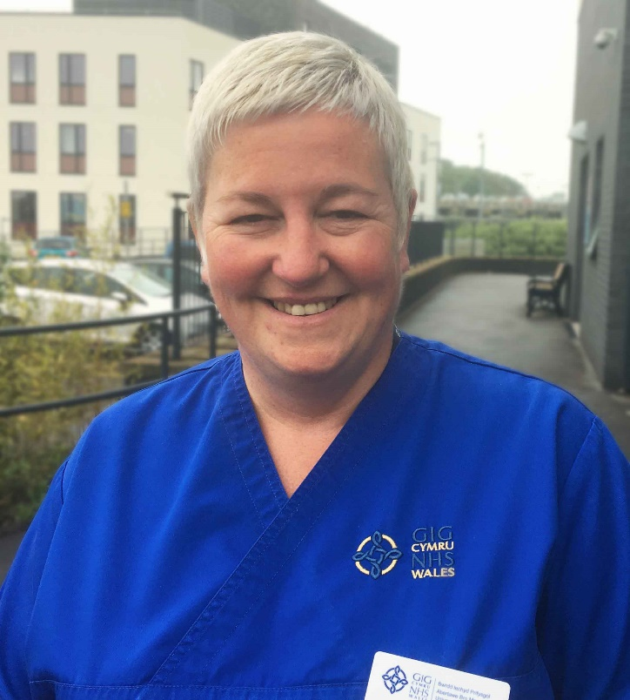
The cardiac unit’s electrophysiology team has been shortlisted in the Integrated Care category at the British Heart Foundation Alliance Awards.

Team member Nerys Ubsdell (left) is also a finalist, in the Rising Star category – with the winners of both to be announced tomorrow night. (TUES 5th June)

The electrophysiology team cares for patients diagnosed with, or at risk of, arrhythmias – abnormal heart rhythms – and those with severe heart failure.

The team was nominated for the BHF Alliance Award for the way it has redesigned services for people diagnosed with atrial fibrillation.

AF, as it is usually known, is the most common form of arrhythmia, and it is increasing.

Senior chief cardiac physiologist Paul Rees said: “The nomination described our work of detecting AF early in patients who happen to have a pacemaker, and then are treated more quickly.

“The other aspect of the service improvement related to providing patients and their family with education and support in pre-AF ablation, which is a specific treatment for AF.

“We moved from individual clinic consultations to group education sessions.”

Arrhythmia nurse Wendy Churchouse added: “This change was based on patient feedback, in that they wanted the opportunity to meet other patients in a similar situation.

“The team has worked hard to bring in these changes, which have not required additional investment but are so much better for our patients.

“We simply listened to our patients.”

Meanwhile, Nerys Ubsdell has been nominated in the Rising Star category for her work in the community.

GP surgeries have a register of patients with coronary heart disease or who have been diagnosed with heart failure.

Previously these patients may not have met the criteria for referral for a complex cardiac device such as an ICD – implantable cardioverter defibrillator.

However, the criteria changed a few years ago so Nerys goes to surgeries and checks the registers to identify any patients who may now be eligible.

They are then invited to a screening clinic either in Morriston Hospital or in the GP surgery.

Nerys said she felt honoured to have been nominated for the award.

“I’m part of a strong, proactive team committed to working together to support patients.

“We are constantly trying to improve services and we pride ourselves in acting on what patients tell us.”

The BHF Alliance Awards is an annual ceremony celebrating the work of professionals across the UK in improving care for patients with, or at risk from, heart and circulatory disease.

This year’s ceremony takes place in Manchester.

Source: Abertawe Bro Morgannwg University Health Board

