Cardiac specialist nurse Gemma's first in Wales achievement
Friday, 29 June 2018
A specialist cardiac nurse at Princess of Wales Hospital in Bridgend has become the first in Wales to qualify to carry out ultrasound heart tests.
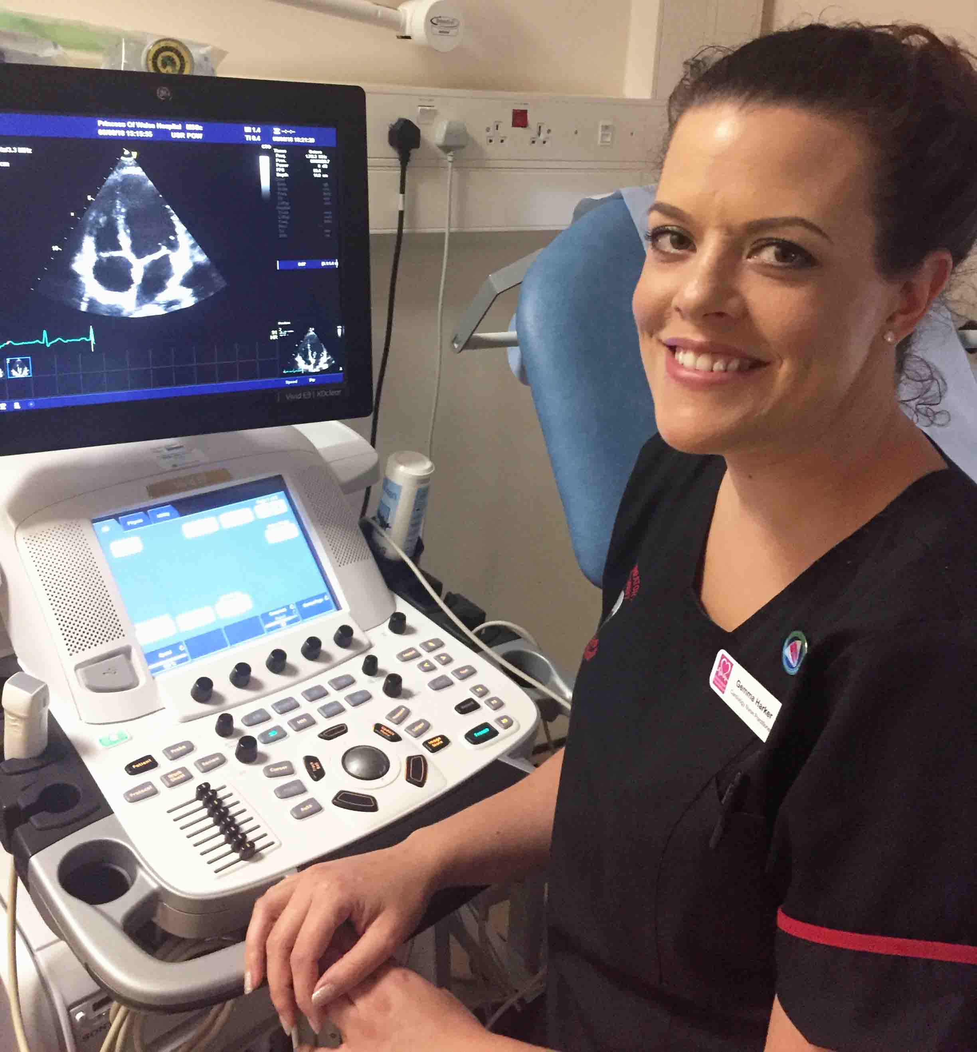
Gemma Harker is one of only a few nurses anywhere in the UK to receive the British Society of Echocardiography (BSE) accreditation.

Gemma has been working in cardiology for more than 12 years.

Her role as a cardiology nurse practitioner, or CNP, has ranged from assessing patients arriving in the Emergency Department with cardiac problems to running a variety of clinics.

Along with three other cardiology nurse practitioners at POWH, Gemma set up the emergency access clinic. This is for patients who don’t need to be admitted to hospital but need urgent follow-up by cardiology.

It’s a one-stop clinic, where patients can have their tests urgently, and get reviewed and treated all on the same day.

Gemma said: “One of the most common tests required is an echocardiogram, or echo.

“This is an ultrasound of the heart, used to assess for any cardiac structure abnormalities, diagnose pathology or follow-up patients known to have cardiology disease.”

Gemma’s role also involved supporting consultant cardiologists with some of the more specialist diagnostic tests.

These include stress echocardiograms – an ultrasound scan combined with an exercise test to assess for coronary heart disease.

In November 2015, Gemma and highly specialised cardiac physiologists Jennifer Torkington and Hugh Pascoe extended their professional roles by setting up the first physiologist/nurse-led stress echo clinic in Wales.

This innovative clinic improved waiting times for patients. Gemma also wrote a protocol so she could give contrast injections independently.

Gemma said: “I’d gained a keen interest in echocardiography and realised the potential to develop our services more. So I inquired about the possibility of training in echocardiography.

“This is almost unheard of. I know of only a few nurses throughout the UK who have gained or are working towards accreditation.

“I wanted to gain full BSE accreditation as it’s a measure of gold standard practice in echo training. This would mean I could scan and report echocardiograms independently.

“I am so grateful my colleagues recognised and supported my drive to widen the scope of practice as a CNP.”

The BSE accreditation process is a Master’s level education programme and involves an extensive period of study.

Gemma had to sit a theory exam and then, over an extended period, compile a logbook as evidence of a wide range of experience.

She also had to prepare five video cases for a practical exam day, during which she also had to perform an echocardiogram before an adjudicator.

“It is a huge achievement being the first nurse practitioner in Wales to gain full accreditation in echocardiography.

“I am proud of what I have accomplished personally, but also professionally.

“Nursing is ever changing and evolving. I am excited for the future and feel proud to be opening up new avenues, widening the scope of nursing practice.

“It’s refreshing to see that boundaries can be pushed and services can be developed with hard work and dedication.

“More opportunities for further education and advanced roles are available for those who wish to push themselves and find new ways to improve patient care.”

Since gaining accreditation, Gemma is scanning almost daily, building her knowledge and experience, as well as continuing her role as specialist nurse in stress echo clinics.

She also hopes to expand her role further in the future with valve disease follow up and contrast echo.

She thanked colleagues for their support, including cardiology consultant Dr Cristina Constanin, the team of cardiac physiologists, especially Jennifer Torkington and Hugh Pascoe, and lead nurse Catherine Theron.

Gemma added: “Their expertise, time and energy helping me through the accreditation process has been greatly appreciated.”

Dr Constantin said: “Since working in the department, Gemma has developed a passion for echocardiography and passed her theoretic BSE examination with flying colours.

“This is a wonderful example of how dedication and focused effort can lead to successful career development.

“I am sure Gemma’s extraordinary achievement will prove inspirational for all her nursing and physiology colleagues.”

Source: Abertawe Bro Morgannwg University Health Board

