Swansea transplant unit marks 20th anniversary with £800,000 expansion
Tuesday, 20 June 2017
A service which has treated hundreds of people over two decades in Swansea is marking its 20th anniversary with an £800,000 expansion.
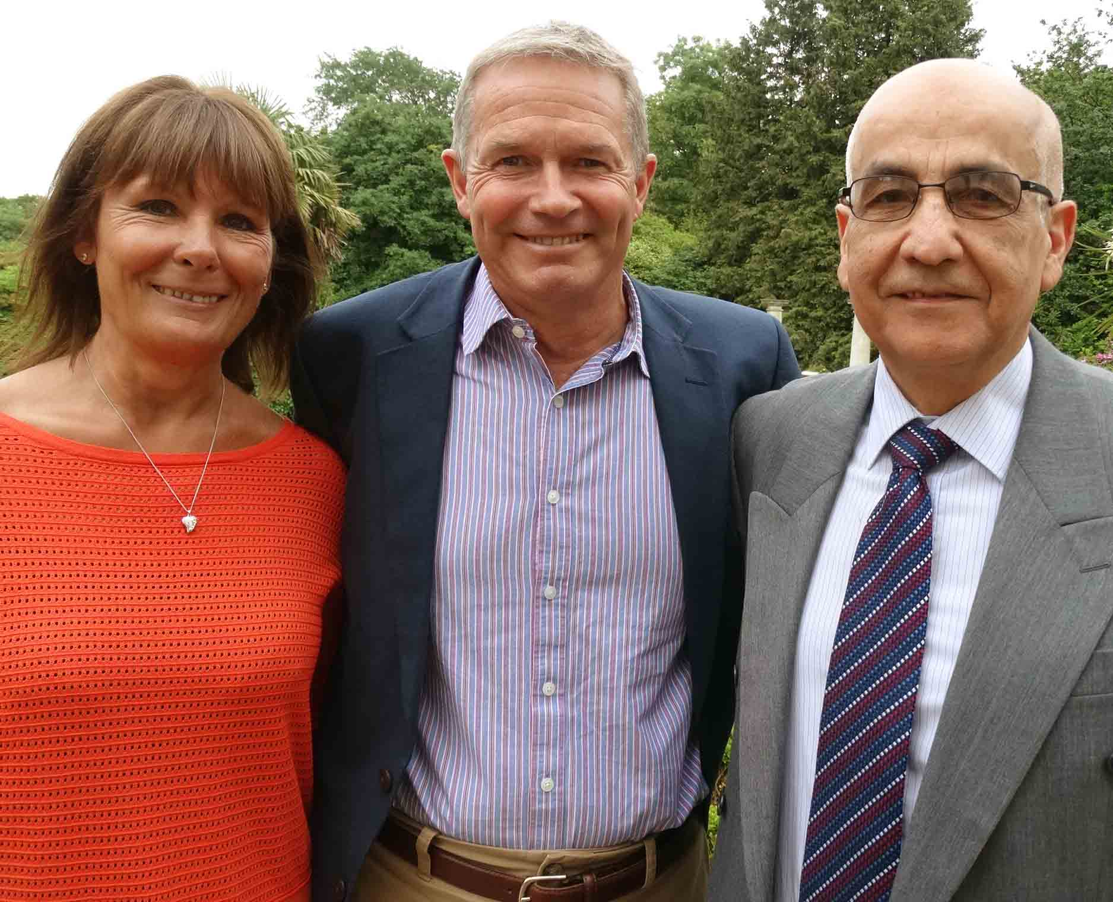
The Bone Marrow Transplant Unit was established in Singleton Hospital in 1997 following a campaign by patients who until then had to travel to Cardiff.
Keith Pearman (centre) with wife Karen and Dr Saad Al-Ismail
Over the years it has gone from strength to strength, more recently joining with Cardiff to offer a regional service that will see more people receiving bone marrow transplants in Swansea than ever before.
Among the almost 300 patients who have been cared for in the BMT unit is Keith Pearman from Llanelli.
Keith was diagnosed with Non-Hodgkin’s Lymphoma in February 1994, just 15 months after tying the knot with wife Karen.
He underwent several courses of chemotherapy in Singleton Hospital and had periods of remission over the following six years.
But in 2001 the disease returned with a vengeance, requiring aggressive chemotherapy followed by bone marrow transplant using Keith’s bone marrow stem cells, which had been harvested and frozen years before.
During a celebration to mark the Singleton unit’s 20th anniversary, Keith said: “The fact that I’m here talking to you now is testament to the unit and all the staff involved.
“It cannot be an easy place to work. All the staff there, every single person involved, I cannot praise them or thank them enough. They saved my life.”
A stem cell (bone marrow) transplant involves replacing damaged blood cells with healthy ones. It’s used to treat a range of conditions affecting blood cells such as lymphoma and leukaemia.
The high-dose chemotherapy damages the bone marrow, leaving the patient highly vulnerable to infection until the transplanted stem cells have had time to repair this damage.
Stem cell harvesting is done in Cardiff in one day but the transplants take place in the Singleton unit, which has all the necessary facilities, involving an inpatient stay of around three weeks.
But pre-1997, patients from Swansea and South West Wales not only had the harvesting but the transplant carried out in Cardiff.
Consultant haematologist Dr Saad Al-Ismail, who leads the service at Singleton, said: “Patients couldn’t understand why they had to spend three weeks in Cardiff.
“We were already treating the diseases. We had the nursing and medical expertise. So adding bone marrow transplantation was not a big undertaking.”
Meanwhile, Cardiff was struggling to meet the demand from across South Wales. Patients were waiting for beds to have transplants, and often their condition deteriorated while they were waiting.
Dr Al-Ismail said: “The demand was for the service to expand. But Cardiff could not expand so Swansea was the obvious choice.”
A vital contribution to Singleton’s ability to provide the service was its two-bed laminar airflow unit which provides a sterile environment for patients while the stem cells repair the bone marrow.
It opened in February 1991 in memory of Petra Gates, a young lady who, in 1988, developed an illness affecting her bone marrow.
When no suitable donor could be found, the Swansea team began a course of treatment which sadly did not prove successful.
However, Petra’s family was so grateful for the care she received that they organised a fundraising campaign to pay for the unit.
The BMT Unit is a self-contained area where patients are nursed on a 1:1 or 1:2 basis, ensuring they have the necessary level of care while they progress through the transplant process.
Swansea specialises exclusively in autologous transplants, where the cells are the patient’s own – as opposed to allogenic, which uses donated cells.
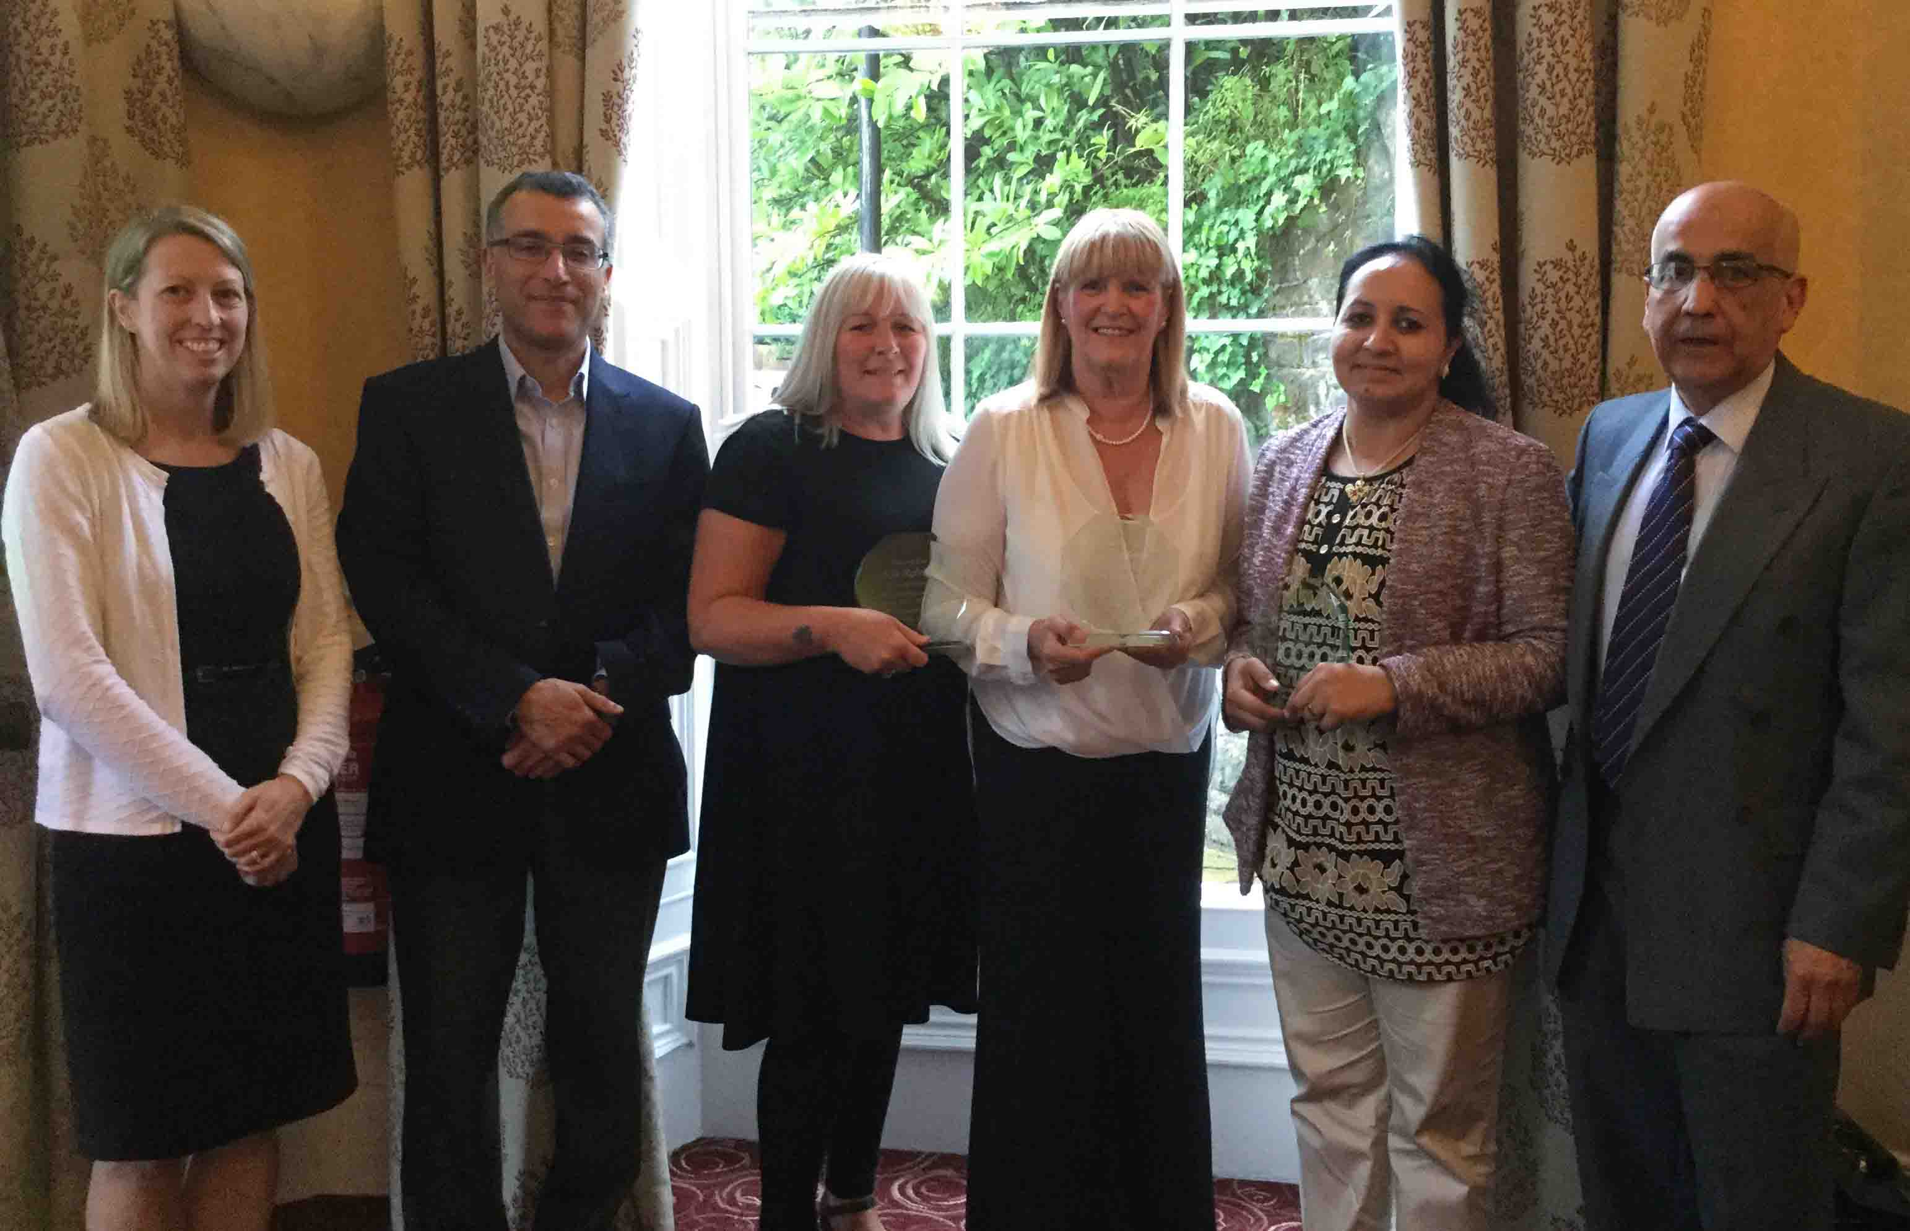
l-r: Dr Wendy Ingram, consultant haematologist, University Hospital of Wales and Dr Hamdi Sati, ABMU consultant haematologist, who both spoke at the anniversary event; testimonial recipients Nia Roberts (who also spoke), Lynda Bray and Sheeja Mathew; Dr Saad Al-Ismail

Since starting in 1997, the unit has treated almost 300 patients. Some of them, along with past and present staff and others involved in the service’s development, attended the anniversary lunch.
Testimonials of appreciation were also presented to three staff for their outstanding services to the bone marrow transplant service at Singleton.
They were Nia Roberts, clinical nurse specialist and ABMU BMT coordinator; Lynda Bray, day unit and BMT Unit manager on Ward 11; and BMT nurse Sheeja Mathew.
Of course there have been changes over the last 20 years – not the least of which was the coming together of Swansea and Cardiff to form a single regional service in 2011.
Dr Al-Ismail said the main reason for this was the steady increase in bone marrow transplants across Britain and Europe.
“It was clear it would be in everyone’s interests that the two services should be combined.”
The increase is reflected in the fact that Swansea, which did fewer than 10 transplants in 1997, has been doing 30 a year since 2011.
The Welsh Health Specialised Services Committee, which commissions the BMT service, has now approved increasing this to 50 a year.
It also approved a £793,000 investment for an expansion of the Singleton BMT unit, which will include new facilities such as extra cubicles as well as additional specialist staff.
Dr Al-Ismail said: “It started as very much a local service for Swansea and Neath Port Talbot and has now moved to a regional service, which means we can treat more people than ever before.”

Source: Abertawe Bro Morgannwg University Health Board

