Retirement sees receptionist leave former home behind
Wednesday, 28 June 2017
Margaret James won’t just be leaving a workplace behind when she finishes her final shift at Swansea’s Central Clinic on Friday, she is saying goodbye to her old home.
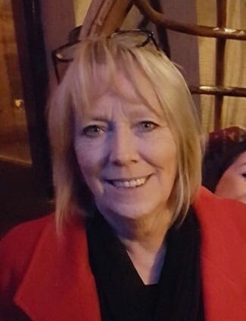
She was just a teenager back in 1968 when her father Irfon Morgan took up his job as caretaker of the building in Orchard Street and moved his family into its top floor flat.

“I remember living there with my mum and dad very well, it was a lovely flat, very roomy and we were very happy,” said Margaret who is retiring from her dual roles as receptionist with the Community Dental Service and Community Mental Health Service.

Margaret first began working for the health service back in 1969 but didn’t have far to go to work. Her job saw her manning the reception desk at Central Clinic.

“It was so easy, I just rolled down the stairs and straight to work. My mum Gwennie worked for Swansea Council then and was based in the building too so all three of us were working under the same roof.”

Her father was a familiar figure around the building until he sadly died in the flat a few months before he was due to retire.

Margaret, who now lives in Fforestfach, eventually went on to work in child health and several other departments before leaving in 1978 to have her daughters Catrin and Nerys. But she was back at Central Clinic by 1989 and has been there ever since.

“I have loved working here. The flat is now offices but I never go up there. I like to remember it as it was.”

The building also holds a special place in the heart of her daughter Catrin.

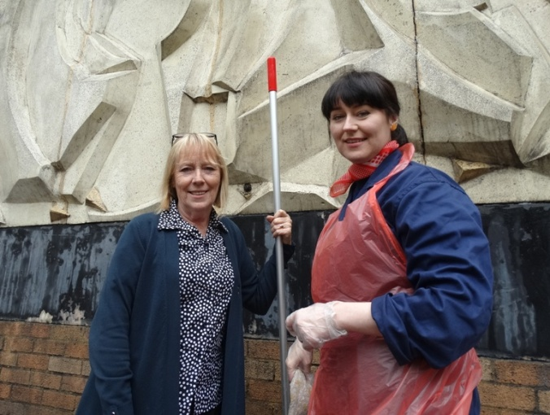
She was the artist whose original Guerrilla Restoration project was the inspiration behind a high-profile clean-up of the distinctive mural artwork on the building’s facade by ABMU’s Heritage Group earlier this year.

Margaret looked on proudly as her Catrin (left) worked with volunteers to bring it back to its former glory.

Margaret is now looking forward to spending more time with her grandson Ioan, gardening and hopes to do voluntary work.

After a 49-year association with the building her colleagues in both departments say Margaret will be greatly missed and wish her best for a long and happy retirement which will include a trip with them to Amsterdam later this year.

“Central Clinic has always been my home from home. It’s been a huge part of my life and I will miss it. I have made many friends and have many happy memories,” she said.

Source: Abertawe Bro Morgannwg University Health Board

