Morriston Hospital staff switch off to help save thousands of pounds
Tuesday, 27 June 2017
A big switch-off campaign at Morriston Hospital has seen outpatients staff generate thousands of pounds in electricity bill savings.

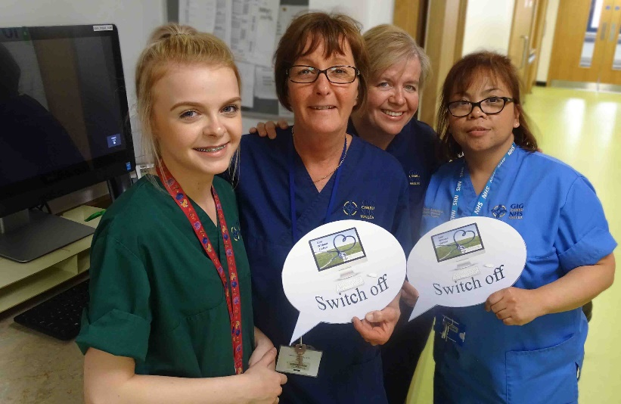
They have really got behind the campaign, which could reduce energy spending by £3,000 a year in that one area of the hospital alone.
L-r: Healthcare support worker Shelby Morris, main outpatient manger Das Harper, head and neck outpatient sister Karen Humphreys and staff nurse Elisa Bautista
Next the health board’s energy and environmental team will introduce the campaign in Singleton Hospital, with Princess of Wales Hospital in Bridgend set to follow after that.
Eventually it will become ABMU-wide, with a team of eco-champions being enlisted to help deliver the campaign wherever they work.
Main outpatient department manager Das Harper said: “I was for it straight away and the staff really took it on board. I didn’t have any problem at all getting them involved.”
Paediatric outpatient sister Shan Owen said it was clear savings could be made with very little effort.
She added: “All my staff are on board with this campaign and we hope it will be just as successful elsewhere as it is rolled out across the health board.”
ABMU environmental officer Mark Humphreys explained the campaign came about as a result of wider discussions about cost-cutting measures.
He and environmental support officer Damian Lewis decided to focus on Morriston Hospital’s new outpatients department to begin with.
Mr Humphreys said: “We couldn’t just go into wards so we decided to look at areas which were shutting down for the evening and weekends.
“During our initial investigations we found a higher-than-usual number of electrical equipment was being left switched on overnight.
“We spoke to the sisters of the outpatient departments, explained to them what we wanted to do and they gave us their full support.”
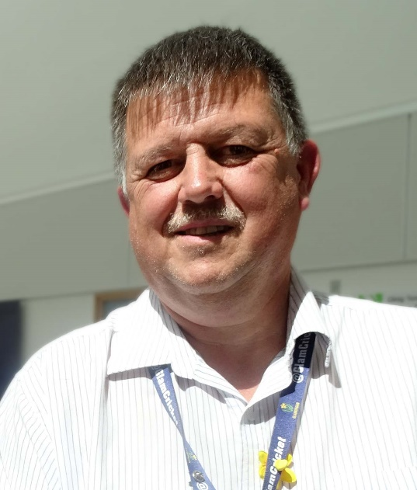
Outpatients has 150 computer workstations. A spot-check before staff were told about the campaign found 130 of these had been left on overnight and at weekends when the area was closed.
By the time the three-month awareness campaign concluded, further checks revealed all but a few of them had been turned off – and most of the very small number left on were actually in use.
Mr Humphreys (right) said: “We will be rolling it out into Singleton Hospital and we have spoken to senior managers in other areas so it will be escalating.
“It will take time but at the end of the day it’s about saving money that we can put back into patient care.
“A lot of people think the health board only runs four big hospitals but we actually occupy around 110 buildings.”
If the good work by Morriston outpatients staff can be replicated across ABMU, it could save the health board £30,000 and more than 200 tonnes of carbon dioxide every year.
Mr Lewis added: “Everyone in the health board has a role to play in this, whether it’s turning workstations off, switching lights off or turning the heating down.
“We all do it at home, and it’s just translating it into the work environment. It helps reduce our energy costs and reduce our carbon footprint, which we are obliged to do.”
As Switch-off spreads into more departments, the environmental team will also be recruiting eco-champions – staff who are keen to help deliver the campaign within their own workplace.
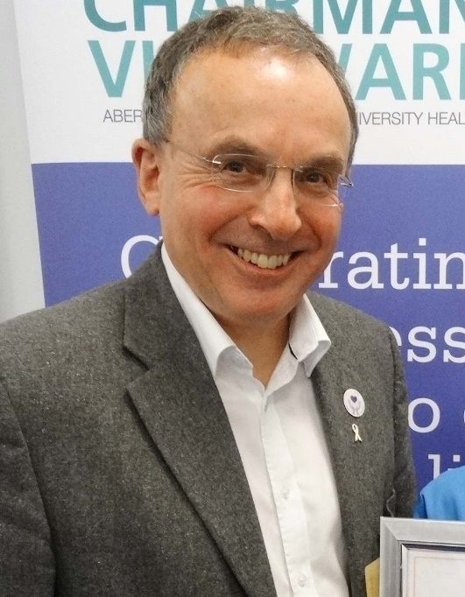
Head and neck outpatient sister Karen Humphreys said some specialist equipment had to be kept on while the department was closed but most of it could be turned off.
“It’s something so simple and the staff are very eager and interested,” she added.
“We don’t just come to work, we come to work to do the best for our patients. If that means saving money in a way that isn’t detrimental to their health then for me it’s a no-brainer.”
ABMU Chairman Andrew Davies (left) said: “I am delighted to see such great progress being made in reducing our use of energy and saving pounds into the bargain.
“This combines saving money with reducing our carbon footprint as an organisation.
“I would like to congratulate Mark Humphreys and Damian Lewis and the team for starting this great initiative and look forward to seeing it being rolled out across the health board.”

Source: Abertawe Bro Morgannwg University Health Board

