Laundry staff’s appeal over lost blanket
Thursday, 29 June 2017
ABMU laundry staff have sucessfully reunited a former patient with a much-loved blanket after a public appeal. UPDATE

Delighted ABMU laundry staff have been able to reunite a patient with the much-loved blanket she had kept by her side during her cancer treatment in hospital.

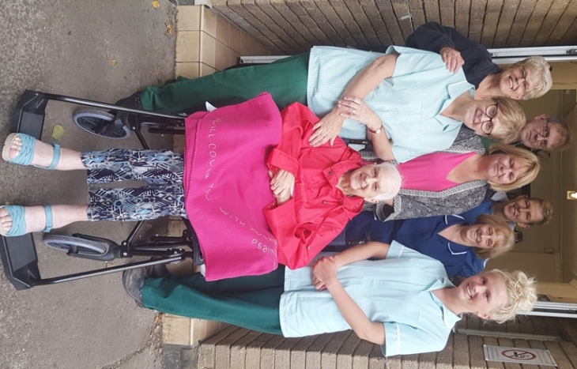
The distinctive blanket belongs to 82-year-old Shirley Evans, of Morriston, but it was misplaced when she was discharged from Gorseinon Hospital.

Shirley Evans reunited with her blanket with her daughters Louise and Isabel Evans and laundry staff.

“We weren’t sure if it would ever be found,” said her daughter Isabel Evans.

The fleecy blanket bears one of Mrs Evans’ favourite Biblical quotations “He will cover you with his feathers” which had been hand-stitched especially for her by family friend Emma Roffey.

Because it was so unusual the team at the Baywash laundry plant at Cefn Coed Hospital realised they had to try to track down its owner as soon as they spotted it.

Laundry manager Yvonne Watkins knew the family were looking for the blanket but by the time it turned up she no longer had their contact details so she went public with her plea to track them down.

The appeal attracted plenty of media attention. Besides featuring on ABMU’s website it was also covered by the Evening Post, WalesOnline and Swansea Sound. Posted on the health board’s Facebook page, it reached 50,000 people including Isabel’s best friend.

“I would really like to thank Peter Thomas who spotted it on Facebook otherwise I might not have seen it. We are so grateful to the laundry staff who really did go out of their way to get the blanket back to us. They have been wonderful,” said Isabel.

She and her sister Louise Evans brought Shirley with them to pick the blanket up at the health board’s Central Laundry in Llansamlet so she could say thanks to the staff.

“When my Mum heard that it had been found she had a tear in her eye. She has been through a tough time recently after being diagnosed with cancer. She has had surgery and spent time in Morriston and Gorseinon hospitals.

“But we are really pleased that she is now doing so much better. She still has a couple of chemotherapy sessions to go but she is now cancer free.

“During all this treatment she has had the blanket with her so it really means a lot to us that she’s now got it back.”

Yvonne added: “All our laundry staff always do what they can to reunite patients with any lost items.

“We are just so pleased we have been able to get the blanket back to Shirley and it was lovely to be able to hand it over to her in person.”

ABMU laundry staff have appeal for help to reunite a former patient with a much-loved blanket.
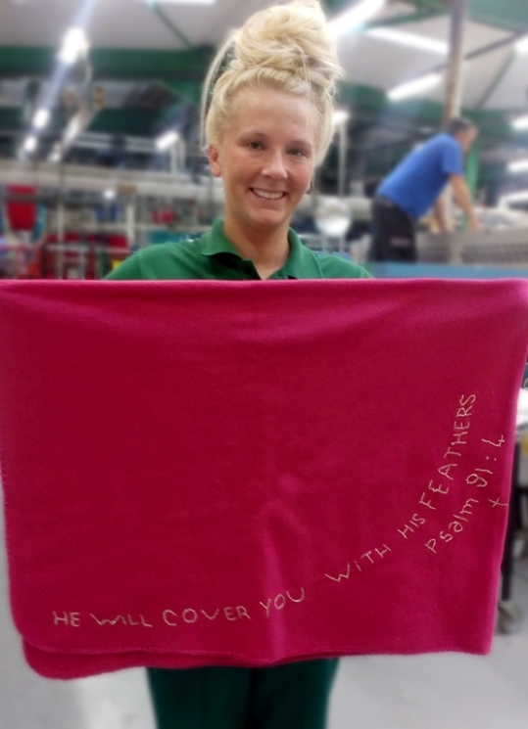
The distinctive pink fleecy blanket has been hand embroidered with the phrase “Will cover you with his feathers” from Psalm 91.

Manager at the Central Laundry in Swansea Yvonne Watkins said she believed the blanket belongs to someone who had been a patient at Gorseinon Hospital recently.

Laundry assistant Hayley Watts with the blanket

She said: “I had a phone call about two weeks ago from a relative who was inquiring about the blanket because it had great sentimental value to the patient.

“We couldn’t find it at the time but now I am pleased to say it has turned up with us.”

Unfortunately Yvonne hasn’t got their phone number and is appealing for them to come forward and get in touch with her again.

“We would love to return this item as I know how upset the patient was at losing it.

“I have tried tracing the patient through staff at Gorseinon Hospital but I haven’t had any luck so far.

“I am hoping the family will see the appeal and get in touch with us again.”
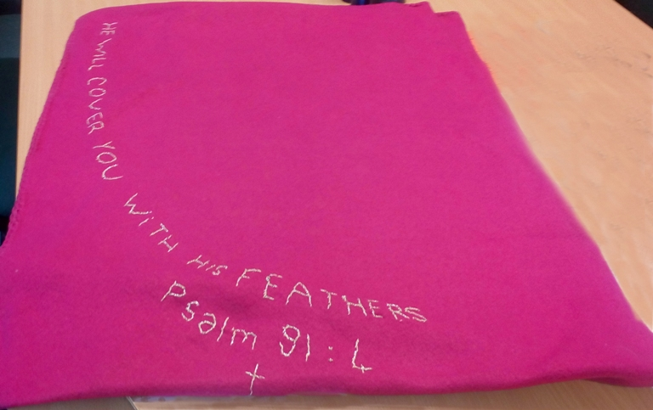
The laundry team has a proud record when it comes to getting lost property back to former patients.

A close-up view of the distinctive embroidered message on the blanket.

A successful appeal to find the owner of a missing military medallion was seen by more than 75,000 people on our Facebook page and last year little Jaxon Phillips-Evans was reunited with his blue elephant toy, the lucky mascot that had been with him through a series of medical procedures.

If you know who the blanket belongs to please contact Yvonne on 01792 410036

Source: Abertawe Bro Morgannwg University Health Board

