Henry flying high after first fundraising venture tops £3,000
Thursday, 1 June 2017
A hospital worker’s first fundraising venture after a life-changing accident has really taken off with more than £3,000 winging its way to charity.

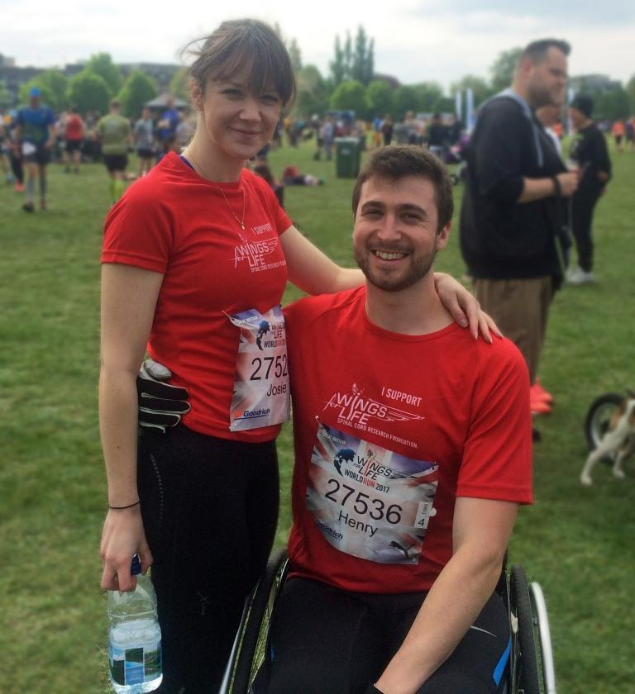
When Morriston trainee pharmacy technician Henry House signed up for the Wings for Life World Race he set a £500 target.

Henry House and girlfriend Josie Evans at the Wings for Life World Race in Cambridge

But, instead, a total of £3,198.51 will go to Wings for Life, a not-for-profit spinal cord research foundation.

Its mission is to find a cure for spinal cord injury, funding first-class scientific research and clinical trials internationally.

Henry, aged 25, had not long started work in Morriston before he suffered serious spinal and head injuries in a fall in 2015.

He was admitted to the hospital’s Emergency Department. After undergoing surgery, Henry was transferred to a specialist rehabilitation unit in Cardiff, and was in hospital for a total of five months.

The accident left him with lower limb paralysis; Henry, from Rhossili, is paraplegic and in a wheelchair.

Fortunately his post as a trainee pharmacy technician at Morriston was kept open so he is able to continue doing the job he loves.

The Wings for Life World Run takes place at locations around the globe on one day each year, starting at the same time. Henry and girlfriend Josie Evans competed in the UK event, held in Cambridge.

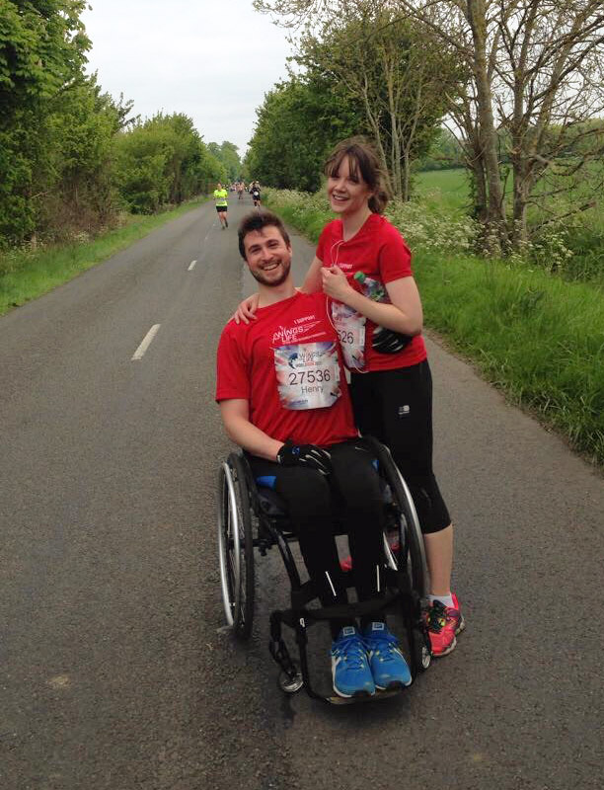
Half an hour after competitors set off, a chase car begins to track them down, starting at a certain speed and then gradually accelerating until every competitor has been caught.

Henry said: “We did very well. We managed 14.8km in under an hour and a half before the car caught us.

“It was brilliant, such a great day out. We’ll definitely be signing up for next year’s event.”

As well as taking part in the Wings for Life event, Henry and his pharmacy colleagues have been collecting money in Morriston Hospital, and held a cake sale and charity raffle.

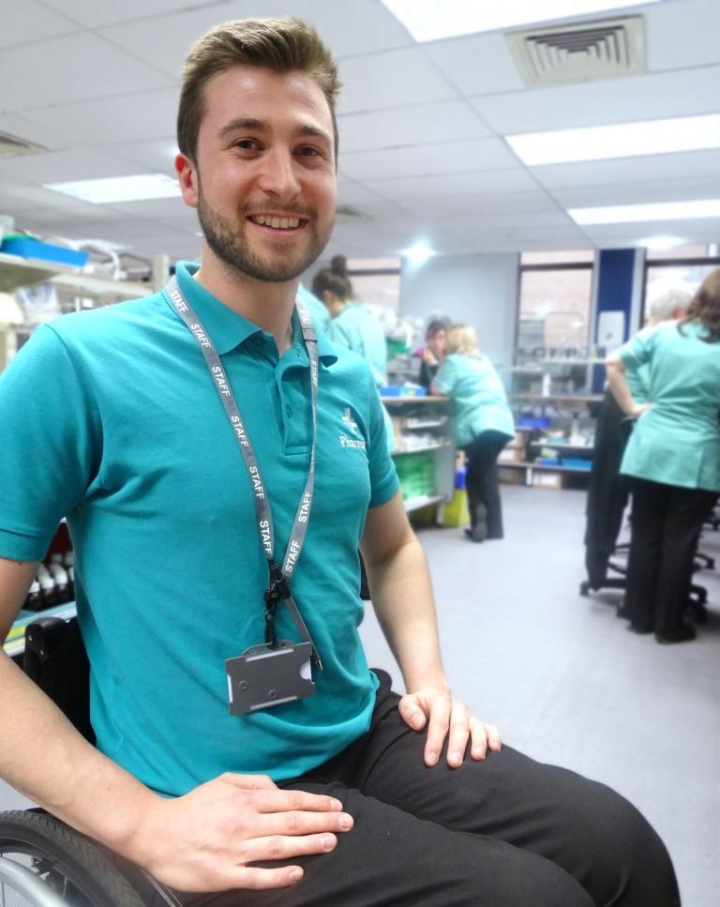
Among the prizes were a signed Chelsea shirt, an Ospreys shirt, a family ticket for a Scarlets match, wines, chocolates and many other goodies.

Left: Henry at work in Morriston Hospital’s pharmacy department

All of this contributed around £1,300 to Henry’s fundraising total.

He said: “We set a target of £500 initially because we didn’t really know what to expect – but we absolutely demolished it.

“We’ve had such fantastic support from work colleagues, family and friends and from patients who bought raffle tickets. It’s been unbelievable.”

You can read our earlier story about Henry here
Source: Abertawe Bro Morgannwg University Health Board

