Doctors ready to use their expertise to help Syrian refugees
Wednesday, 21 June 2017
Two Morriston Hospital doctors with a passion for global child health are preparing to join a humanitarian trip to help refugees from war-torn Syria.

Smiti Bihari and Munirah Mazlan will be putting their skills as paediatric registrars to the test during the mission to Al Zaatari refugee camp in Jordan.

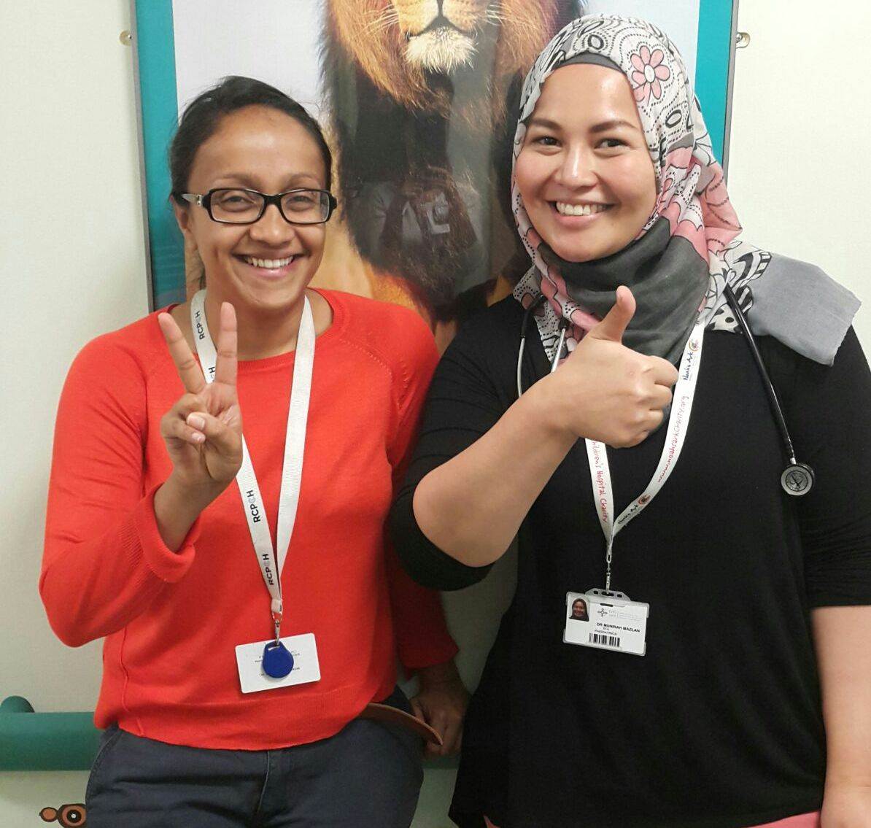
The camp, near the border, was set up host Syrians fleeing the violence in their country and is gradually evolving in to a permanent settlement housing more than 83,000 refugees.

Smiti Bihari and Munirah Mazlan are preparing to head to
ordan to help young Syrian refugees.

Half of those are under 12 and many are in desperate need of medical care. During their 10-day trip Smiti and Munirah are each expecting to see at least 30 children every day.

They will be working alongside colleagues from the Syrian American Medical Society (SAMS), a non-political non-profit medical relief organisation that works on a regular basis at the camp which is run by the Jordanian Government and the UN Refugee Agency.

Smiti said: “We have first-hand experience of child health in extreme situations. SAMS were in need of paediatricians to join their July medical mission so we applied without hesitation.”

As part of the Royal College of Paediatrics and Child Health Global Links programme Munirah has previously spent time in rural Uganda as a senior paediatric doctor in a district hospital while Smiti spent six months in Sierra Leone working in the intensive care unit in the children's hospital.

Smiti said: “The current situation in Syria is dire, the civil war is now in its sixth year, resulting in thousands upon thousands of displaced children and families. Jordan has accommodated many of those refugees.”

SAMs is currently establishing a permanent clinic at the camp to provide regular child health care to the residents. This involves newborn care – the birth rate is very high in the camp – running immunisation campaigns to control and prevent outbreaks, acute general paediatric care, management of chronic conditions and monitoring and assessing malnutrition.

Smiti said: “It will be a unique and eye-opening experience for us.”

The pair, who head to Jordan on 6th July, are using annual leave and are self-funding their trip.

“We will contribute to caring for children in the 10 days we are out there as well as helping to build sustainable capacity for longer-term paediatric care and broaden our own horizons when it comes to global child health.”

Munirah said: “UK paediatricians know very little about the situation despite our college (RCPCH) advocating for more support for unaccompanied child refugees both in Syria, the camps and in the UK.

“Our first-hand experience will help raise awareness of the situation, amongst out paediatric colleagues and beyond.”

Anyone who would like to support their work should visit their fundraising page at https://www.justgiving.com/crowdfunding/Wales-to-Jordan

Source: Abertawe Bro Morgannwg University Health Board

