Blue Peter badge after Iolo speaks up about his treatment
Friday, 16 June 2017
Porthcawl schoolboy Iolo Evans is now proudly sporting a very special addition to his school uniform – a Blue Peter badge.

He was awarded a blue badge by his favourite TV programme after sharing his experiences of the help he received to cope with his stammer.

Iolo, who is now 10, came to a clinic after his mum Lucy contacted ABMU’s speech and language therapy team for advice.

After getting over his initial nerves about going along, he ended up really enjoying the appointments and wanted to encourage other children not to be afraid if they needed help too.

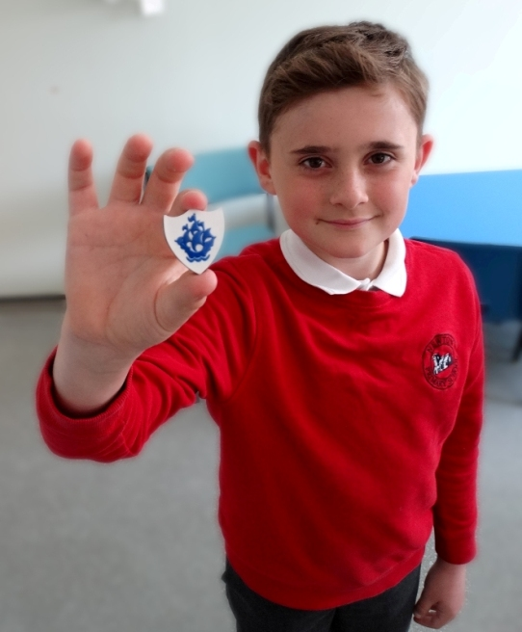
In his letter to the show Iolo said: “I would say to kids who have stammers that they shouldn’t worry.

“What is good is if you don’t try to keep your stammer a secret because parents, speech therapists and teachers can help if you get stuck on words.”

Iolo Evans proudly shows off his Blue Peter badge.

Lucy, who works at Princess of Wales Hospital as a maxillofacial nurse, said: “He started having problems in Year Three, his stammer started to bother him so I contacted the speech therapy department and they were just so helpful from the very first phone call.

“He had his first session with speech and language therapist Lowri Roberts and they just seemed to bond straight away.”

Newton Primary School pupil Iolo joined a dysfluency group for sessions held in community clinics. This brought together children aged between seven and nine who had had similar experiences.

They were able to talk openly and confidently while speech and language therapists explained the importance of good communication skills and taught them techniques to help with a stammer.

These include slowing speech down, pausing during sentences and freezing speech on the stammer until the tension passes.

The therapists helped the pupils decide which methods were right for them so they could practise with other members of the group.

Lowri said: “Five per cent of children stammer as they grow up. It is more common for boys than girls, and how the stammer appears can differ from person to person.

“For example, some may repeat words or sounds, others may prolong sounds or pause while they try to get their words out.
“Having a stammer makes people feel self-conscious and isolated, especially as they are growing up, so it is important they have the opportunity to meet people of a similar age with similar experiences.”

Speech and language therapists Sara Evans (centre) and Lowri Roberts work on some of the techniques with Iolo.

Her colleague Sara Evans, who also worked with Iolo, said as children grow up help is at hand so they can maintain their progress and confidence in dealing with their stammer.

“We hold regular group and individual sessions for those in primary schools and we also see youngsters as they prepare to move up to secondary school which can be a big challenge for them,” she said.

A delighted Lucy said: “Iolo just grew in confidence and started making progress, it has all been so beneficial.

“Lowri and Sara gave him the tools to deal with his stammer, nothing invasive or scary, just little techniques he can use that really work.”

Iolo, who lives with Lucy, dad Nev, sister Lois and little brother Albie in Porthcawl, was so pleased he decided to send off the letter.

“Writing the letter was all his idea. He didn’t want other children to be worried if they had a similar problem,” said Lucy.

“Iolo is a much more confident boy, the techniques have really empowered him. We are very proud of him.”
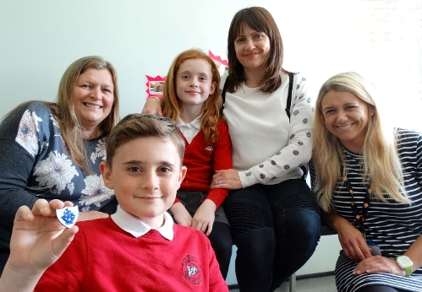
Iolo received a reply telling him how interested presenters Barney, Lindsey and Radzi had been to hear about the classes and that they had decided to give him a coveted Blue Peter Badge.

Iolo Evans with (from left) speech and language therapist Sara Evans, his sister Lois, aged eight, mum Lucy and
speech and language therapist Lowri Roberts

ABMU’s head of speech and language therapy Alison Clarke added: “We’re so pleased Iolo had such a positive experience and that he wanted to share that with other children.

“These sessions are aimed at helping youngsters to cope with their speech problems and we are so pleased to know that they are really making a difference to young people like Iolo.

“Hopefully other families will be encouraged to get in touch with us to see what help we can offer.”

ABMU’s speech and language therapy team offer various group and individual sessions across the locality to support young people with a stammer.

For more information please contact them on 01639 862718 or 01656 754019.

Source: Abertawe Bro Morgannwg University Health Board

